My Boxford 300 VMC story

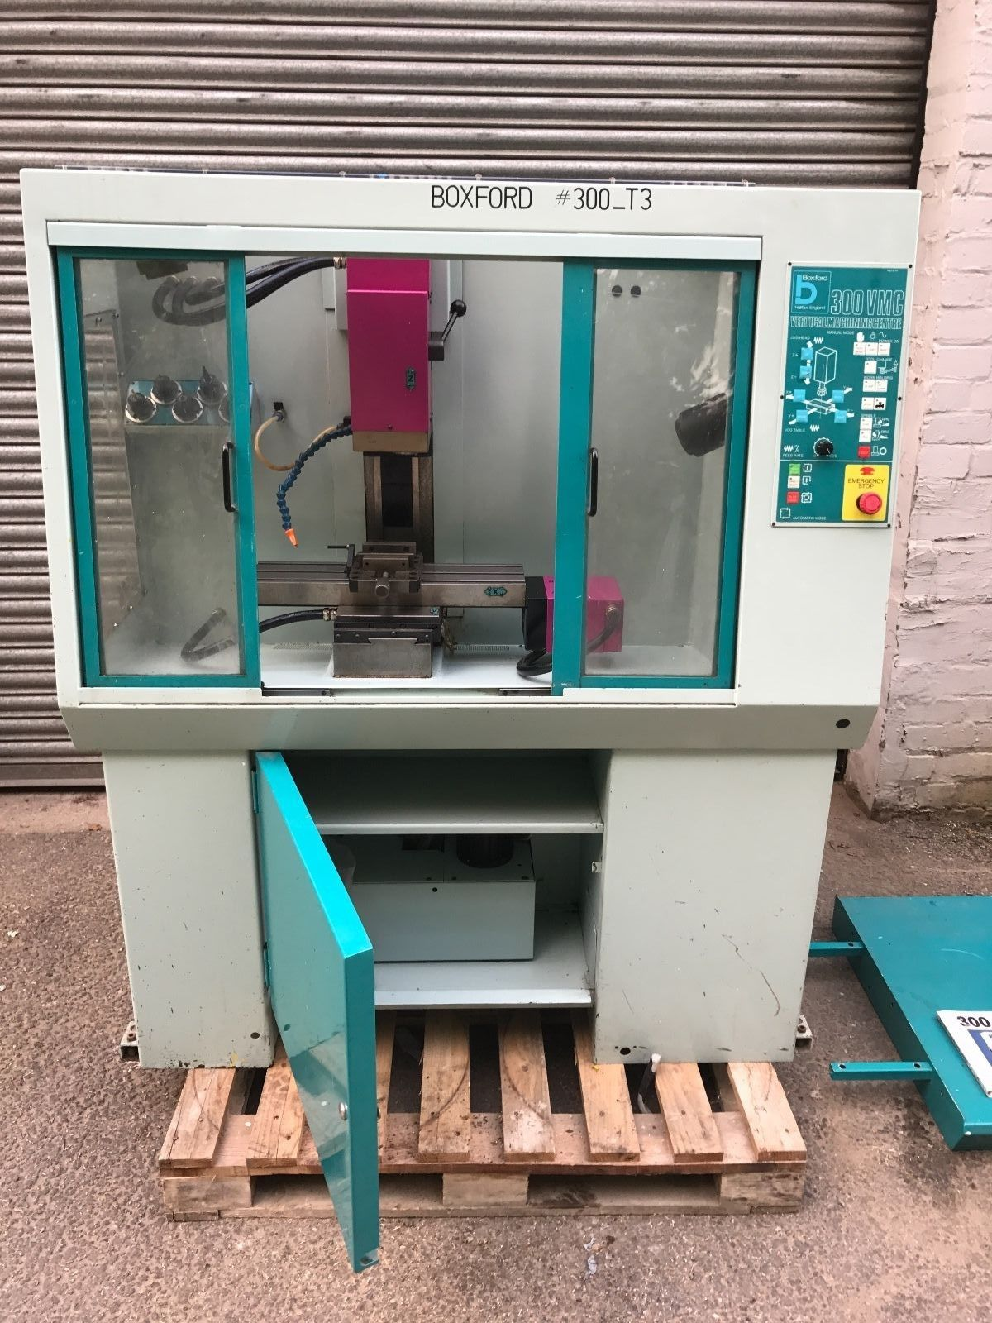

Table of Contents
Top electrical area of VMC300 3
Bottom electrical area of VMC300 4
Wires that go from the top section of the VMC to the bottom section where the above board was housed. 6
Relays: 7
Lighting 7
How is the Emergency Stop contactor wired? 11
The other relays 13
Detailed relay connections 16
So, how do all the relays work? 17
The VFD 19
Spindle connections 20
The 34 pin cable function and assignments 24
The feed rate override switch and its logic 25
X, Y and Z limit switches 31
Plans moving towards fitting the Ethernet Smooth Stepper and breakout boards. 32
Front panel and manual control revisited: 35
The ESS port pin assignment 37

Top electrical area of VMC300
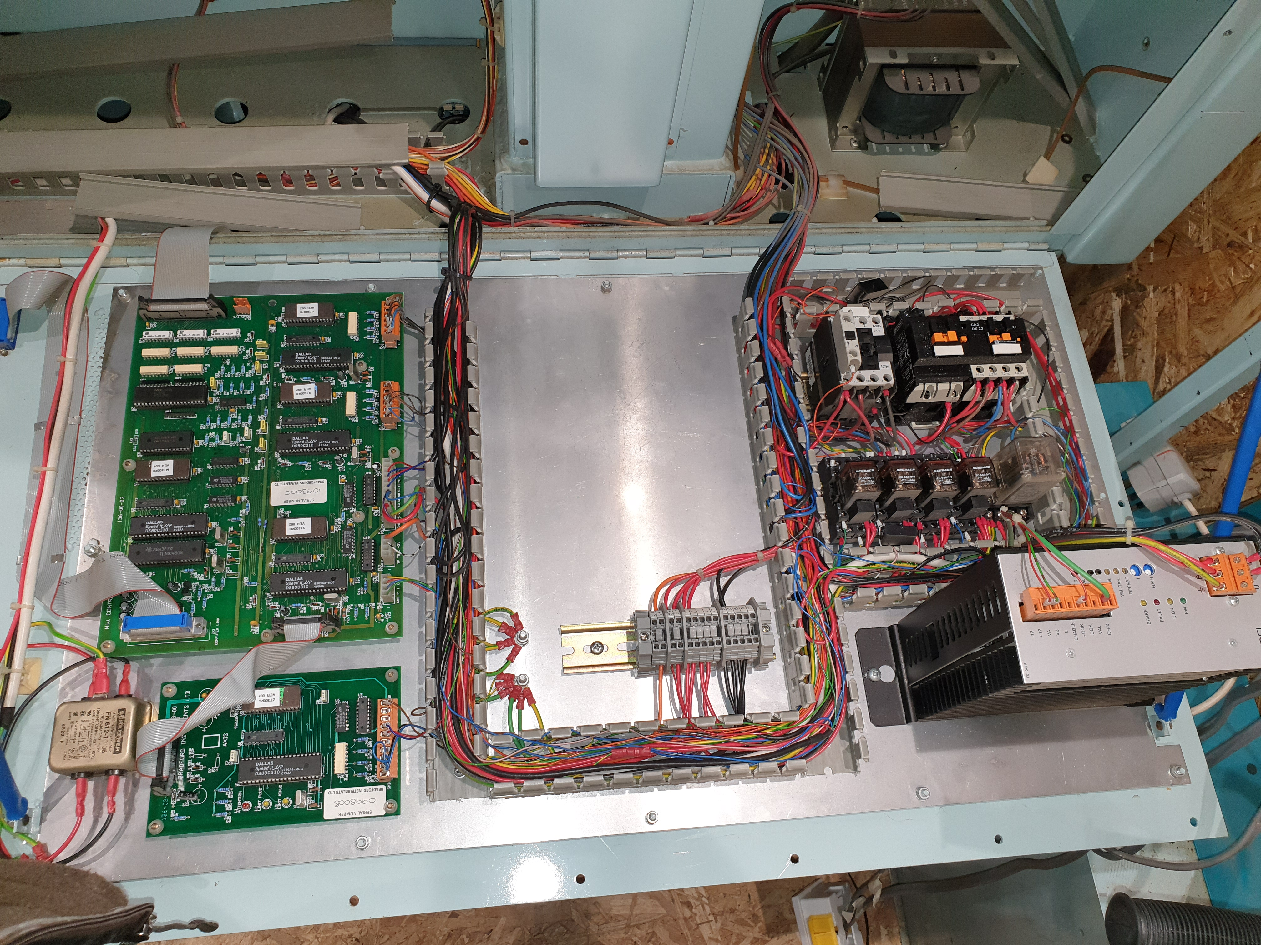
Secondary board
Door switch + spindle enable relay
Connector block
Spindle enable relay
Coolant relay
Spindle direction relay
Lighting relay
Main board
VFD
Transformer
RFI filter

Bottom electrical area of VMC300
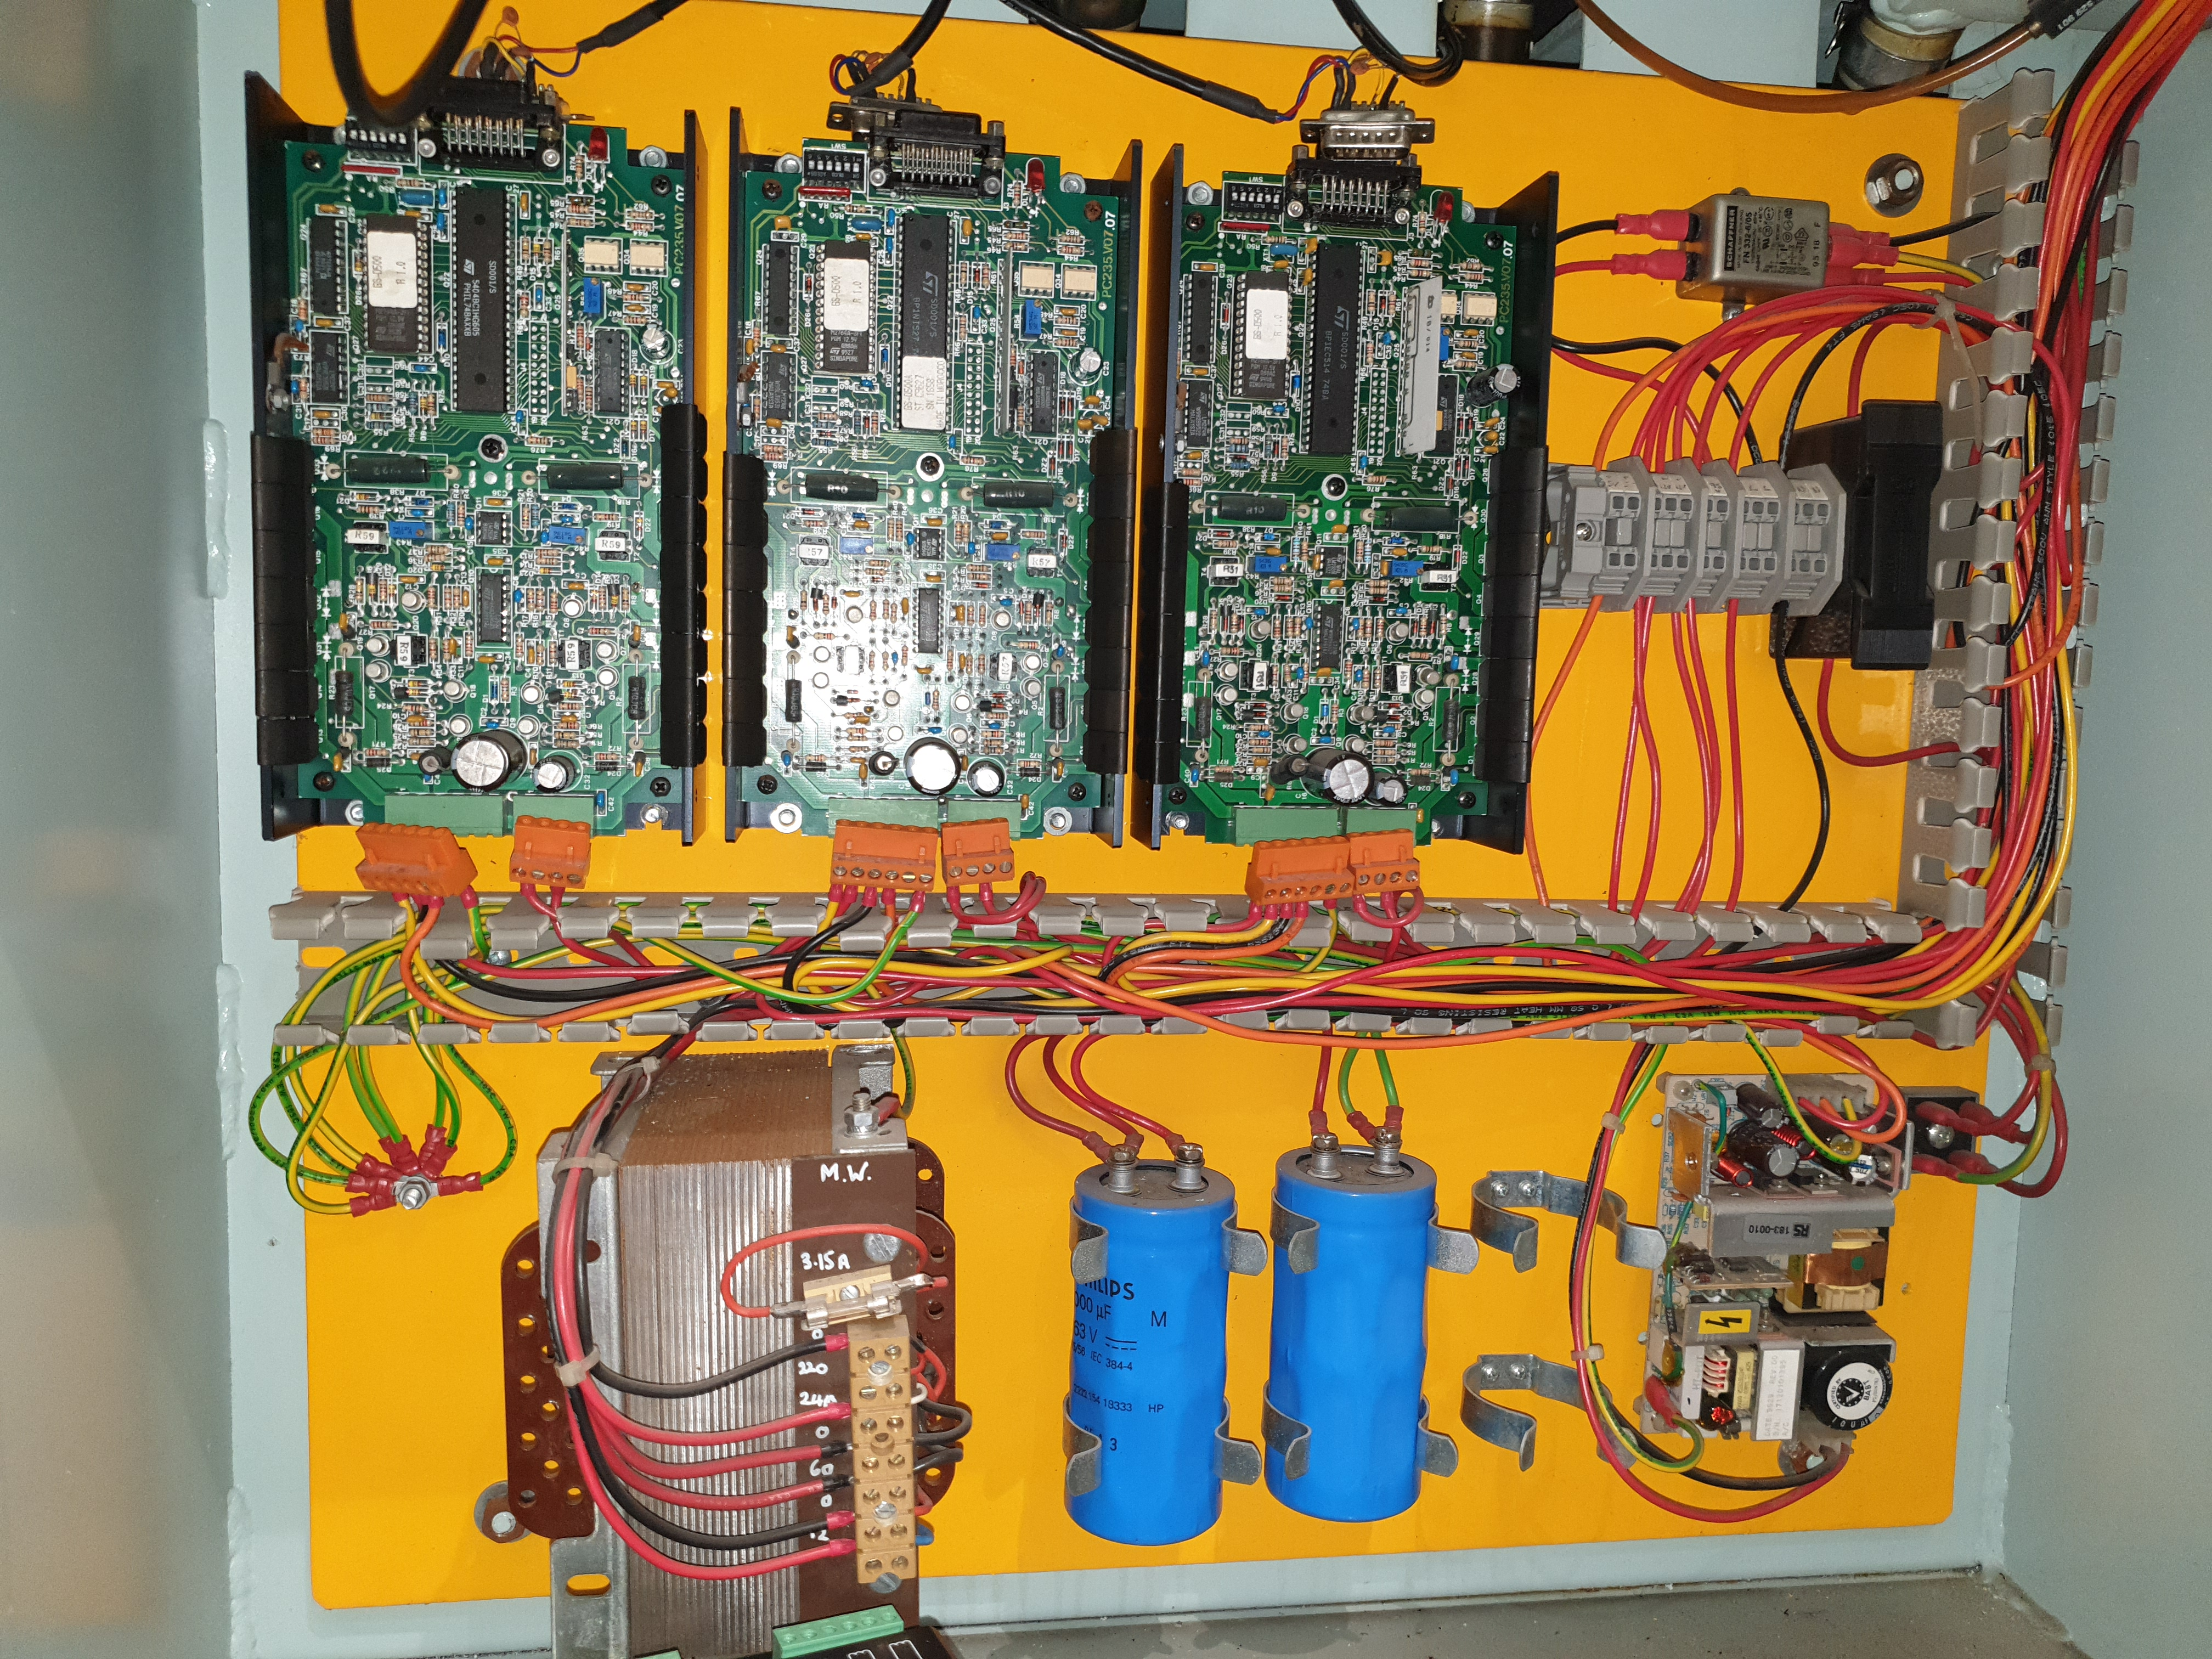
RFI filter
3 of stepper motor drivers
12v & 5v switch mode power supply
Capacitors
Transformer
Fuse 16A
Connector block
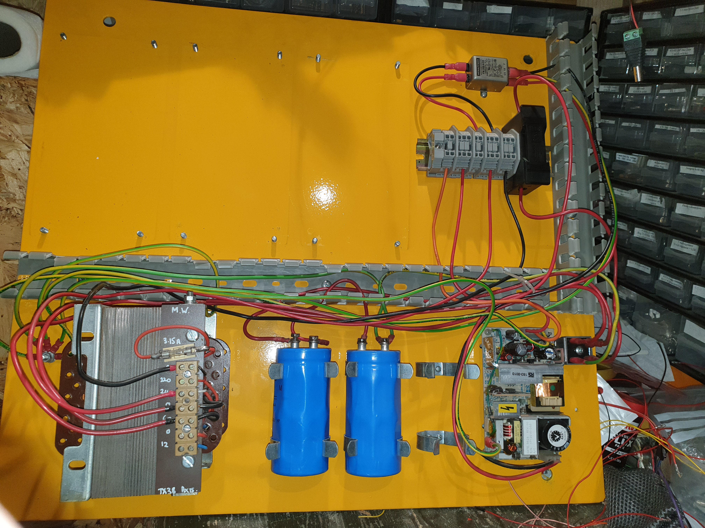×
PSU connections
0v black goes to the RFI filter via the N connector
220v is empty
240v red goes to the RFI filter via the L connector
0 red goes to one of the rectifier AC connections
60v goes to the other rectifier AC connection via the 16amp fuse
0v – Black – long one from the transformer to top
12v – Red – long one from the transformer to top
12v red &
5v orange &
Ground
230v in via RFI filter &
Ground to power supply
60v+ DC across capacitors from voltage regulator and ground. Caps are wired in series
Full wave bridge rectifier running at 60v AC to DC
Stepper motor supply cables in red to 12 and 95 labelled pins

Individual stepper motor power supply cables go to the 95v and 12v posts in the splitter box by the fuse
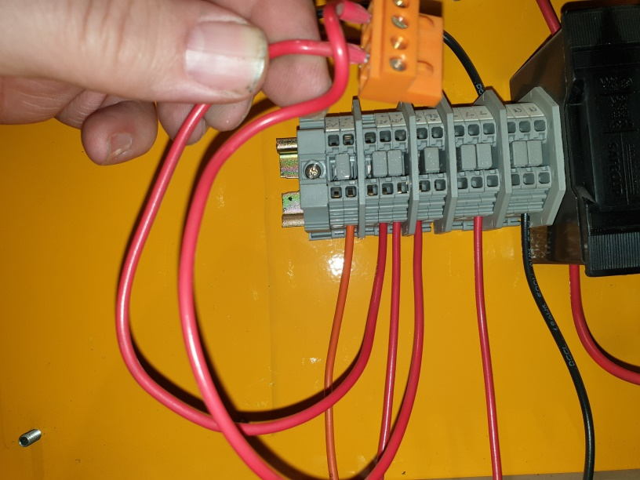

Wires that go from the top section of the VMC to the bottom section where the above board was housed.

3 times stepper control wire blocks of 4 wires each (to the coils)
5v DC – Orange
12v DC – Red
N AC – Black
95v AC – Red
L 220v AC – Red
12v AC – Red – long one to the transformer
0v AC – Black – long one to the transformer
Cap DC - Red terminal carrying 60v
Earth AC and DC

Relays:

Lighting
Current version https://uk.rs-online.com/web/p/products/0348245/ or 24v for new version https://uk.rs-online.com/web/p/non-latching-relays/0348239/

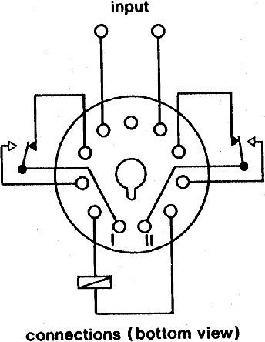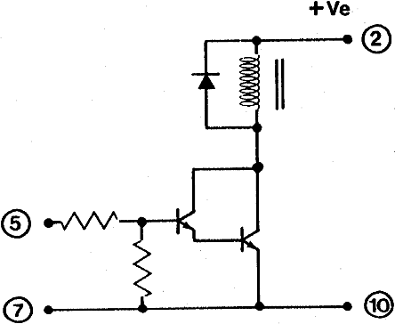

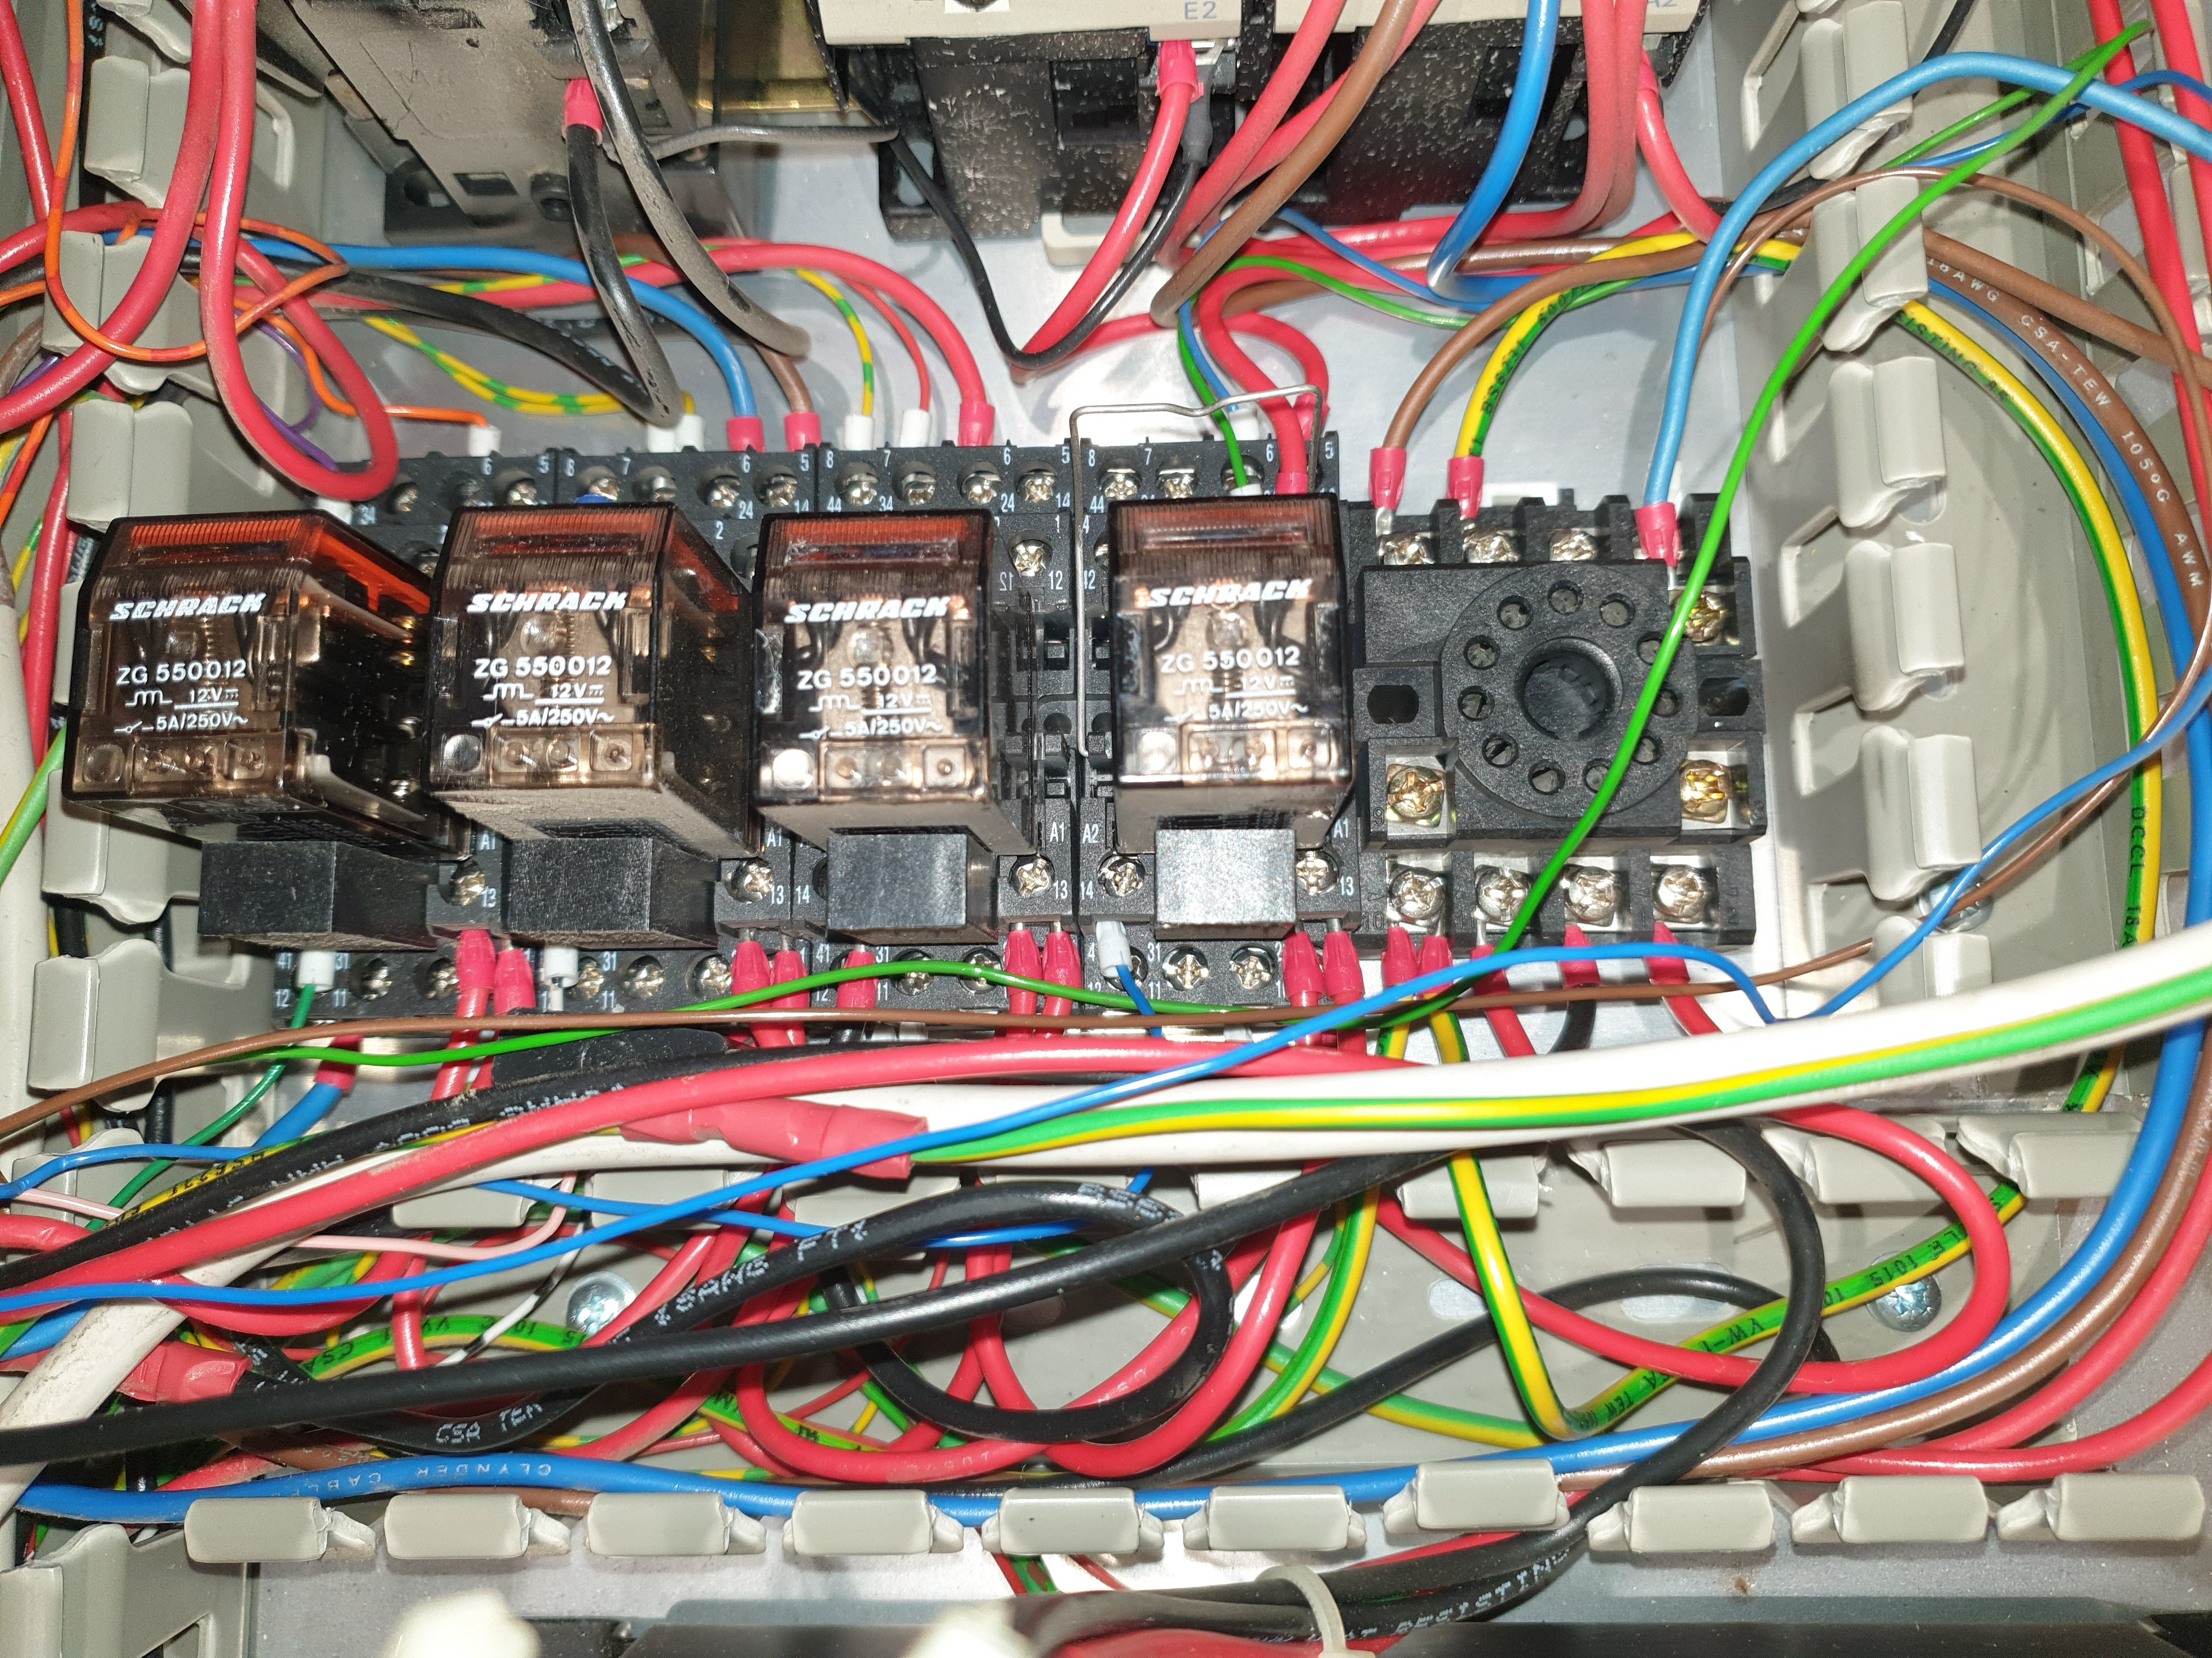
12v AC Brown & Blue to the right lamp (from door)
NC relay contacts
CMOS DC trigger line Brown +ve (from the front panel & hidden behind the blue) & Ground
Pin 1 then count anti-clockwise

Pin 11
12v AC Red & 0v Black from the bottom transformer
+12v DC Red from the bottom switch mode transformer
Here are the relay contacts and how I think they work. It seems to be the switch for the main interior lighting
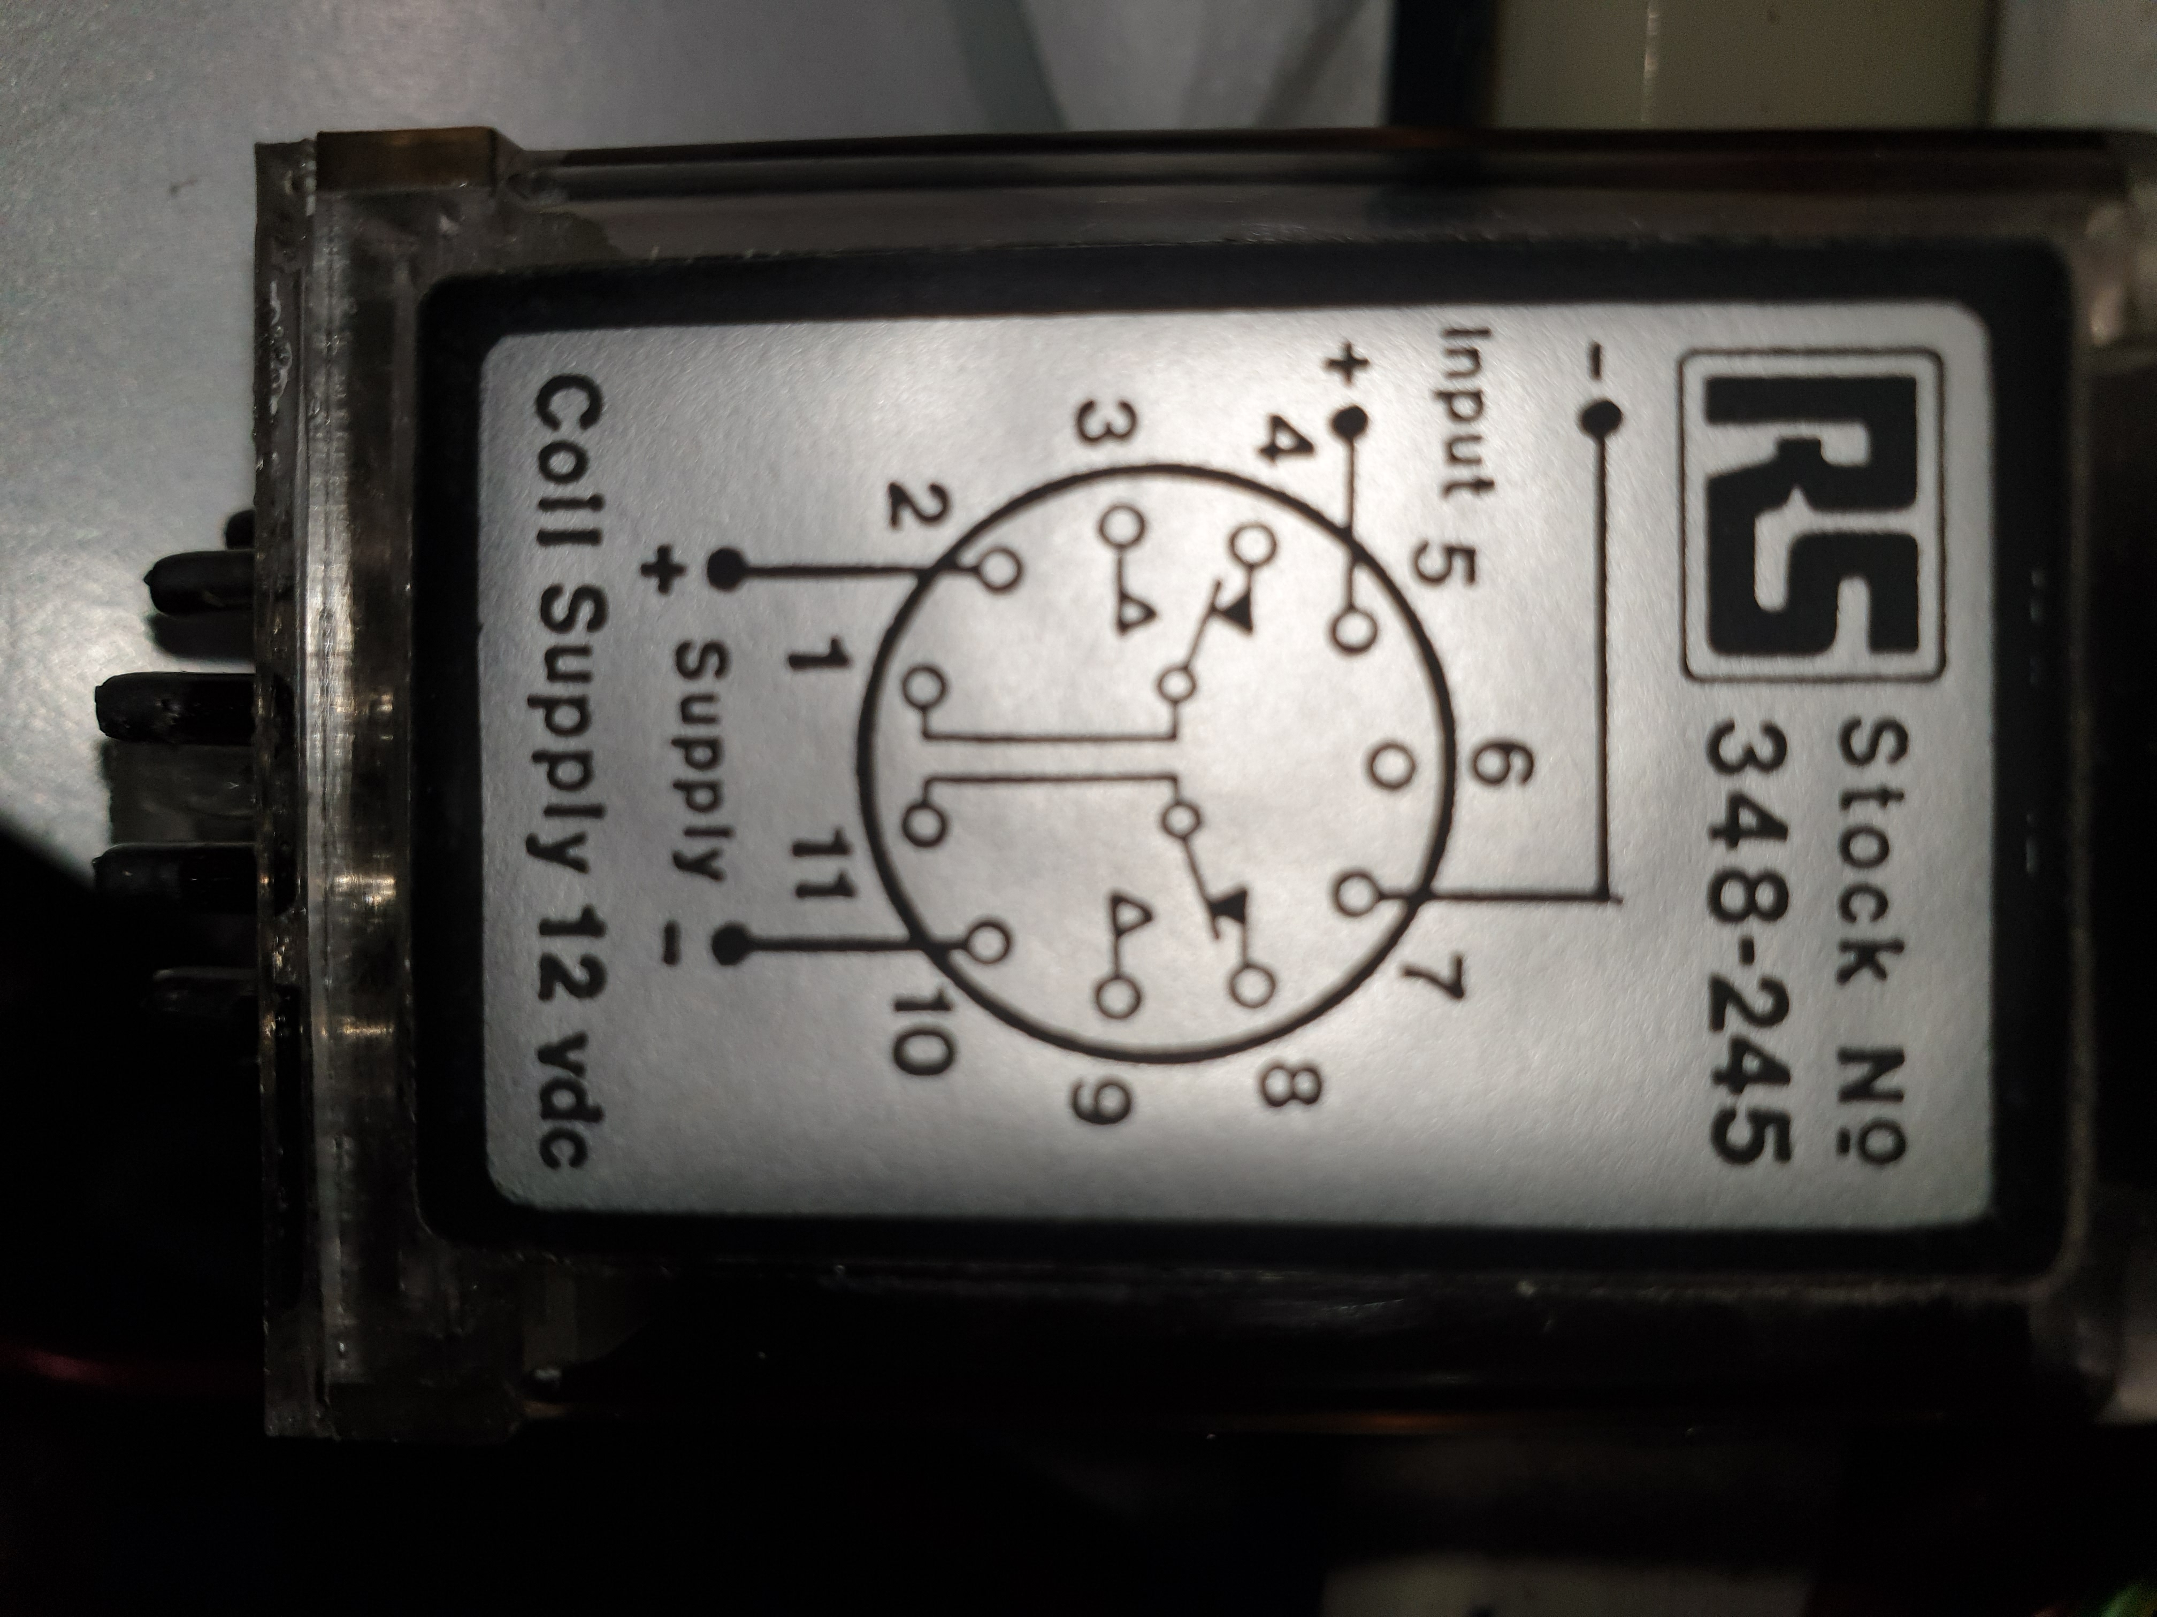
12v supply to pin 2 to power the relay coil
3.5 to 50v input to pin 5 to activate the relay. Runs through a Darlington pair so very low current. Currently comes from the front panel via the tiny brown wire
Pins 4 and 8 connect through NC contacts to pins 1 and 11.
Pins 6, 3 and 9 seem not to be connected to anything

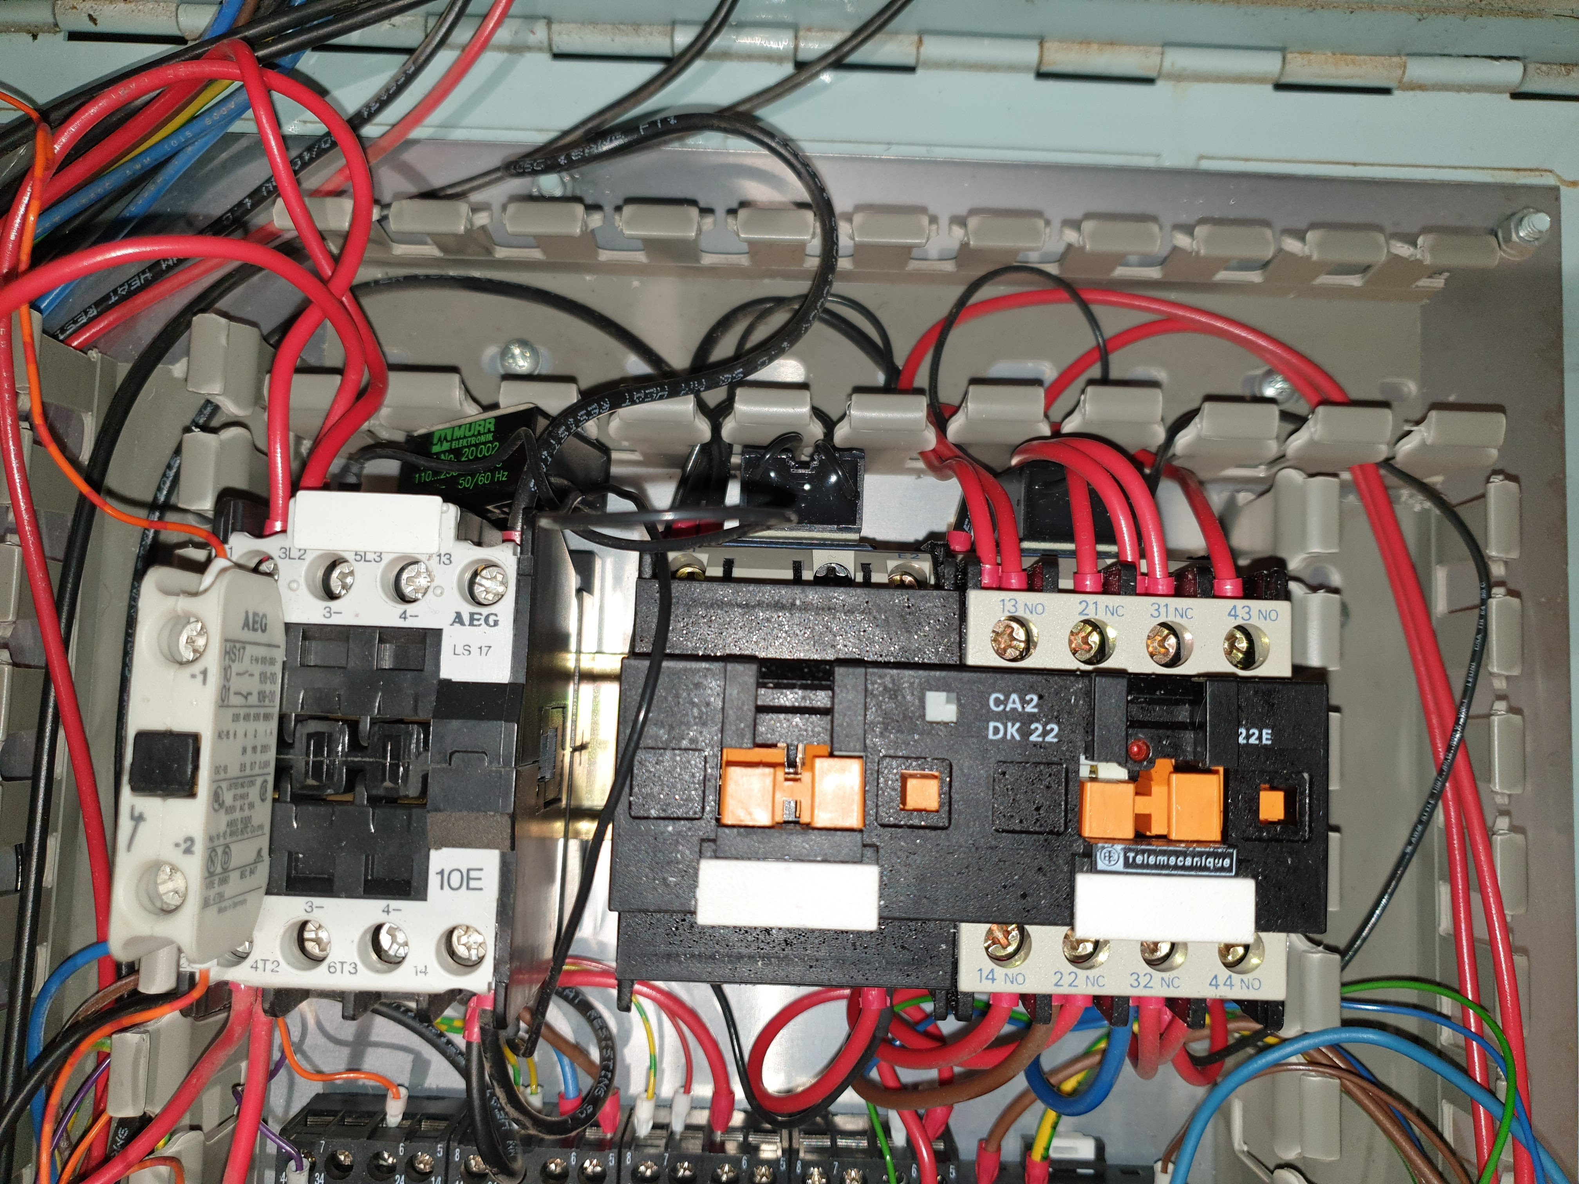
Wired to the clamp/unclamp switch on front panel I think

How is the Emergency Stop contactor wired?
Main power comes into the top connector 3L2. This is then bridged around the NO contactor pole to 4T2. It then goes off to the emergency stop switch which has to conduct for everything to work. It then returns to the coil inbound terminal under the 3L2 terminal
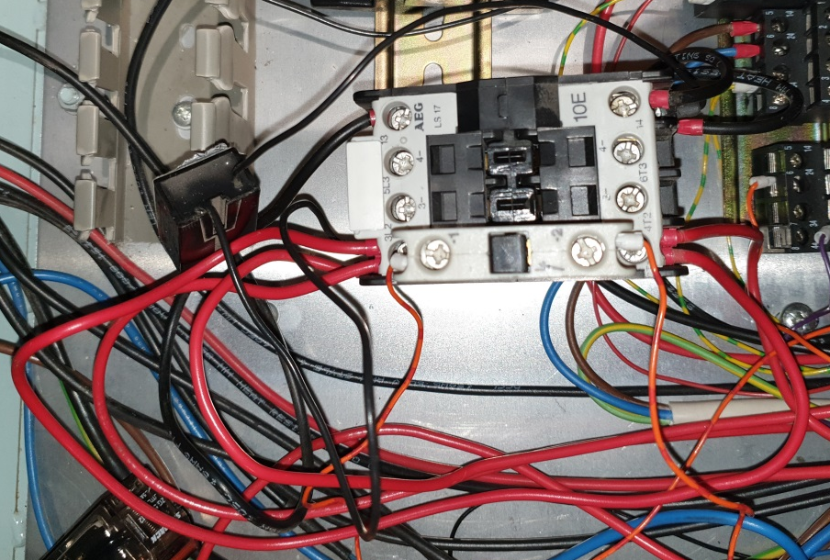
These two terminals are bridged bypassing the contactor contacts
The Coil Live terminal is connected to both the Estop switch and the bottom left terminal in the photo
Black 115AC to the VFD
Black 115AC from the transformer
Contactor coil output wired in black to Neutral
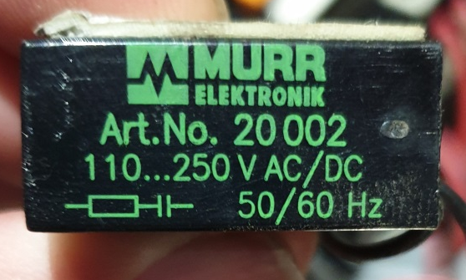These 3 little guys attached to the contactors are surge suppressors

Red Live 240AC
Black 115AC from the transformer
The Coil Live terminal is connected to the Estop switch

E-stop switch opens when depressed
All main contactor terminals are NO when power is off or E-stop is pressed
I think these terminals are connected to the chuck release and are normally closed. Opens when mill active but provides a ground if E-stop pressed

Black 115AC to the VFD
Contactor coil output wired in black to Neutral

The other relays
Relay 1
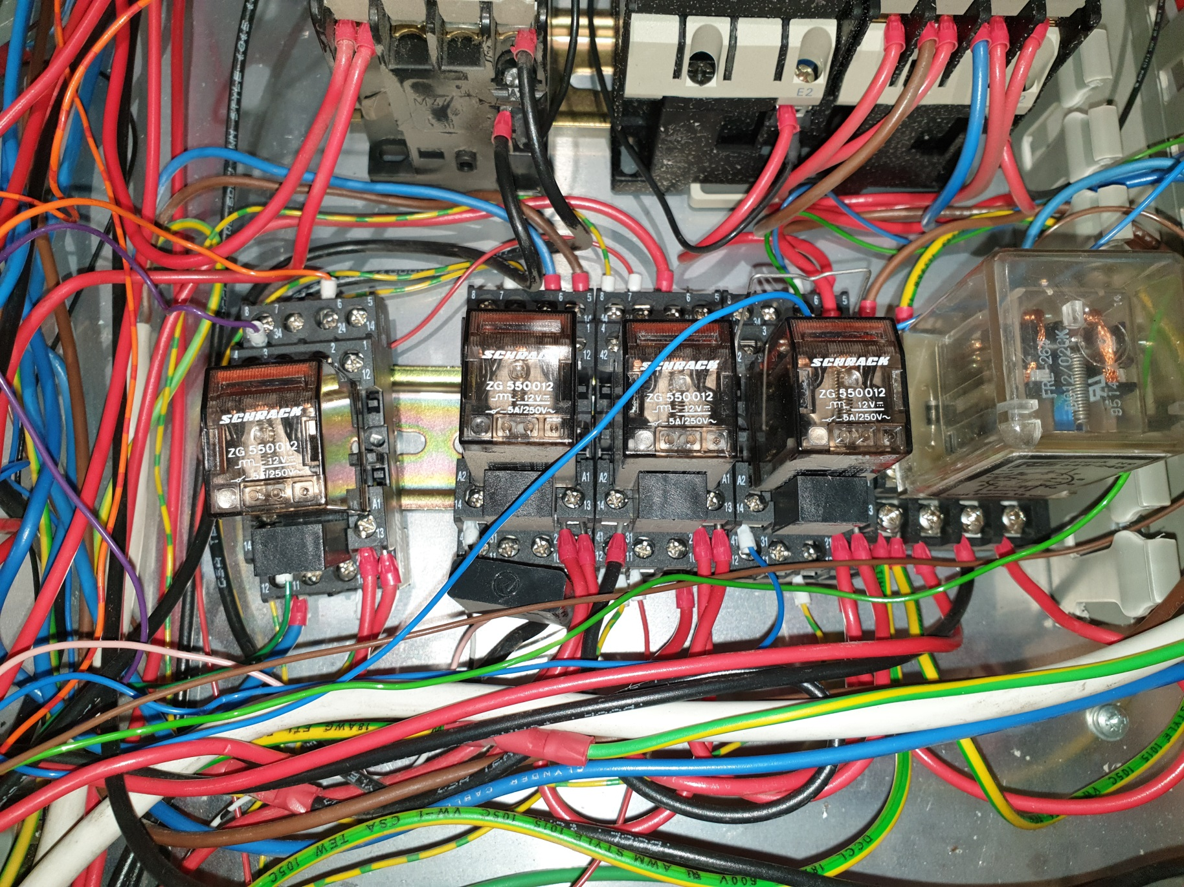
Purple wire goes to SE term on motherboard
Orange wire goes to the front panel and then back to the motherboard via the ribbon cable
12v DC in from power supply
Green wire goes to the 12v door interlock switches. I guess it sinks current to turn on the relay

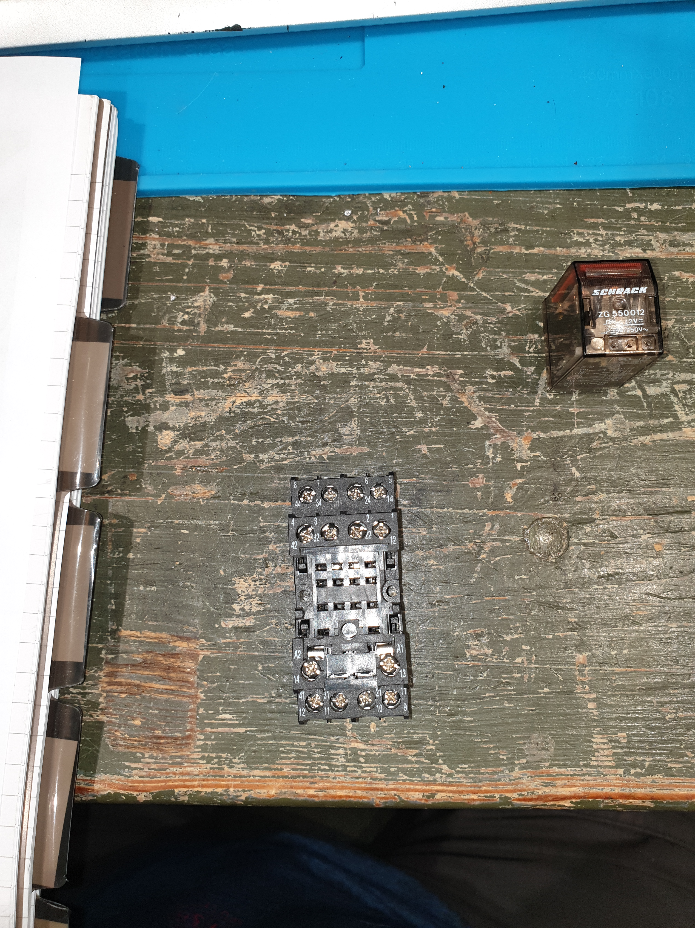
NO contacts for 4 sets of contacts
NC contacts for 4 sets of contacts
Coil contacts A1 and A2. Also has a separate diode for back emf.
Common contacts for 4 sets of contacts

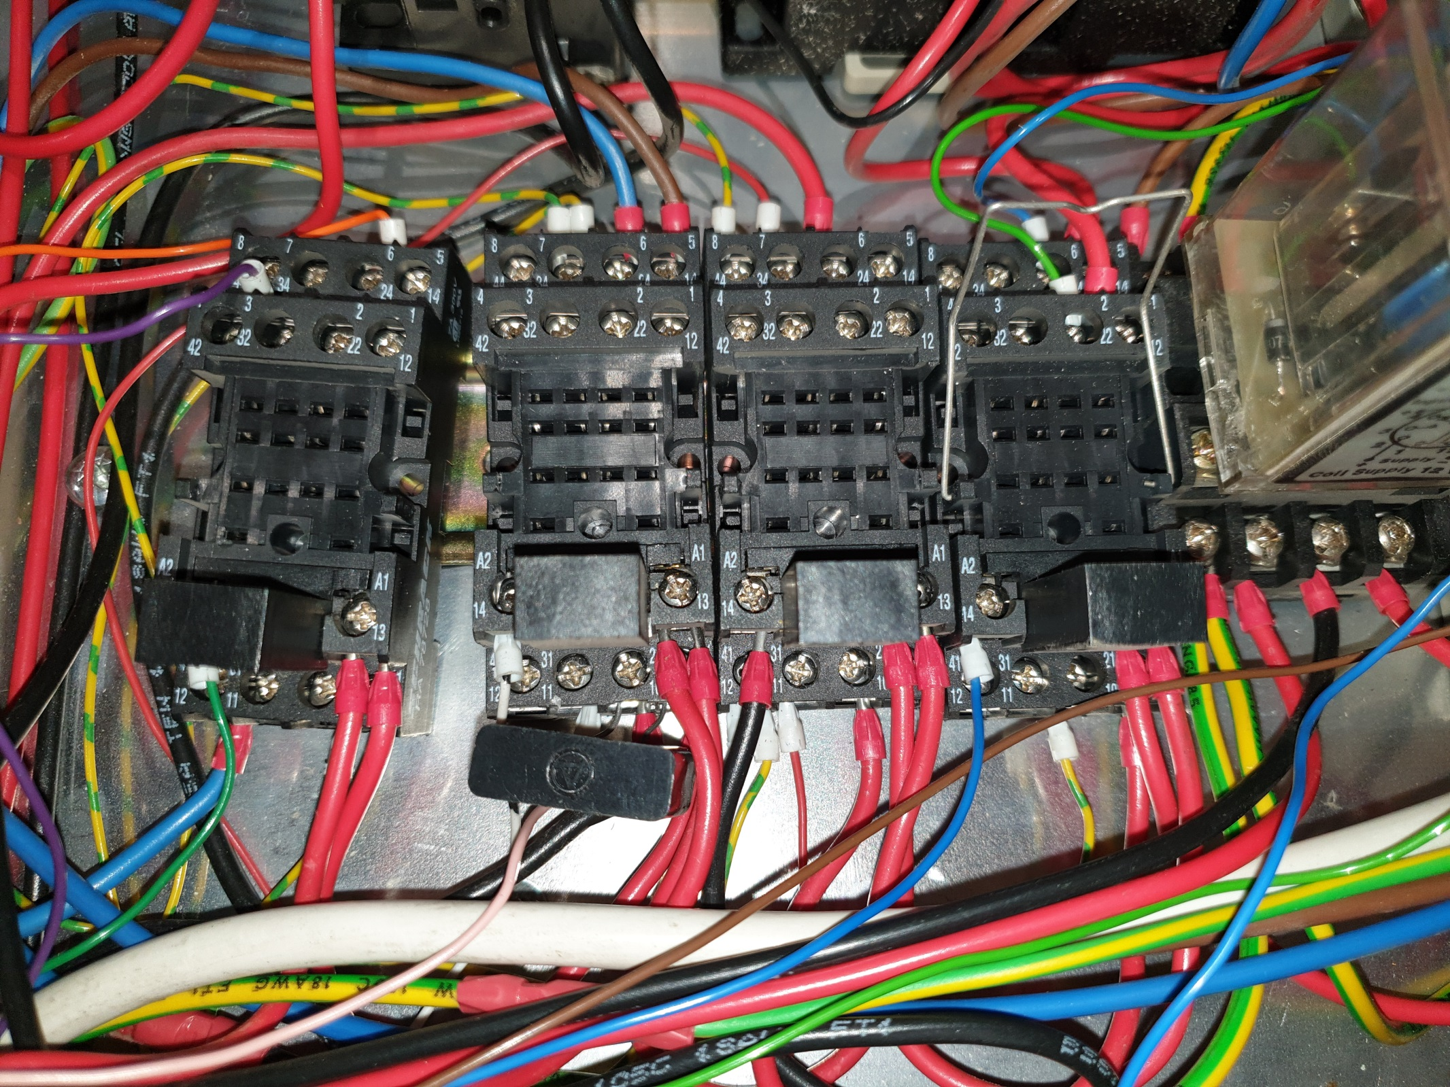

Detailed relay connections
Spindle
Lock
Switch
To coolant pump 240v
Orange from MB to front panel. Permanent connection i.e. no buttons etc. on front panel
Purple to MB pin SE white connector (Spindle Enable)
Green to door interlock switches. Must be a ground
+12 DC
+12 DC
+12 DC
+12 DC
Blue. From spindle lock switch
Relay 1 – Door switch and spindle enable
Relay 2 - Coolant
Relay 3 – Spindle enable
Relay 4 – Spindle direction
Direct to Ground
Blue
Brown
White with black rings. Goes to MB darlington array to ground labelled C (on MB)
To mains in 240v
Black

Red

Pink to coolant LED ground side
Switched Ground to Relay 4 terminal 10
Red to +12 position on VFD
Red from Live 240v
Red to Enable position on VFD
Red to Relay 4 terminal 9
Relay top connections are NO, next row are NC
Black becomes blue, goes through spindle lock switch and then to Relay 1 pin 12
MB label SD (spindle direction?)
Switched ground through relay 3 conn 8
Red from Relay 3 terminal 10
Blue to front panel REV LED –ve conn
Green to front panel FWD LED –ve conn
To spindle contactor, one each side for direction
Red
Red
Direct to Ground
Pump Motor
Direct to Ground
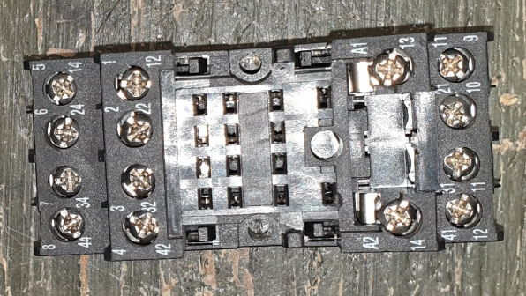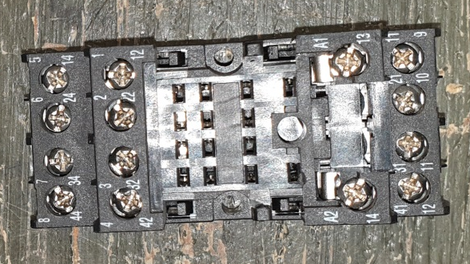

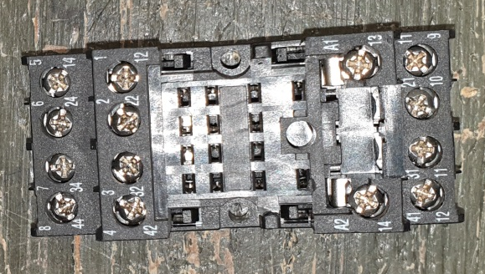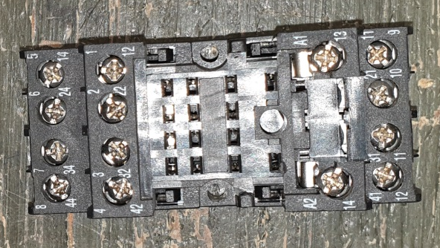

So, how do all the relays work?
Relay 1: The coil is energised when both doors are closed therefore the interlocks must be conducting to ground. They then provide an earth for the coil energising the relay. The bit I don’t understand at the moment is they both have to ‘closed’, open either door and the relay de-energises? This implies they are wired in series but it looks like parallel to me…………. Works though so another day maybe
Connection 6 must be a signal wire from the motherboard which is grounded when the relay is energised.
Connection 4 goes to the motherboard pin labelled SE presumably acting as a switched ground to enable the spindle via other relays.
Connection 12 comes from the spindle lock switch which is activated when you pull the collet release lever down. Relay 3 A2 is in the loop too
Relay 2: The coil is energised when the motherboard grounds this connection. This can be activated from G code or the front panel switch
Connection 5 and 9 and 6 and 10 switch the mains current on and off energising the pump or not.
Connection 11 is connected to the –ve side of the coolant warning LED. When the relay is energised this is then connected direct to ground through connection 7
Relay 3: The coil is energised when both the spindle release lever is disengaged AND the doors are closed.
Connection 6 is connected to the mains live
Connection 21 is the switched mains output when the relay is energised. This then goes off to relay 4 and becomes the signal for the spindle direction
Connection 7 is connected to the VFD +12 output.
Connection 11 is connected to the VFD enable line when the relay is energised
Connection 8 is connected to relay 4 connection 10. This acts as a switched earth for the relay 4 connection
Connection 4 is a permanent ground connection
Relay 4: The coil is energised by the motherboard pin labelled SD which I assume is spindle direction. Both NO and NC contacts are used here effectively
Connection 1 and 5 are the NO and NC outputs. Only one can be live at a time. Each is taken to a different input on the VFD direction contactor.
Connection 6 is connected to the negative terminal of the REV LED indicator
Connection 2 is connected to the negative terminal of the FWD LED indicator

Connections needed to reuse the above:-
Permanent: R1 Door interlocks, R2 coolant LED, R4 FWD & REV LEDs,
Switchable: Relay 2 connection A2 to turn on the coolant. Switch to ground
Relay 4 connection A2 Spindle Enable. Switch to ground

That’s it folks. All relays traced and explained. Now, on to the contactor

Part numbers CA2DK122, CA2DK22 and CA3DK22 referred to latching contactor relays in the old contactor relay range, which have now been replaced.
They consisted of two N/C contacts and two N/O contacts and two coils, A and E. A pulse on A energised the contactor and a second pulse on E de-energised the contactor.
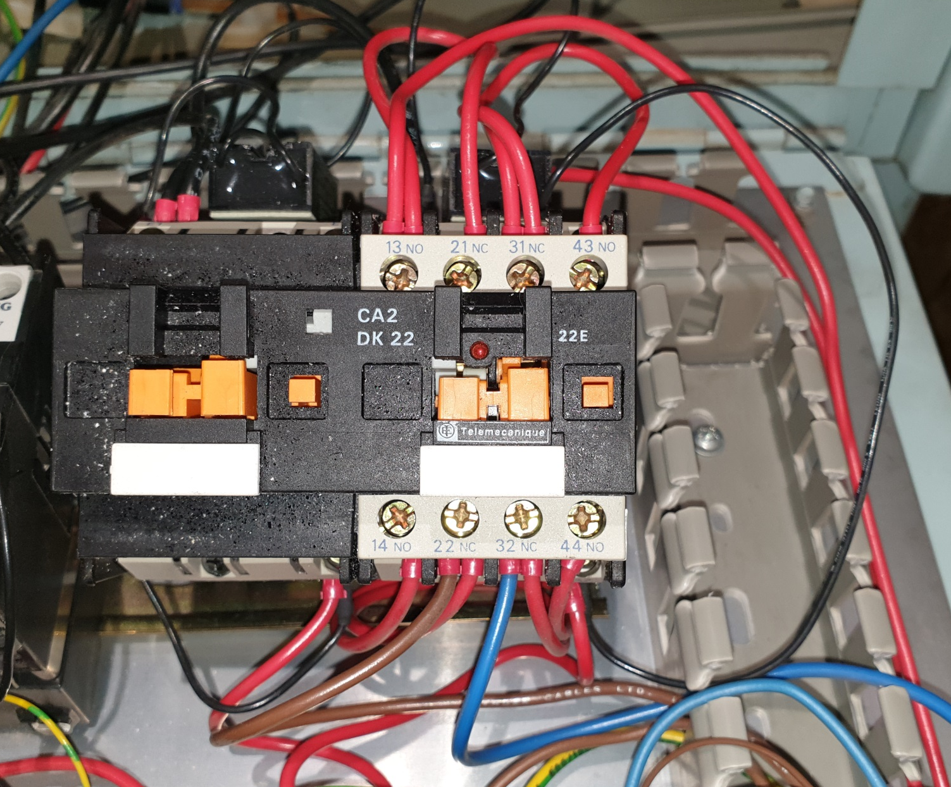
Black surge suppressor lead
Red inbound wires from the VFD
Red trigger/coil wires from the NO/NC relay contacts.
To the spindle. Current is reversed through these by the contactor
Blue
Brown

The VFD
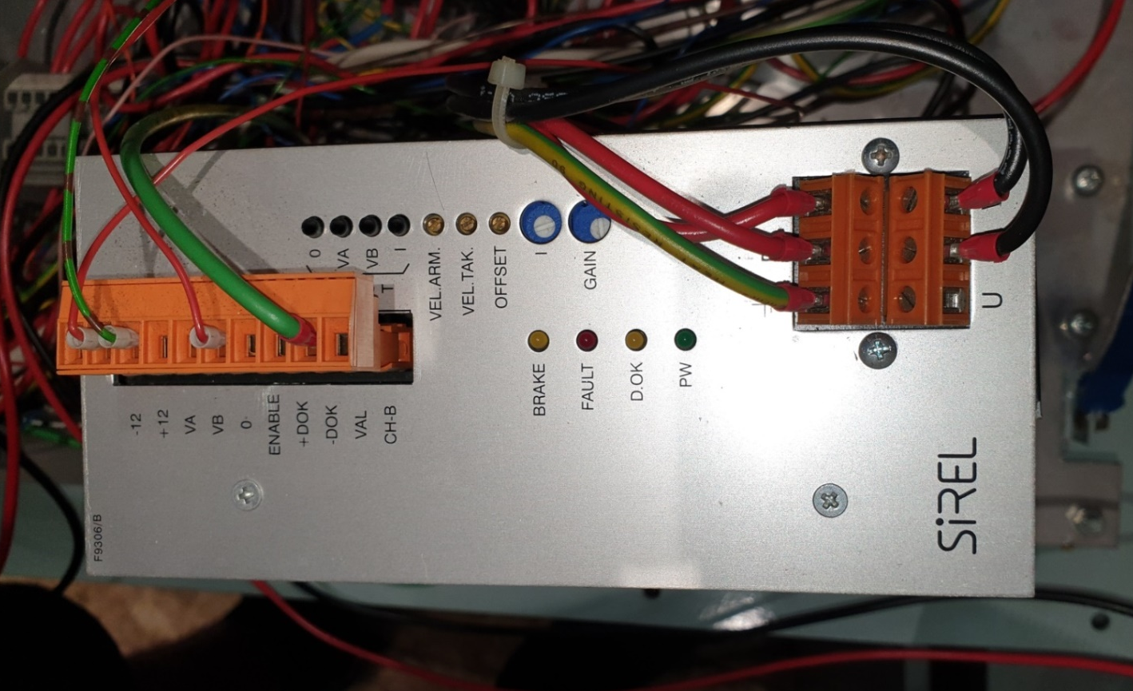
+12v out to relay
Goes to Val and is connected to ground
+12v return from relay to enable

Output to spindle at varying frequencies through the direction contactor
110v AC in from transformer. The 0v line goes through the emergency stop relay
Analogue speed input

Spindle connections

110v AC:- Brown, Blue and Ground
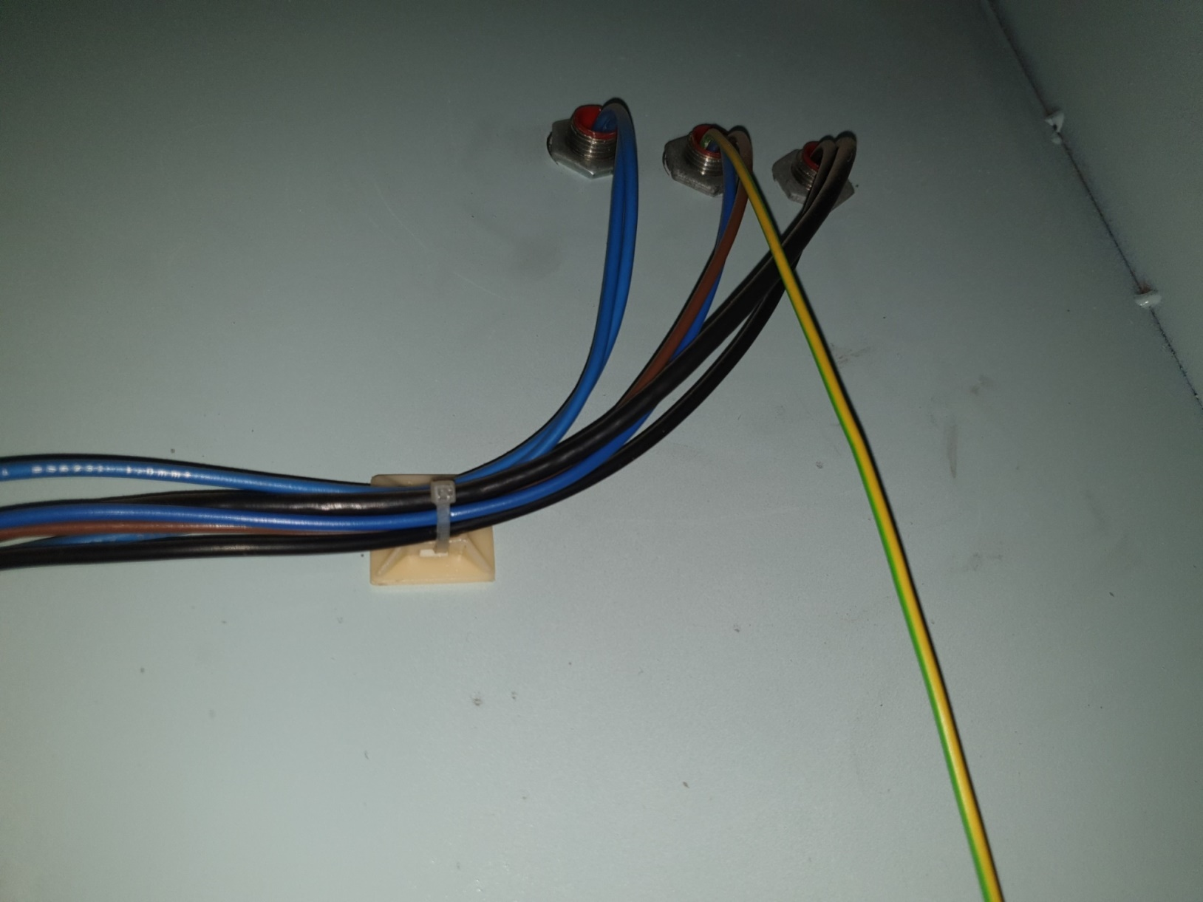
RPM counter and maybe z limit switches (1 or 2 or possibly combined?)
Contacts indicating use of the manual chuck release
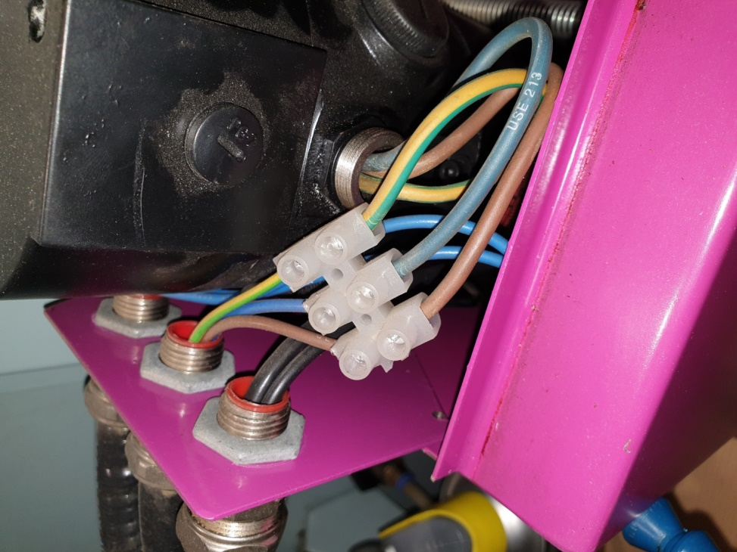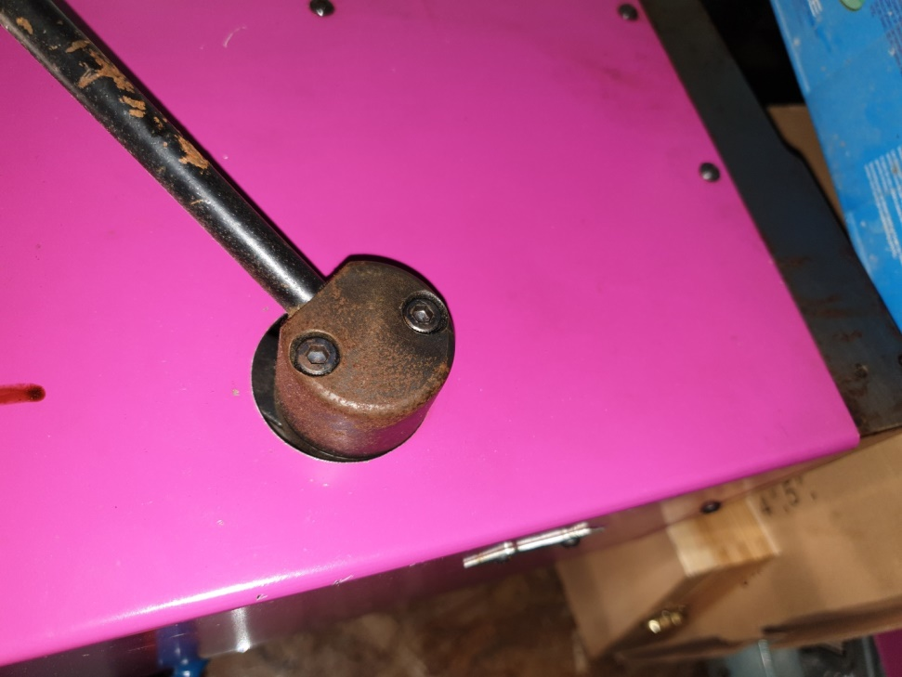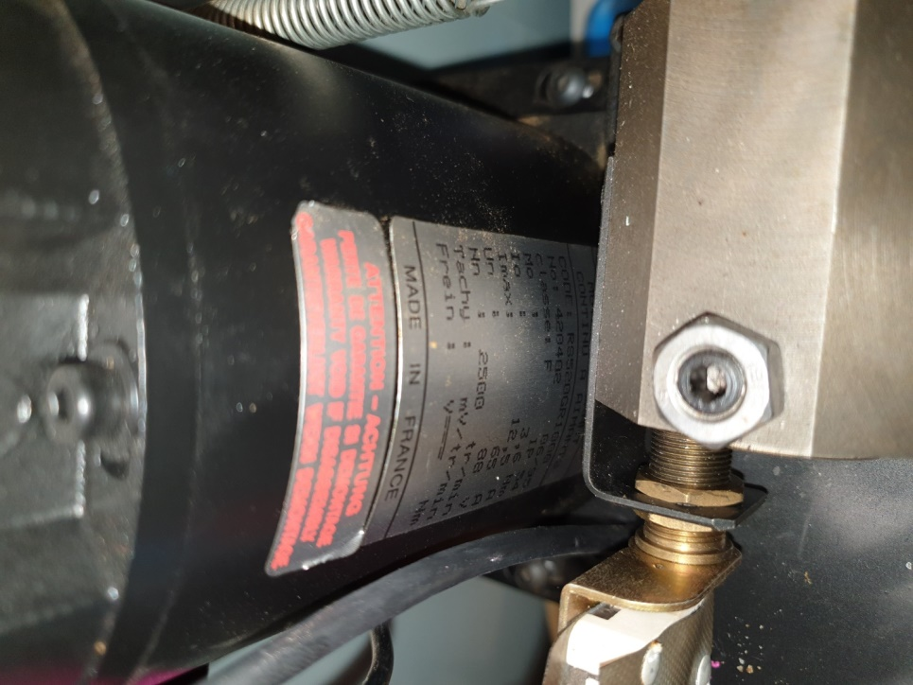
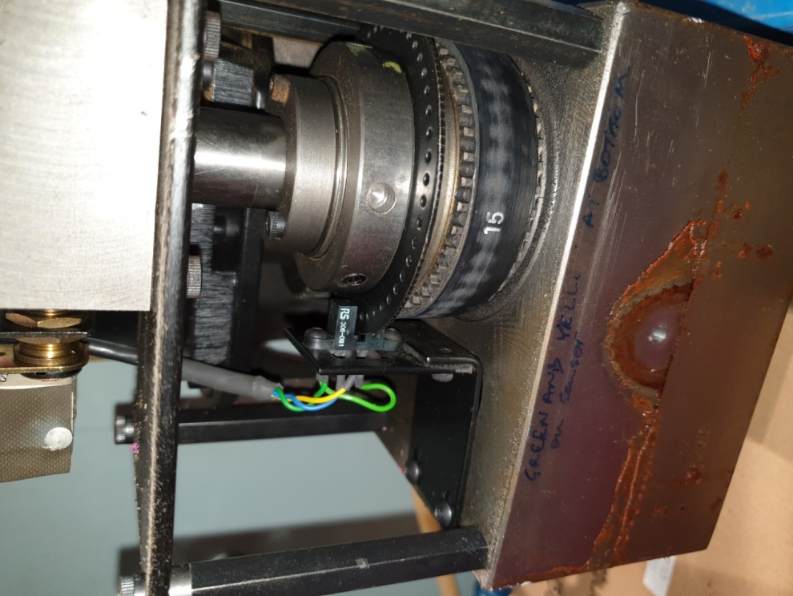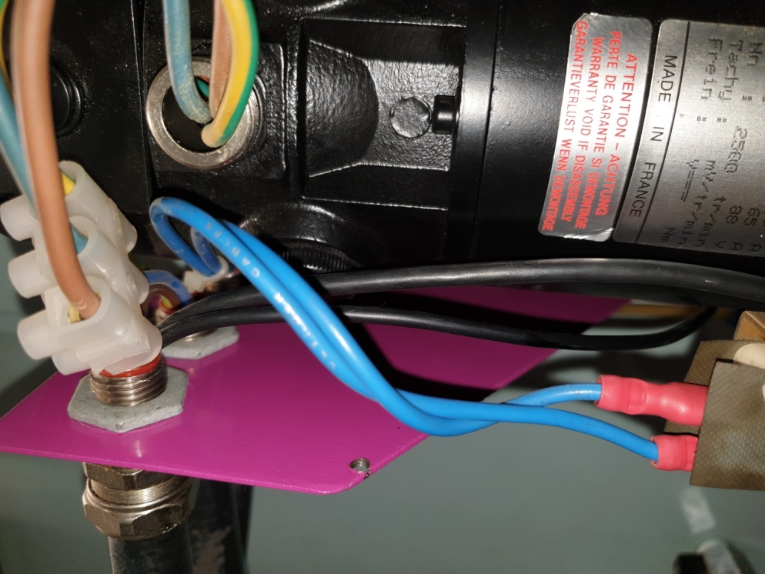
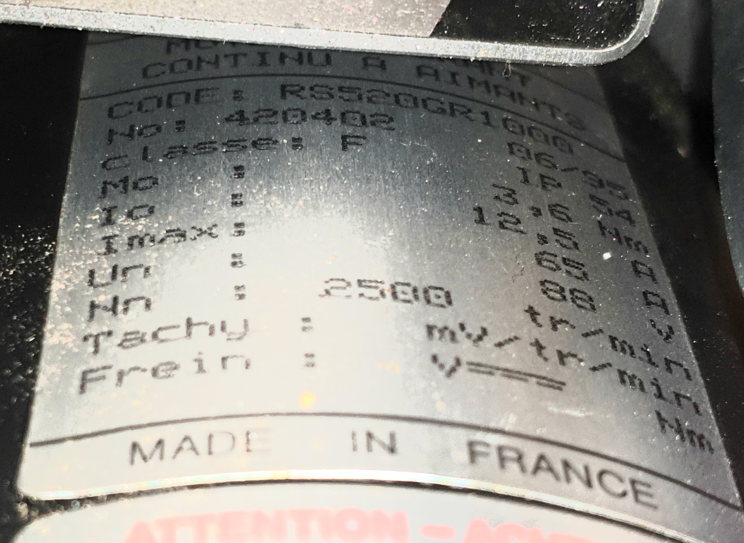

The 34 pin cable function and assignments
Pin 1 12v in to rotary encoder board and main board
Pin 2 = reset. Press button to drag it low. Pull up gives a nice +5 or 0v reading. LED is unaffected and cannot be turned off
Pin 3 12v in to rotary encoder board and main board
Pin 4 to pin 4on the CD4070BCN XOR chip. Goes high when position 1 is selected. Value ‘C’
Pin 5 12v in to rotary encoder board and main board
Pin 6 to pin 7 value ‘B’ on the cd40147be encoder IC
Pin 7 12v in to rotary encoder board and main board
Pin 8 to pin 14 value ‘D’ on the cd40147be encoder IC
Pin 9 Ground to rotary encoder board and main board
Pin 10 to pin 10on the CD4070BCN XOR chip. Value ‘A’
Pin 11 Ground to rotary encoder board and main board
Pin 12 goes to the Right jog button
Pin 13 Ground to rotary encoder board and main board
Pin 14 goes to left jog button
Pin 15 Ground to rotary encoder board and main board
Pin 16 goes to back jog button
Pin 17 Orange plug pin 2
Pin 18 goes to front jog button
Pin 19 PL2 9 then PL4 pin 10. Orange wire to enable relay which then earths it
Pin 20 second pin down left side of CD4518BCN Dual Synchronous Up/Decade Counter. Pin 2 is enable
Pin 21 Orange plug pin 3
Pin 22 Through PL1 to pin 6 on CD40106BCN which is a Schmitt trigger output
Pin 23 PL2 7 then goes to the Down jog button
Pin 24 goes to the output of a 2 input nand gate IC6 pin 11
Pin 25 PL2 6 then goes to the Up jog button
Pin 26 goes to the output of a 2 input nand gate IC5 pin 2
Pin 27 No connect
Pin 28 goes to IC6 pin 11 on CD40106BCN which is a Schmitt trigger output
Pin 29 PL2 pin 4 goes to PL4 pin 8. Orange and red band wire to ‘switch’ on top of the emergency stop relay
Pin 30 Goes to PL4 pin 12 through a signal diode. This is jumpered to pin 9 which makes it come on when the RUN switch is pressed. It goes off when released i.e. momentary
Pin 31 Orange plug pin 4
Pin 32 Ground to rotary encoder board and main board
Pin 33 Orange plug pin 1 which is connected to the pink wire to main board PL5 pin 5. This is connected to the coolant switch which provides an earth when pressed. No idea why though……
Pin 34 Ground to rotary encoder board and main board

Bold connections need some further looking into
Annotations in red go to the rotary encoder board only. No connect on main input panel
Green are explained reasonably well and go to both the main board and the rotary board at least for power

The feed rate override switch and its logic
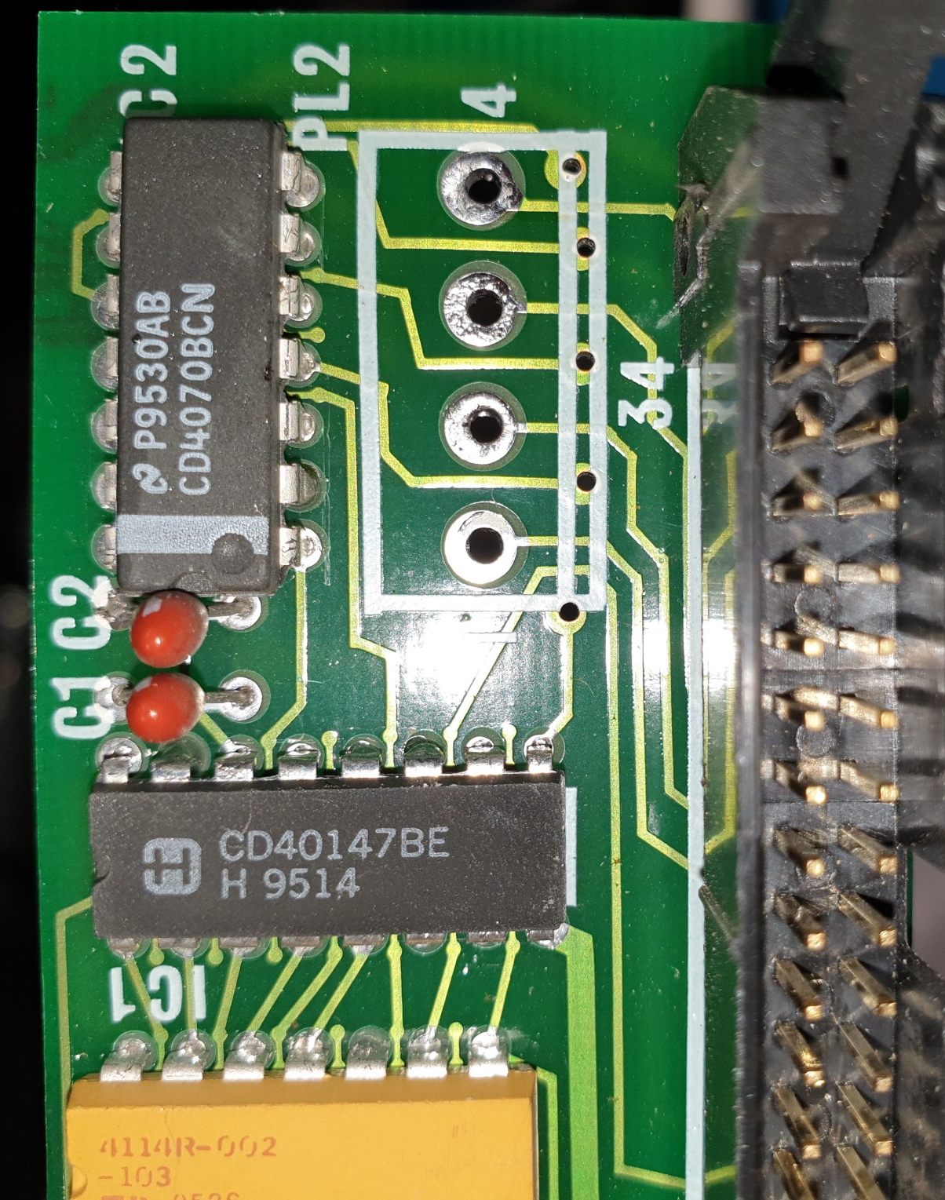
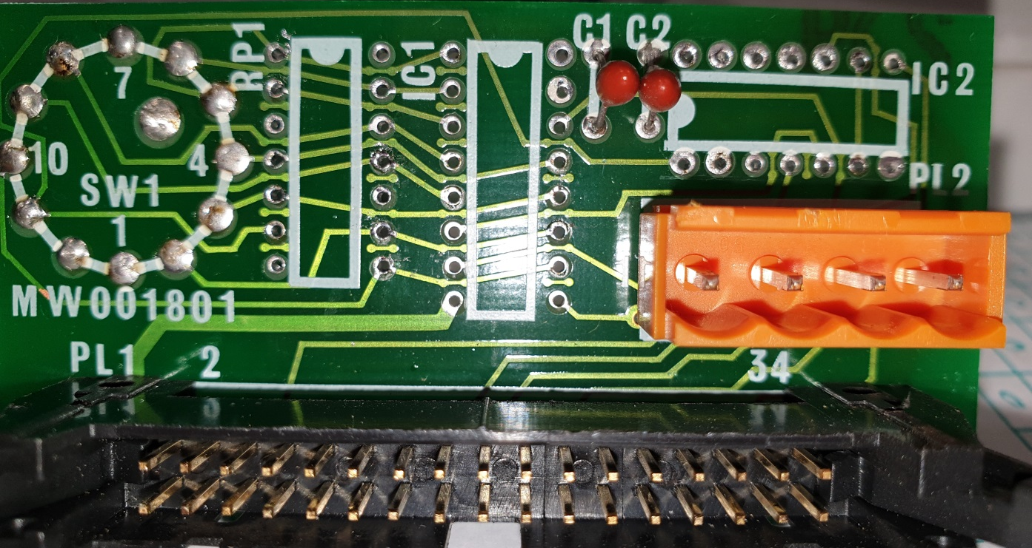The second photo is mirrored to match tracks
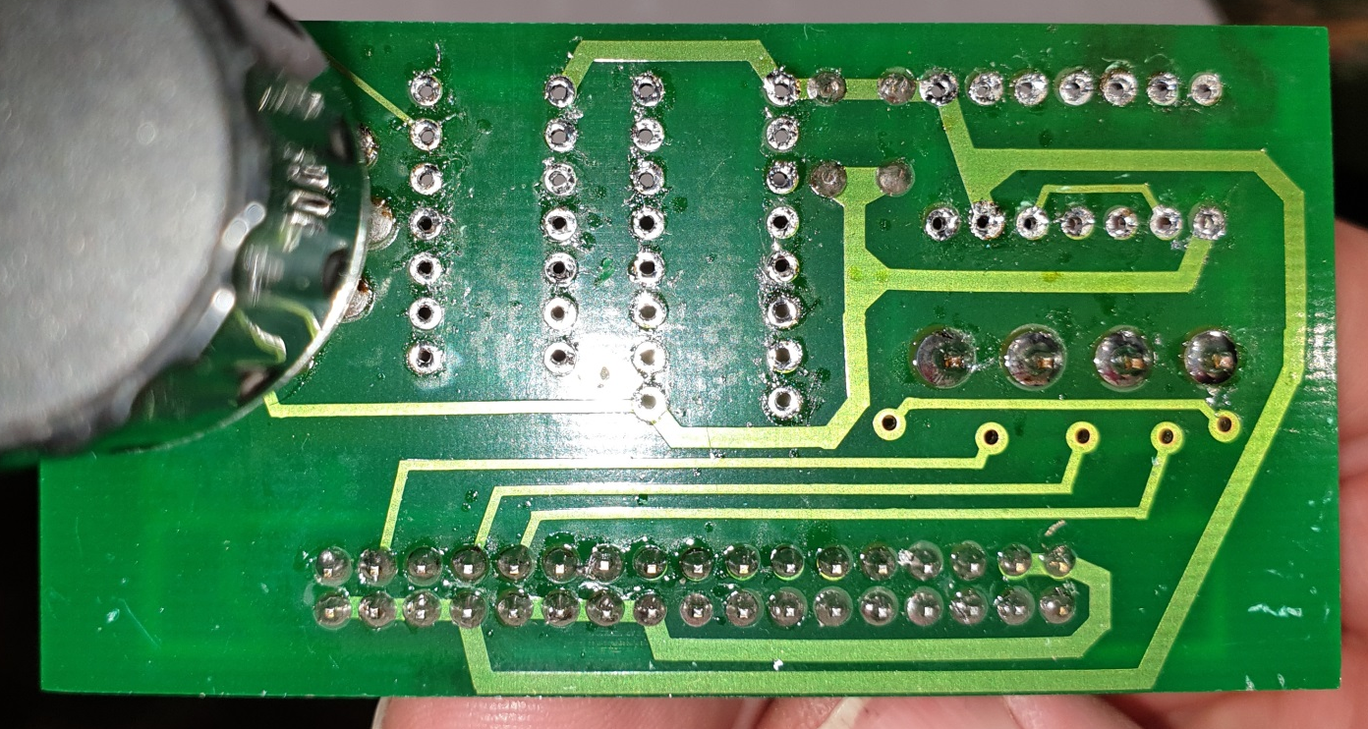

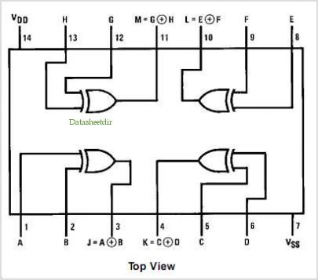 CD4070BCN

10 line to 4 line BCD priority encoder. Really 9 and 1 as 10 does not produce sequential BCD

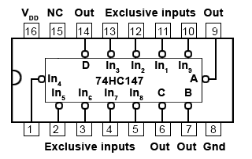
How does the feed rate override encoder work?
There are 11 positions in all ranging from encoder positions 1 to 11. Because the scale is in % this can be thought of as 0 to 100%. The system works by using the encoder positions 1 through 11 and encoding them into values 0 through 10. The encoder uses negative logic so 0 volts is a one etc. which reverses the truth table.

The truth table looks like this with a 1 representing a logic high and the LED if fitted would be on:
Rotary position | Actual BCD output inverted logic at ribbon cable |  |  |  | Decimal value | 15 – Decimal value i.e. % (then multiply by 10)
 | D | C | B | A
1 | 0 | 0 | 0 | 0 | 0 | 0 – odd case
2 | 1 | 1 | 1 | 0 | 14 | 1
3 | 1 | 1 | 0 | 1 | 13 | 2
4 | 1 | 1 | 0 | 0 | 12 | 3
5 | 1 | 0 | 1 | 1 | 11 | 4
6 | 1 | 0 | 1 | 0 | 10 | 5
7 | 1 | 0 | 0 | 1 | 9 | 6
8 | 1 | 0 | 0 | 0 | 8 | 7
9 | 0 | 1 | 1 | 1 | 7 | 8
10 | 0 | 1 | 1 | 0 | 6 | 9
11 | 0 | 1 | 0 | 1 | 5 | 10

The final column contains thoughts as to how this might be implemented to change the feed rate when running in manual mode.
Electronics wise it is straight forward for all values except rotary position 11. This is taken through the XOR gate system and mixed with existing values and 12v to achieve the last correct BCD output.
BCD output A goes through the XOR chip to ribbon cable pin 10
BCD output B goes direct to ribbon cable pin 6
BCD output C goes through the XOR chip to ribbon cable pin 4
BCD output D goes direct to ribbon cable pin 8

Note here the switches are pulled high and then low to indicate selected values. 0 is low all the time and a priority encoder is used to get the bcd values out. Priority means the highest selected value only is returned.

Standard BCD encoding
Decimal digit | BCD
Decimal digit | 8 | 4 | 2 | 1
0 | 0 | 0 | 0 | 0
1 | 0 | 0 | 0 | 1
2 | 0 | 0 | 1 | 0
3 | 0 | 0 | 1 | 1
4 | 0 | 1 | 0 | 0
5 | 0 | 1 | 0 | 1
6 | 0 | 1 | 1 | 0
7 | 0 | 1 | 1 | 1
8 | 1 | 0 | 0 | 0
9 | 1 | 0 | 0 | 1
10 | 1 | 0 | 1 | 0

Actual BCD output inverted logic and meaning at the cable – NOT 0
 | D | C | B | A
0 | 0 | 0 | 0 | 0
1 | 1 | 1 | 1 | 0
2 | 1 | 1 | 0 | 1
3 | 1 | 1 | 0 | 0
4 | 1 | 0 | 1 | 1
5 | 1 | 0 | 1 | 0
6 | 1 | 0 | 0 | 1
7 | 1 | 0 | 0 | 0
8 | 0 | 1 | 1 | 1
9 | 0 | 1 | 1 | 0
10 | 0 | 1 | 0 | 1

Actual output at ribbon cable translation to BCD
 | D | C | B | A
0 | 0 | 0 | 0 | 0
14 | 1 | 1 | 1 | 0
13 | 1 | 1 | 0 | 1
12 | 1 | 1 | 0 | 0
11 | 1 | 0 | 1 | 1
10 | 1 | 0 | 1 | 0
9 | 1 | 0 | 0 | 1
8 | 1 | 0 | 0 | 0
7 | 0 | 1 | 1 | 1
6 | 0 | 1 | 1 | 0
5 | 0 | 1 | 0 | 1

Binary to Gray Code Converter Table
Decimal Number | Binary Code | Gray Code
0 | 0000 | 0000
1 | 0001 | 0001
2 | 0010 | 0011
3 | 0011 | 0010
4 | 0100 | 0110
5 | 0101 | 0111
6 | 0110 | 0101
7 | 0111 | 0100
8 | 1000 | 1100
9 | 1001 | 1101
10 | 1010 | 1111
11 | 1011 | 1110
12 | 1100 | 1010
13 | 1101 | 1011
14 | 1110 | 1001
15 | 1111 | 1000

Thoughts: maybe I can take the current output and pop it directly into a Gray code encoder and then translate the outputs to percentages in Mach4.
Off to find a BCD to Gray code chip now

Using an XOR IC 7486 or similar:
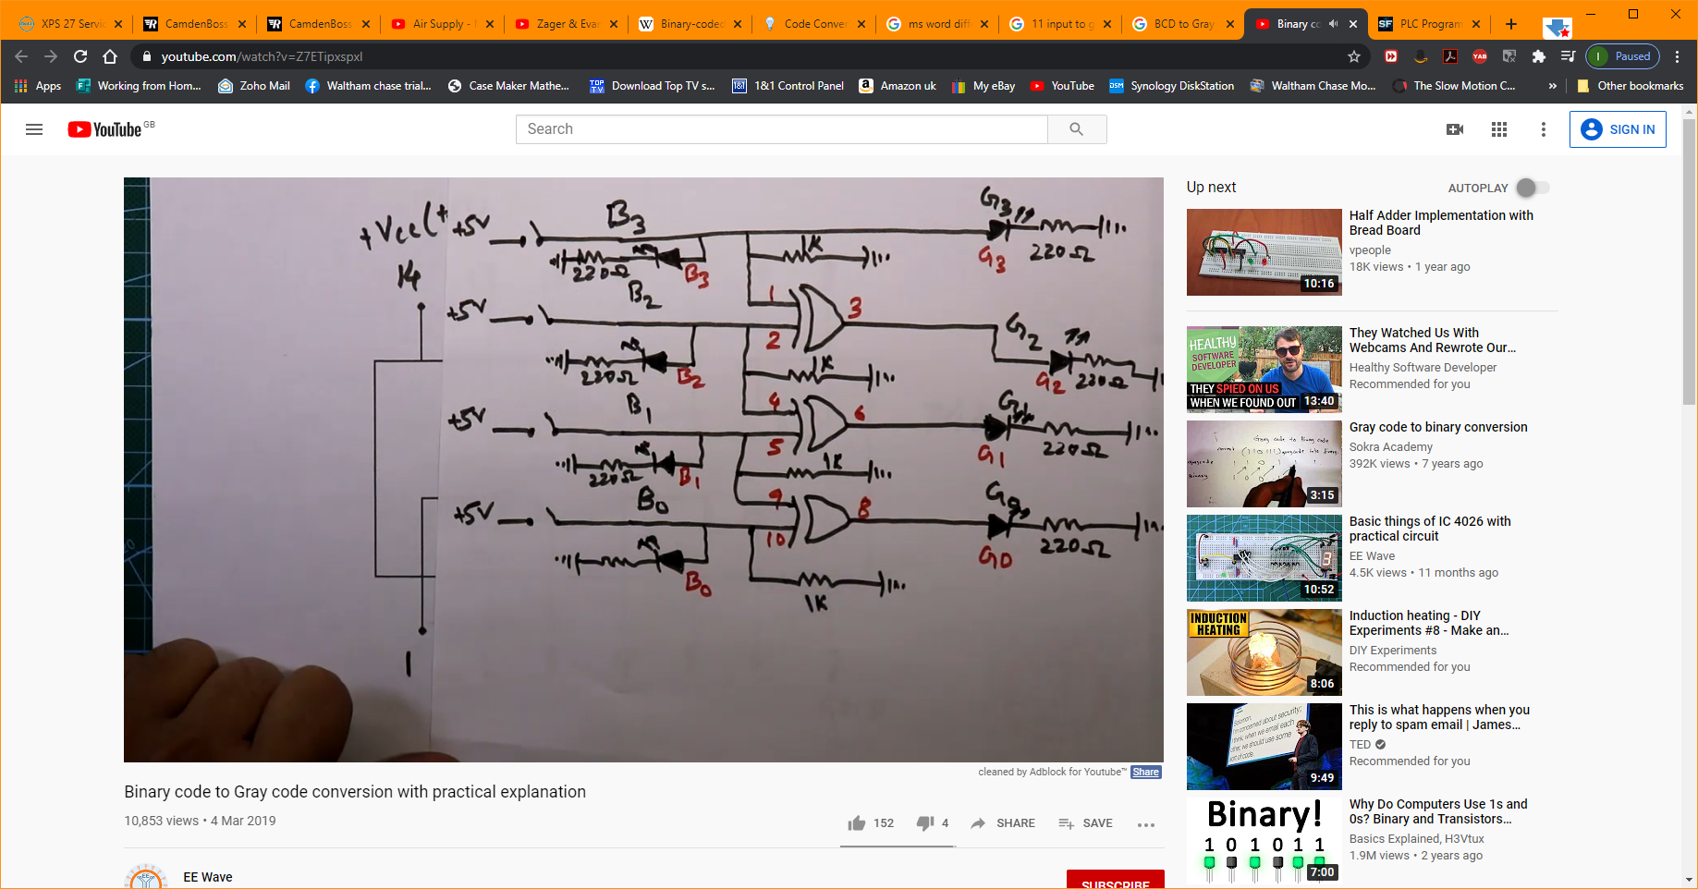
This is the one I have gone for and am currently in the process of building a PCB which takes the standard 9 in 4 bit BCD out and makes it 11 in 4 bit sequential BCD out. I then turn this into Gray code and trigger optos to make them open collector inputs for the breakout board. With Gray code only one bit changes for any switch movement clockwise or anti clockwise. This means Mach4 will hopefully have less fits as many inputs change as a t the moment

X, Y and Z limit switches
OK, working these out was a little trying however……..
They seem to have three wires Blue, Black and Brown. They are wired as follows:
Brown is the positive supply between 10 and 36v DC
Blue is the negative connected to ground
Black is switched to ground when there is a metal object detected.

And here’s the kicker. The Boxford has the metal present all the time the axis is in the correct range so my test LED was ON during most of the travel of the axis. It goes out when the axis nears its limit. So, for a controller point of view using pull up resistors on its inputs when they are low all is well but if it goes high then stop!!

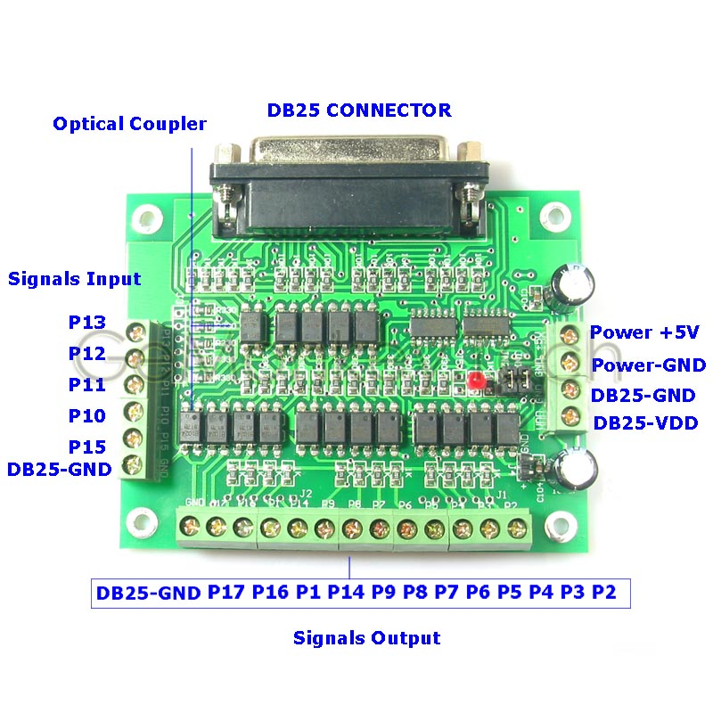

Plans moving towards fitting the Ethernet Smooth Stepper and breakout boards.

Available components:
AC Transformer with outputs of 12, 60, 220, and 240v 3 to 15A
AC Transformer with outputs of 115, 120, 130, 135, 220 and 240v 400va which is about 1.7A at mains voltage
36v DC switched mode power supply 9.7A
24v DC switched mode power supply 10A
5 and 12v DC switched mode power supply RS 183-0010 2.5A 5A
RFI filters times 2
16amp Fuse
Wirings splitters
VFD
Spindle
Optical encoder
Door sensors – 12v

What we still need:
IO Board(s) for manual control i.e. 13 inputs. I might even need two boards for all the front screen functions. Each button can be wired to its own input. The kicker is the feed rate override which will use 9 or 10 inputs I think.
Other functions are: Manual mode, lamps, reset, 4 x table movement, 2 x head movement, door, coolant, spindle forward, spindle reverse, spindle stop
Unused: tool change, work clamp, work unclamp, all automatic mode buttons (3)

Requirements:
230v input
115v AC for the VFD
36v DC power supply for the stepper motor drivers
12v DC for the various sensors e.g. limit stops. Also used for relay coils
5v DC for the ESS, breakout boards, front panel manual input logic and rotary encoder

Function thoughts:
Wire in the stepper enables so they shut off when the emergency stop is pressed
Reuse all the relays and contactors in their current form - Done

Plan of action:
Move all the electronics into the top compartment.

Testing
Door interlocks are a little ‘sticky’. You have to close the door smartly to get them to engage

I have now solved the runaway spindle issue. It’s caused by the implementation of the parallel port standard which calls for a 1.2k pull up resistor on the output ports. When the SmoothStepper does not have control of the breakout board i.e. Mach3 is not connected to it then the port goes high. This sends 5v to the speed control board and hence the issue is explained. I have resolved this by installing a bank of opto controlled relays which are active high. This means I can use the fact one of the ports on the BOB goes high to turn on the relay which in turn grounds the PWM line to the speed controller. 0v = no rotation – yippee.

X, Y & Z limit switches. These conduct to ground when in normal travel range but stop conducting when triggered. This means on an input the line goes high when a limit is reached.

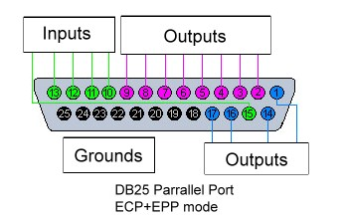

Front panel and manual control revisited:
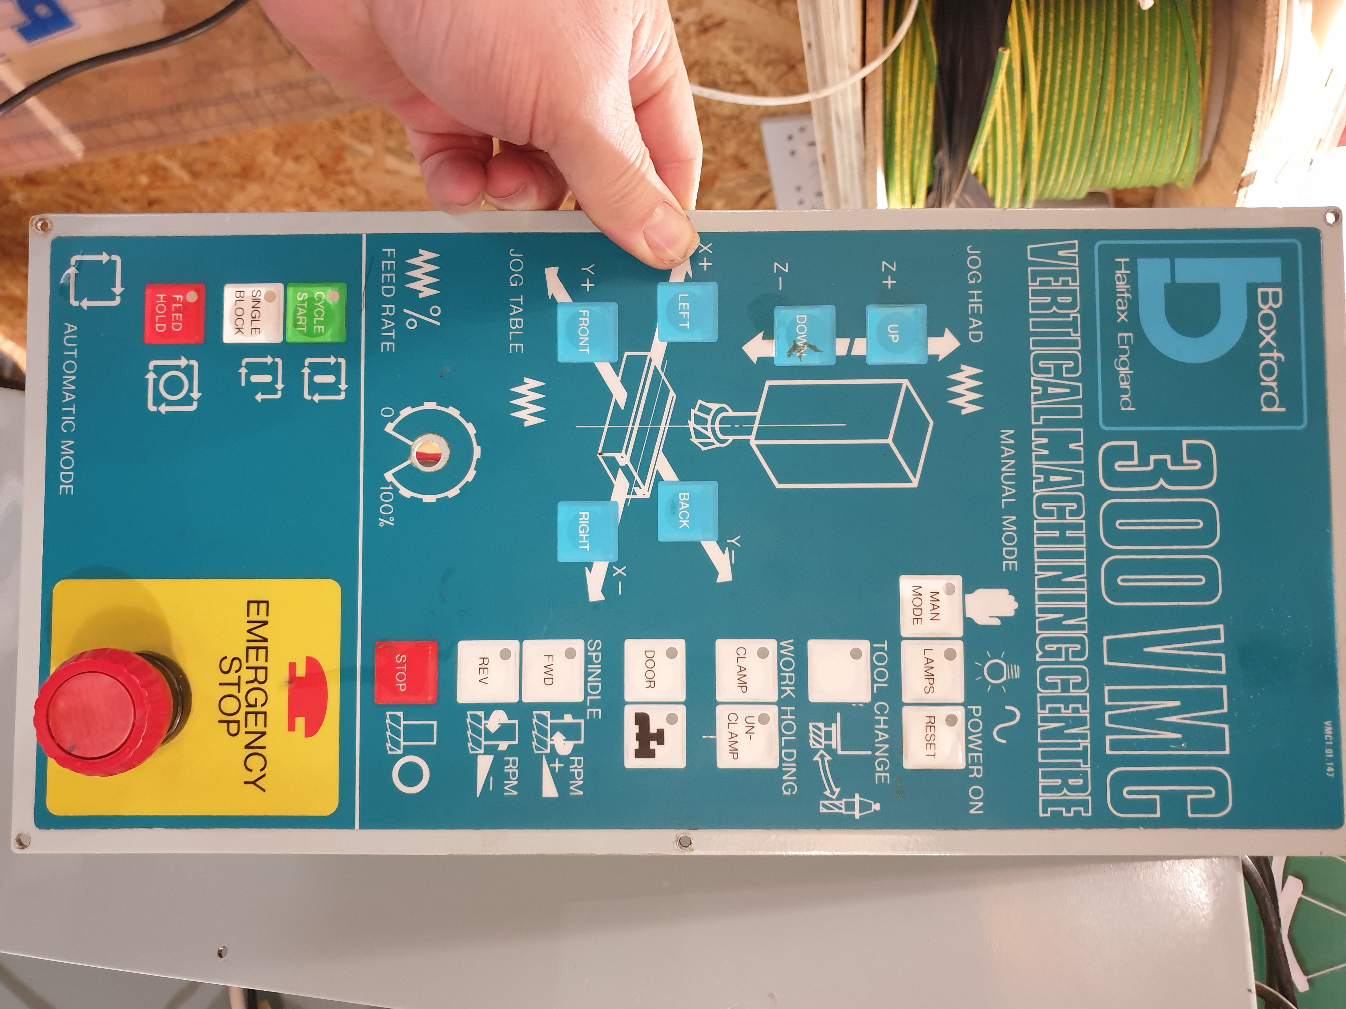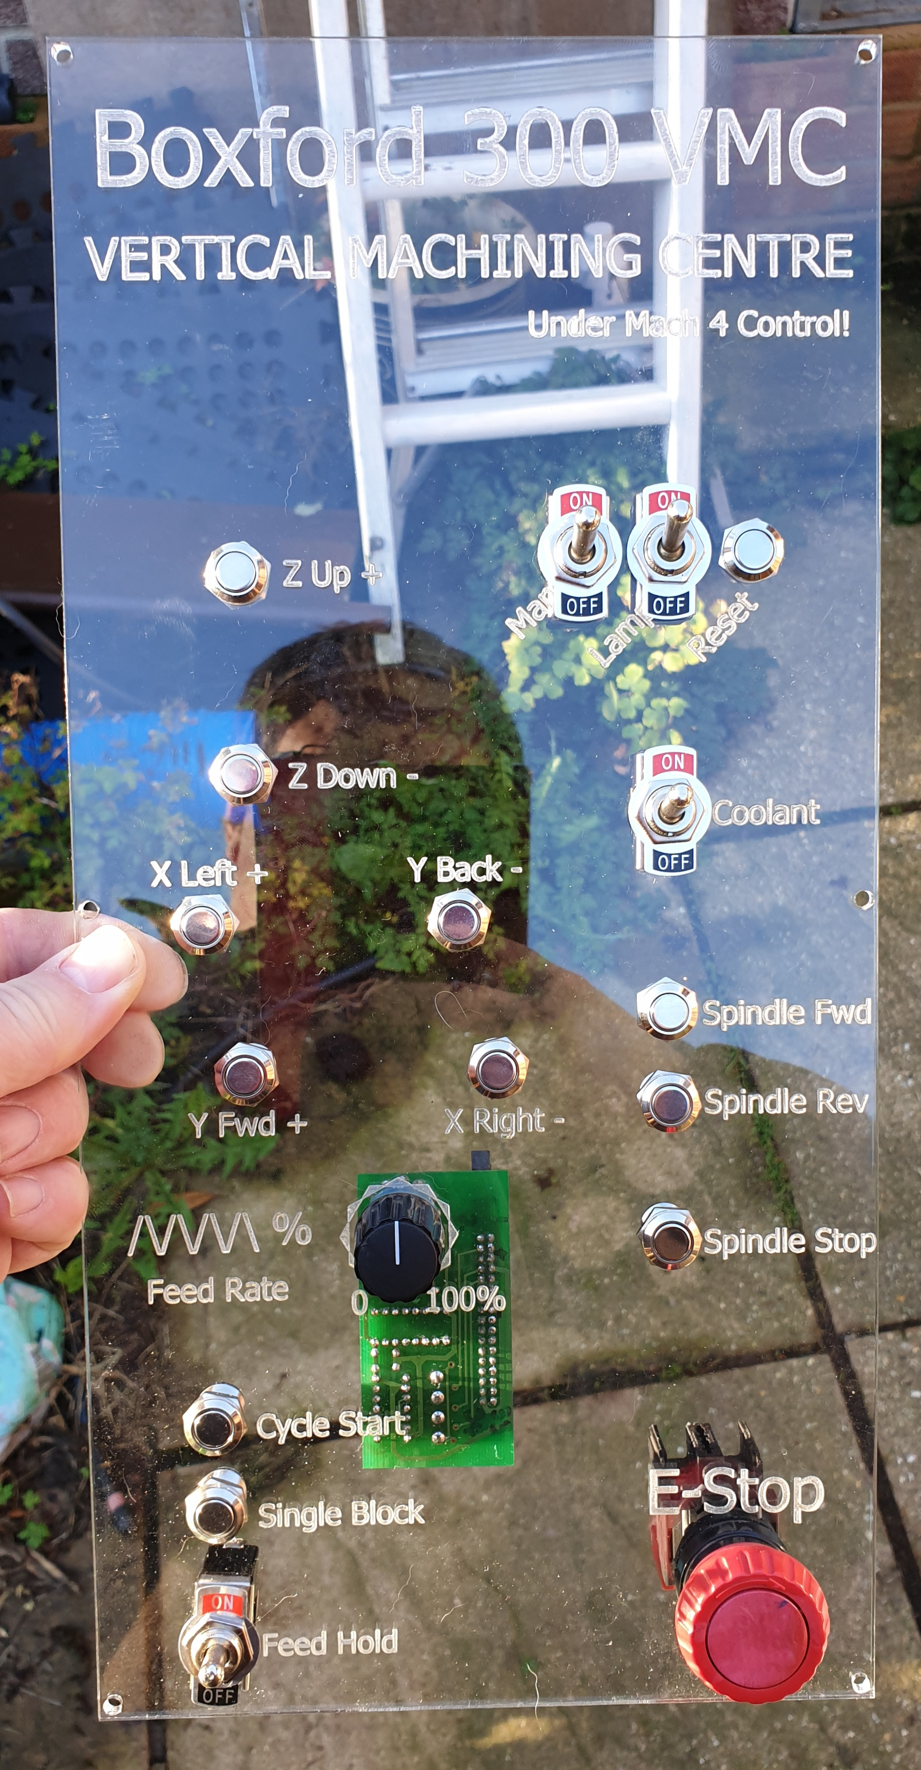
Functions to replicate on the new panel
- X, Y and Z movement – 6 momentary buttons
- Lamps on / off
- Coolant on / off
- Spindle forward + speed increase 1 momentary button
- Spindle reverse + speed increase 1 momentary button
- Spindle stop 1 momentary button
- Manual mode? 1 momentary button
- Reset? 1 momentary button
- Emergency stop switch location
Total of 9 or 10 or 11 momentary buttons plus two on / off buttons

Possibly add cycle start, single block and feed hold buttons if I can get them working – 3 more momentary buttons

All buttons are normally high. Press to send low and alter input state in Mach4. I think I should run these at 12v to allow the feed rate selector logic to work!
There may not be enough outputs to have all the LEDs I want so I may add an Arduino to control some of them?
Momentary switches are:
Switch function LED needed? IO board line needed?
Z+ No Input
Z- No Input
X+ No Input
X- No Input
Y+ No Input
Y- No Input
Reset No Input
Spindle forward Yes Input
Spindle reverse Yes Input
Spindle stop No Input

On/Off switches are:
Manual Mode Yes Input
Lamps Yes None
Coolant Yes Input
Feed Hold Yes Input
Single block/step Yes Input
Feed rate selector No Inputs x 4

Ground lines
2

Thoughts
Do I need two other buttons to actually single block/step each line and resume program control?
How to control the backlighting for the input panel? Should it be switchable? Use the cable to switch one of the available relays to send 12v to the LEDs

Summary
# of ground lines 2
# of +ve lines 2 at 12v
# of inputs to SmoothStepper 18
# of outputs for LEDs 7
# of lines for cable 30
Available on break out boards 22 inputs and 8 outputs

ESS Port 1 setup as Outputs 1-9, 14, 16 & 17. Inputs 10-13 & 15 Total 12 Outputs, 5 Inputs
ESS Port 2 setup as Outputs 1, 14, 16 & 17. Inputs 2-13 & 15 Total 4 Outputs, 13 Inputs
ESS Port 3 setup as Outputs 1, 14, 16 & 17. Inputs 2-13 & 15 Total 4 Outputs, 13 Inputs

The ESS port pin assignment
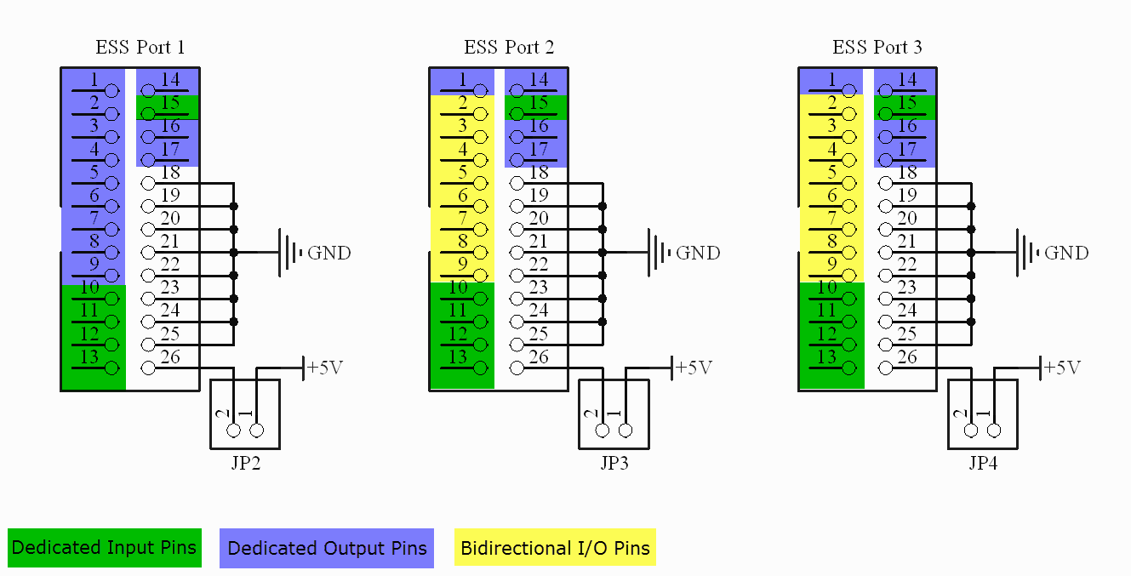

Proposed breakout board assignments
In/Out | Port and Pin | Active
O | 1 / 1
O | 1 / 2 | Low | X Step
O | 1 / 3 | High | X Dir
O | 1 / 4 | Low | Y Step
O | 1 / 5 | High | Y Dir
O | 1 / 6 | Low | Z Step
O | 1 / 7 | High | Z Dir
O | 1 / 8 | High | Spindle Direction
O | 1 / 9 | High | Spindle Low
I | 1 / 10 | High | X++ Limit was 2/2
I | 1 / 11 | High | X-- Limit was 2/3
I | 1 / 12 | High | Y++ Limit was 1/11
I | 1 / 13 | High | Y-- Limit was 1/12
O | 1 / 14
I | 1 / 15 | High | Z++ Limit was 1/13
O | 1 / 16
O | 1 / 17
O | 2 / 1
I | 2 / 2
I | 2 / 3
I | 2 / 4
I | 2 / 5
I | 2 / 6
I | 2 / 7
I | 2 / 8
I | 2 / 9
I | 2 / 10
I | 2 / 11
I | 2 / 12
I | 2 / 13
O | 2 / 14
I | 2 / 15 | Low | E-Stop was 1/10
O | 2 / 16
O | 2 / 17
O | 3 / 1
I | 3 / 2
I | 3 / 3
I | 3 / 4
I | 3 / 5
I | 3 / 6
I | 3 / 7
I | 3 / 8
I | 3 / 9
I | 3 / 10
I | 3 / 11
I | 3 / 12
I | 3 / 13
O | 3 / 14
I | 3 / 15
O | 3 / 16
O | 3 / 17

These tables have been filled, just not in the document at the mooment

Adventures in LUA scripting
Mapping input signals to output signals to make something happen…..
Hardware: ESS, eBay BOB, home made mostly input BOB, 5v on the ESS side and 12v on the Boxford side of things
Note, during testing the LED’s on the eBay version became very hot. To lessen this I replaced the 100 ohm resistors on the inputs with 470 ohm ones. I may do the same on the outputs though these are not nearly as hot, less volts I guess.
OK, the steps:
- Configure your inputs in the ESS Pins Configuration screen. Mine are port 2 pins 2 to 5
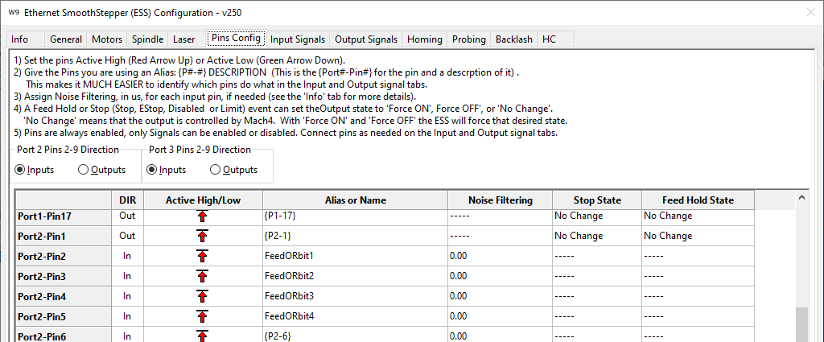
- Map the input signals and don’t forget to enable them like I did.
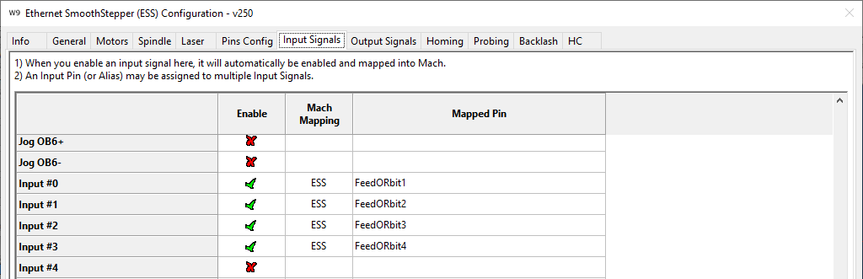
- Map some outputs if that is what you want to happen. I was just using the LEDs as indicators of success
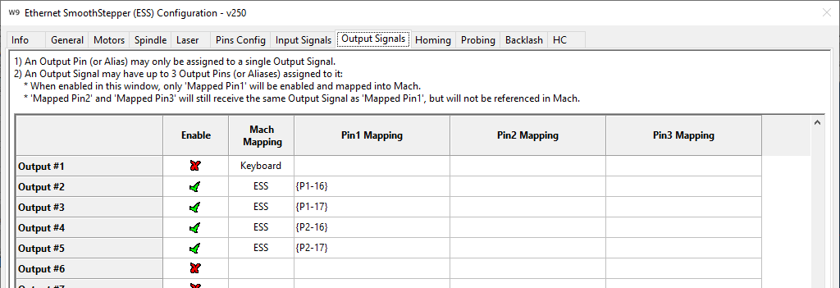
- Go to Configure/Control and add your inputs here too
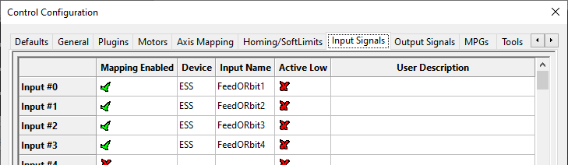
- Do the same for the outputs. I have not named mine meaningfully as this is not going to be the intended target for these particular ones.
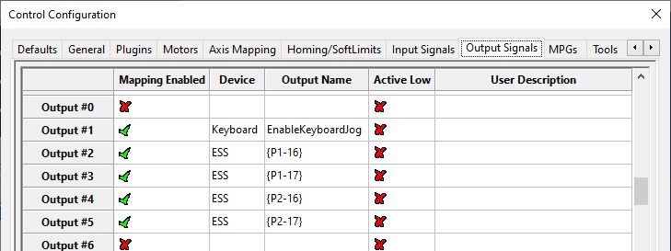
- After this setup is complete go to Operator/Edit Screen for your choice of screen, select the root node ‘wx4VMC300’ in my case, click events and edit the Screen Load Script
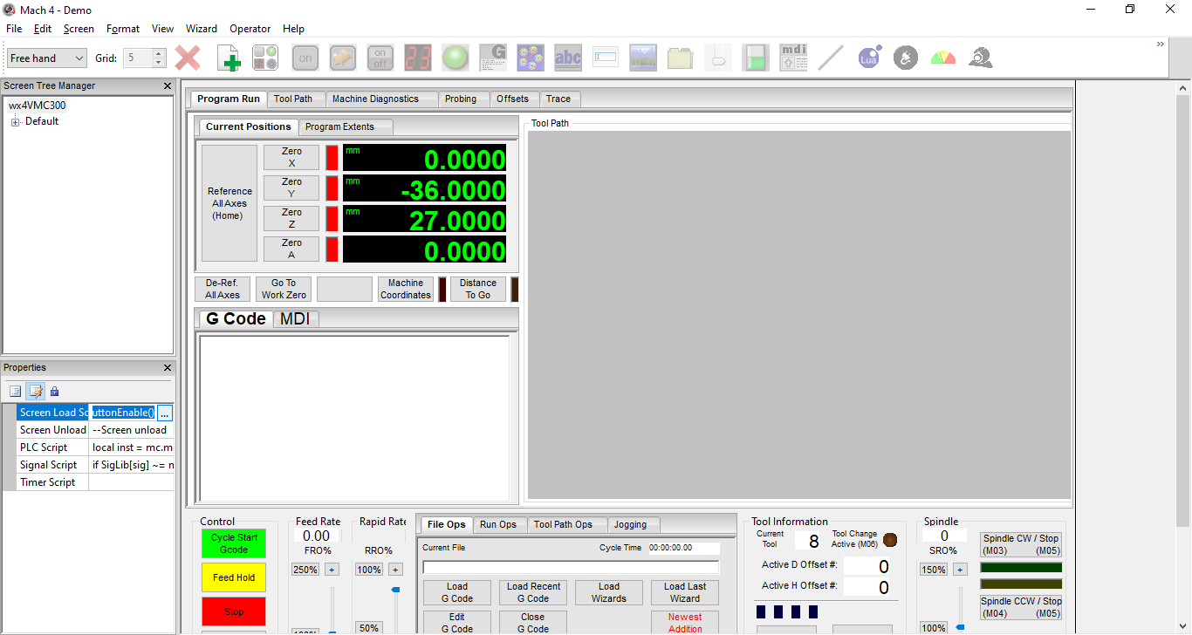

- This is the code I added to the SigLib section very close to the top
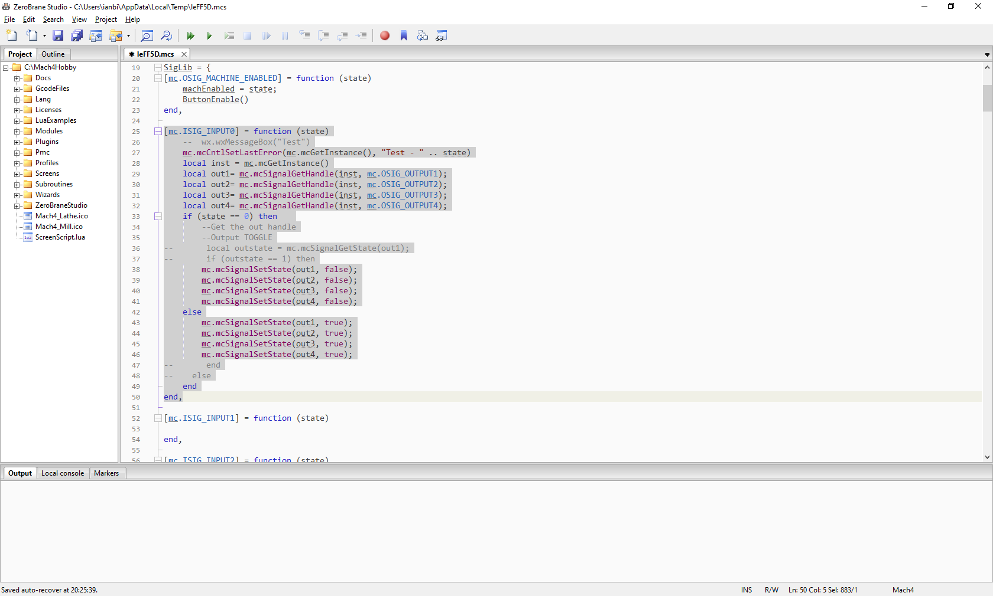
- That’s all folks but work continues…………….

