My Boxford PC250 lathe story

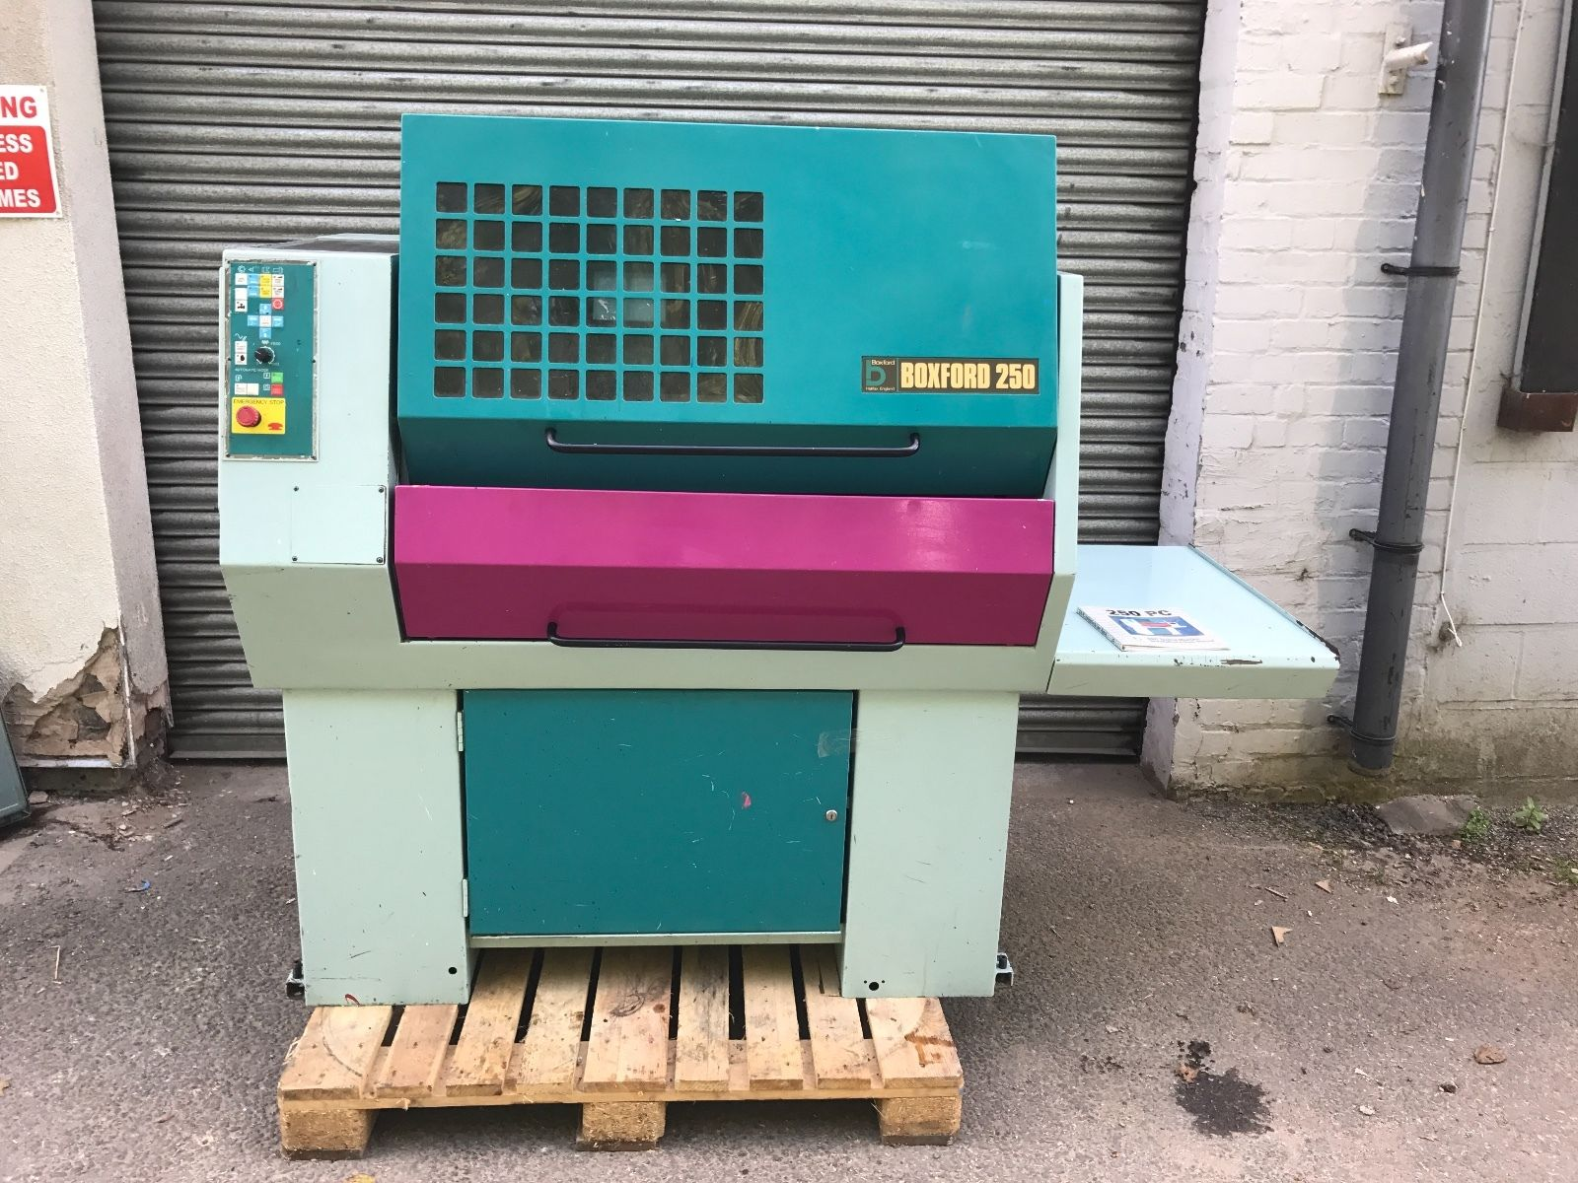

Table of Contents
Regretful note: 3
Top electrical area of PC250 4
Sensor Wiring 6
PC250 Safety Circuits 8
Spindle Enable 10
Spindle Direction 11
PC250 Coolant pump 15
PC250 VFD Connections 16
PC250 optical speed pickup 17
How is the Emergency Stop contactor wired? 18
E-stop: The new world 20
Limit switches 21
The other relays 27
Manual Inputs 28
The PLAN moving forward 28
Possible input board SPECS – probably abandoned now 29

Regretful note:
Unfortunately I did not start recording my exploits into the guts of this machine until after I had a burst of enthusiasm and ripped out a load of bits of pieces. On the up side nothing I removed was particularly vital to the record but it still unbalances my karma a bit.

Because I have redone the VMC300 since I started on this project and then put it on the proverbial shelf this cabinet seems a little bare and hopefully simpler. Time will tell but the experience I have gained will no doubt be a massive shot in the arm.

Top electrical area of PC250
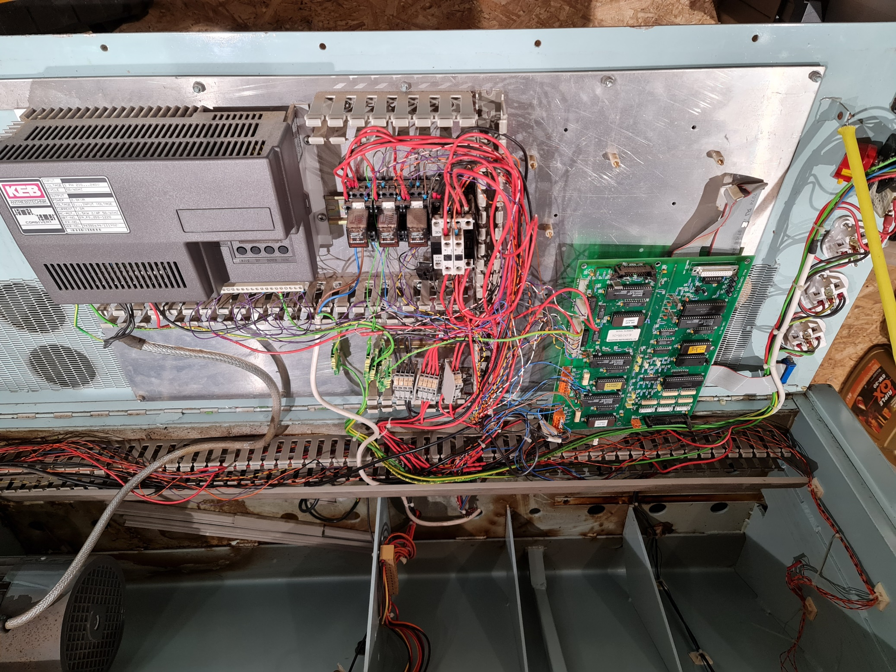
Secondary board - removed
Main contactor
Spindle direction relay
Spindle enable relay
Coolant relay
VFD
Connector block
Main board

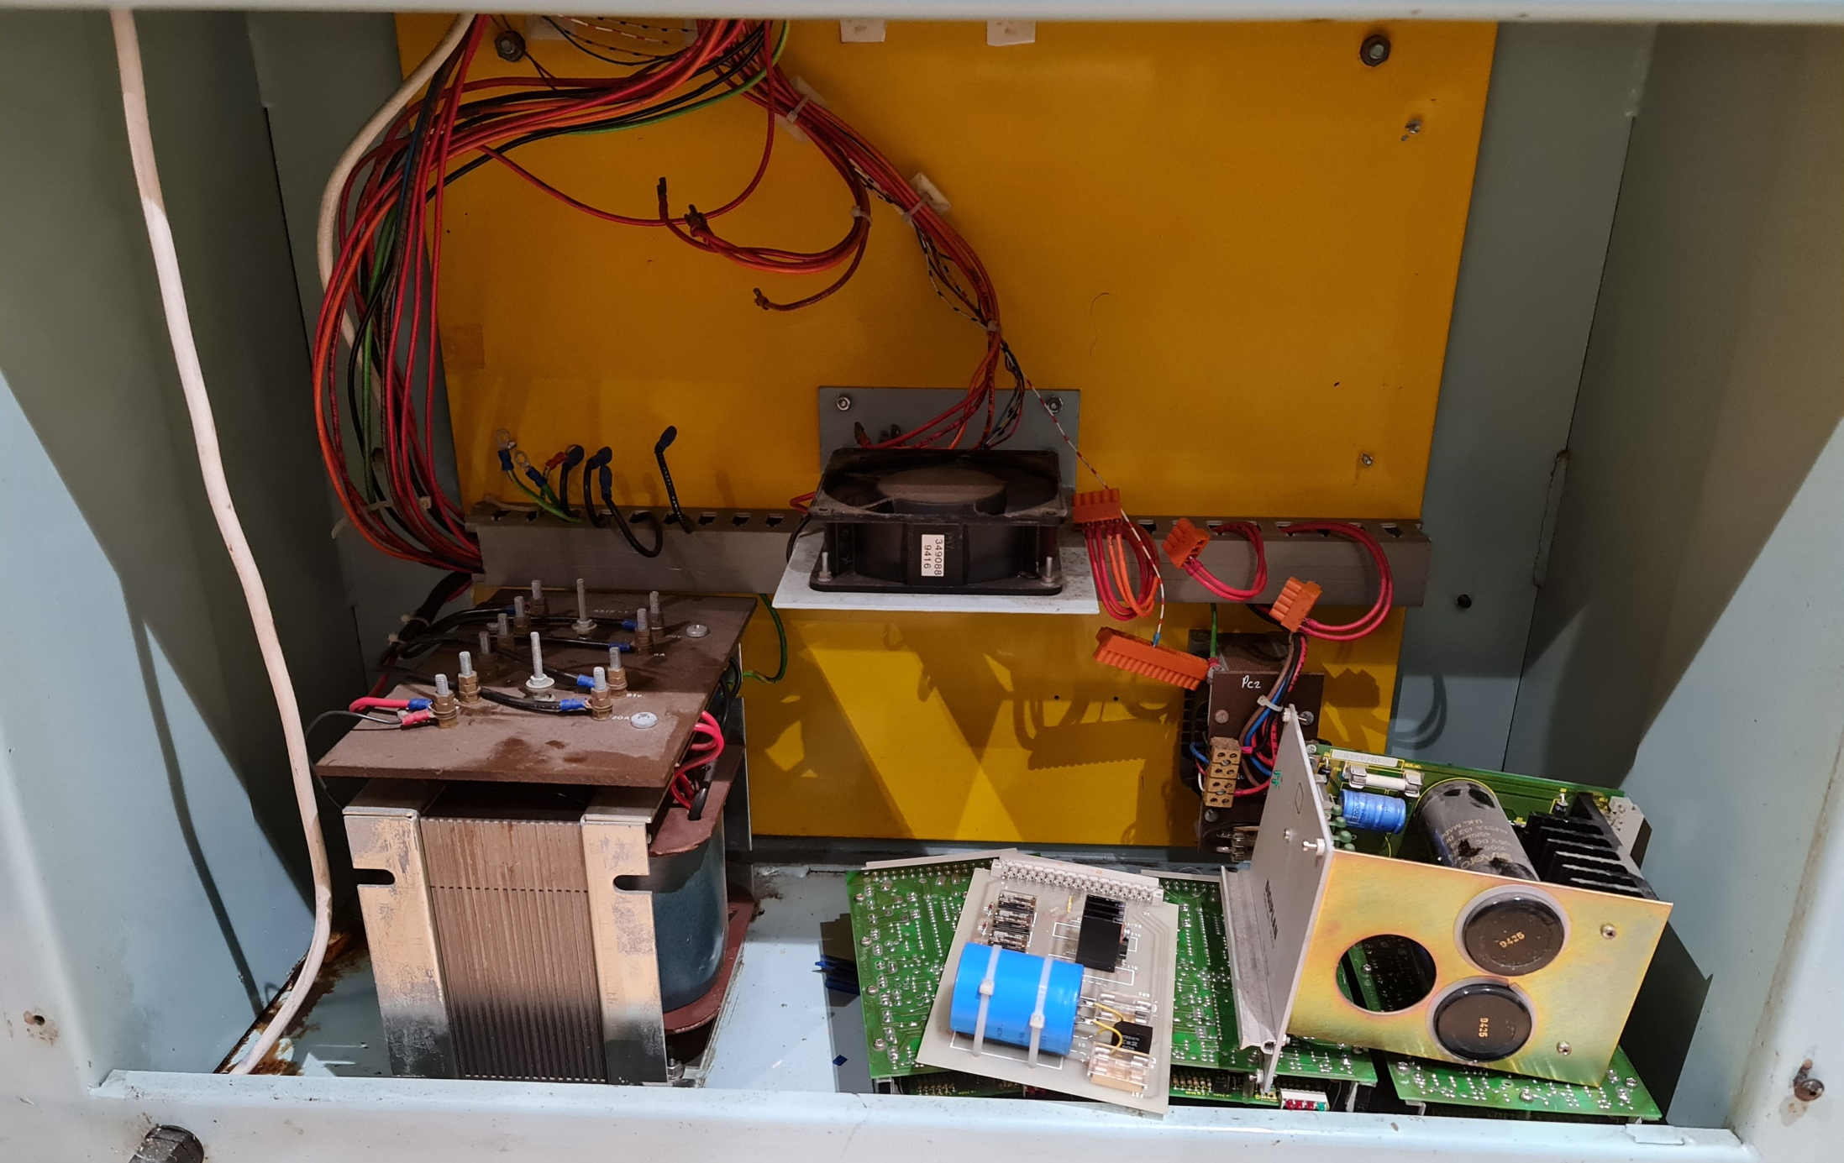
Remains of the original stepper drivers and low voltage power supply
Transformers

Sensor Wiring

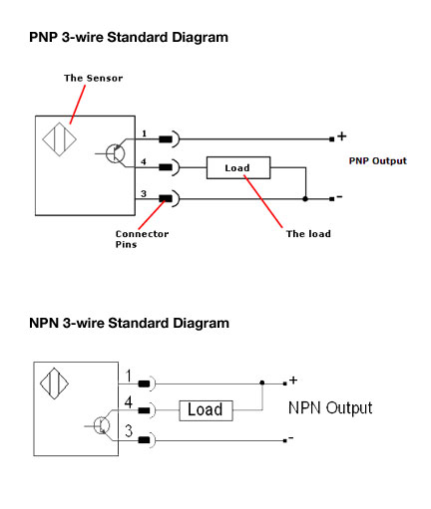

 NPN Proximity Sensor

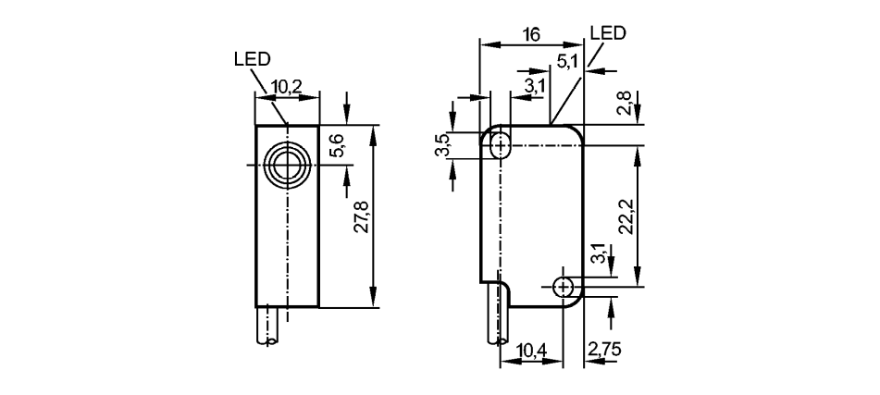

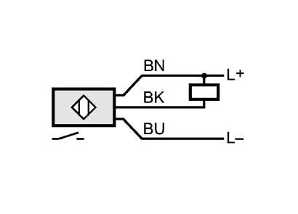

Wiring
Core colours
BN brown
BU blue
BK black

PC250 Safety Circuits
The three main relays

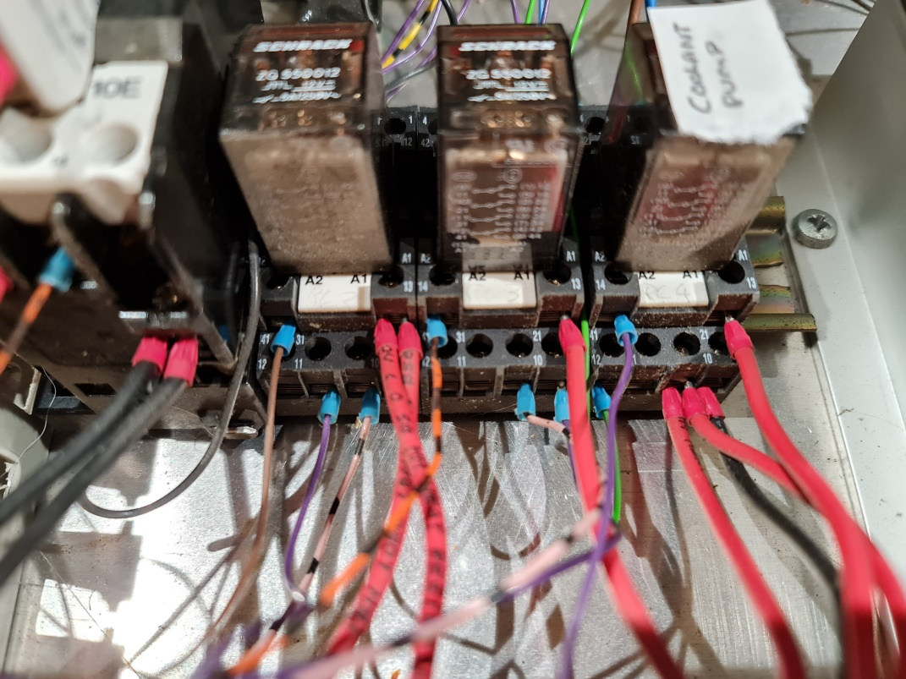
3 of 12v coil relays
Left: Spindle Direction Middle: Spindle Enable Right: Coolant

Safety Circuits: The spindle side door has a switch on it and is activated by a plate welded onto the door.
Wiring from inside the cabinet and the switch and a hint of the wiring (contacts for both open and closed)
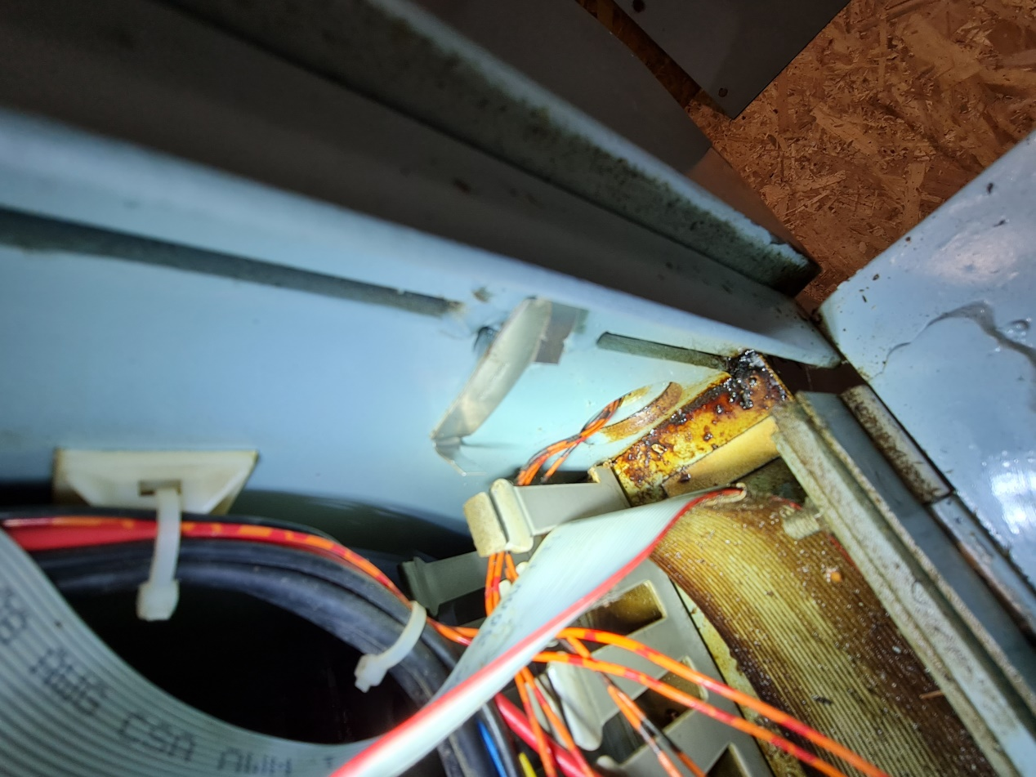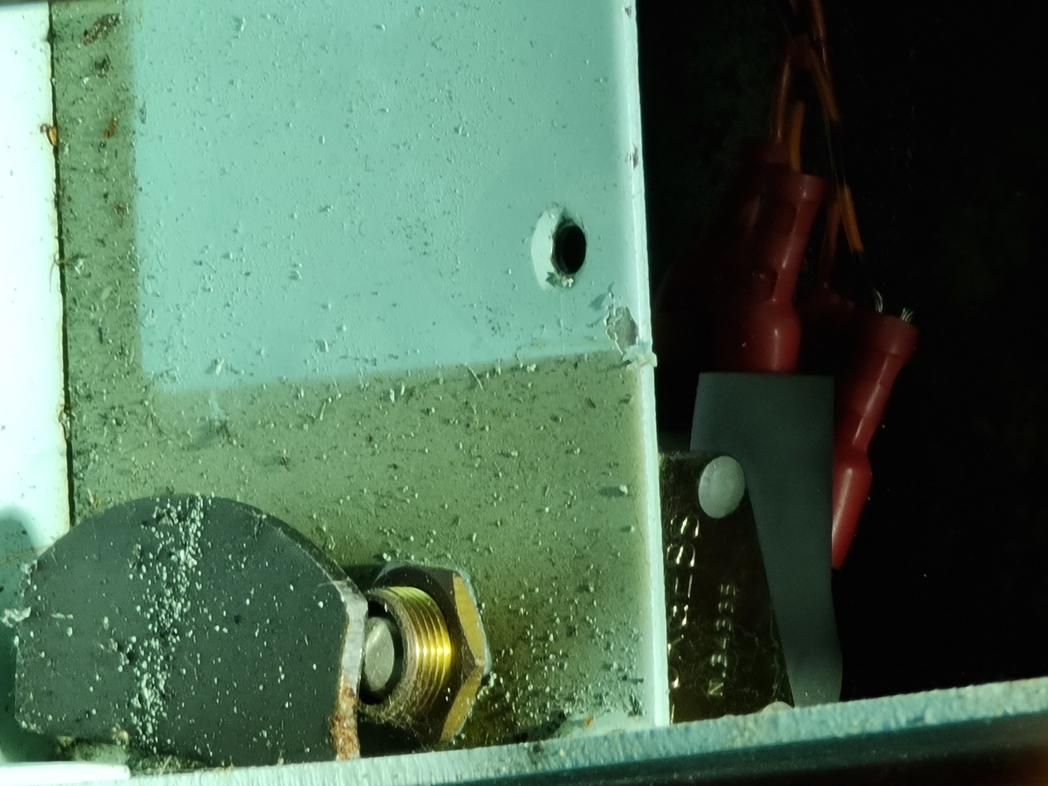

Spindle Enable
When operating this circuit is a series circuit through the relay coil, two switches and the contactor. The Orange wires with black bands are closed circuit when the door etc. is in the operating position. They start at the middle relay coil with 12v being input on the right through the red wire. It goes through the coil and off to the door switch by the chuck. It returns from this and goes through the main main contactor and then off to the lid switch and finally returns to the motherboard with the pin marked SE (Spindle Enable probably). If voltage is present it is grounded by the main board, the relay flips and the spindle works. The main contactor is operated by the emergency stop hence breaking the circuit and diabling the spindle.
Ground wire
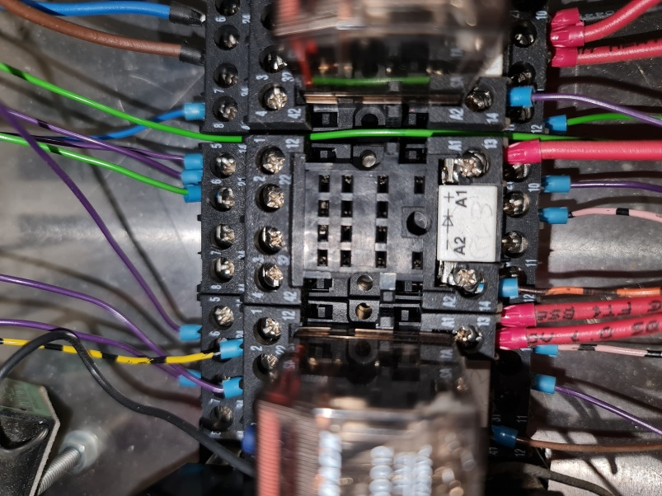
12v in
2 purple wires, one goes to pin 23 on the VFD
The other goes to pin 11 on the direction relay
Pink/Black in from the spindle direction relay pin 10
Purple goes to pin 19 on the VFD
Black/Orange out on its travels round the safety switches etc.
This is where it starts, red 12v in, Black/Orange out

Exit from the contactor

Spindle Direction
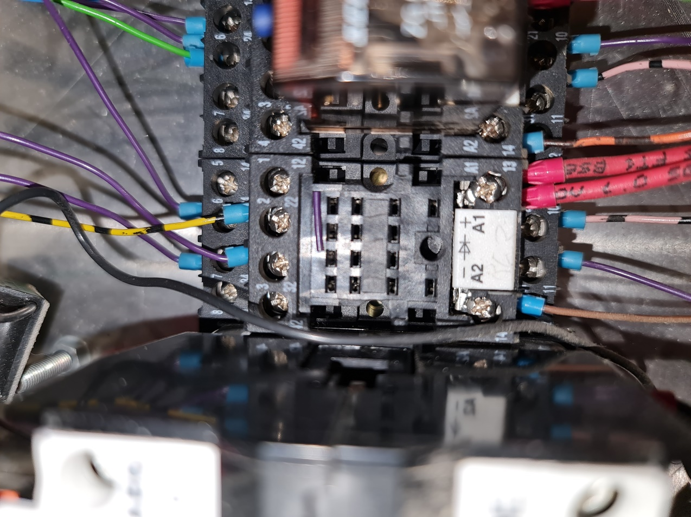
Brown goes to the MB and controls spindle direction
Purple goes to pin 5 N/O on the spindle direction relay

Pink/Black in from the spindle enable relay pin 10

12v in
Yellow/Black goes to the spindle active (fwd) LED as well as the MB. Provides an earth through the enable relay
Purple does the same except for reverse
Purple goes to pin 11 on the VFD, N/C on the spindle direction relay

Purple goes to pin 10 on the VFD, N/O on the spindle direction relay

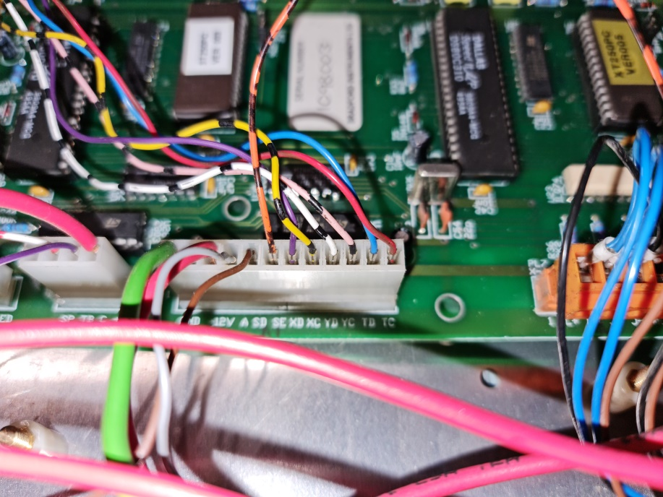
Orange/Black - spindle enable
Brown - spindle direction relay ground
Grey – Analogue out to pin 17 of the VFD.
Red and Green are +12 and ground

The Orange wires with red bands are open circuit it in the same run position. They switch over when the lid or door is open.
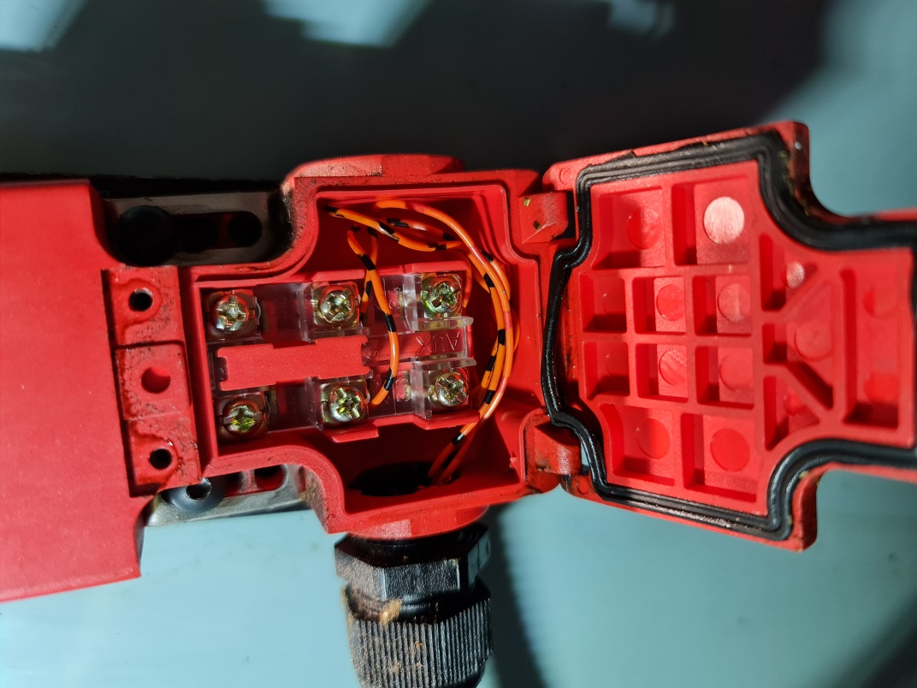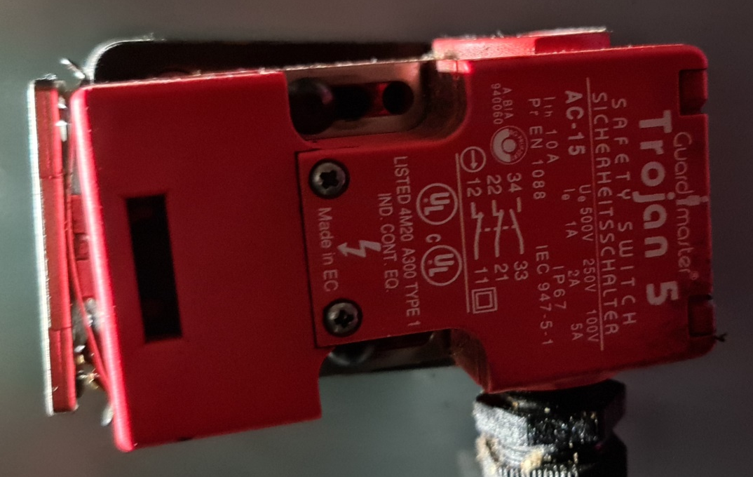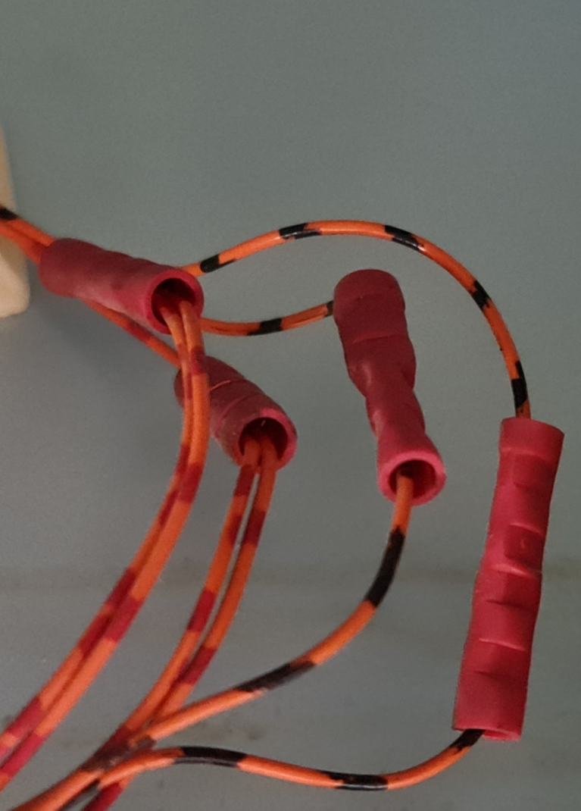
The right photo is where the wires split to become parallel for the two switches (lid and chuck side panel).
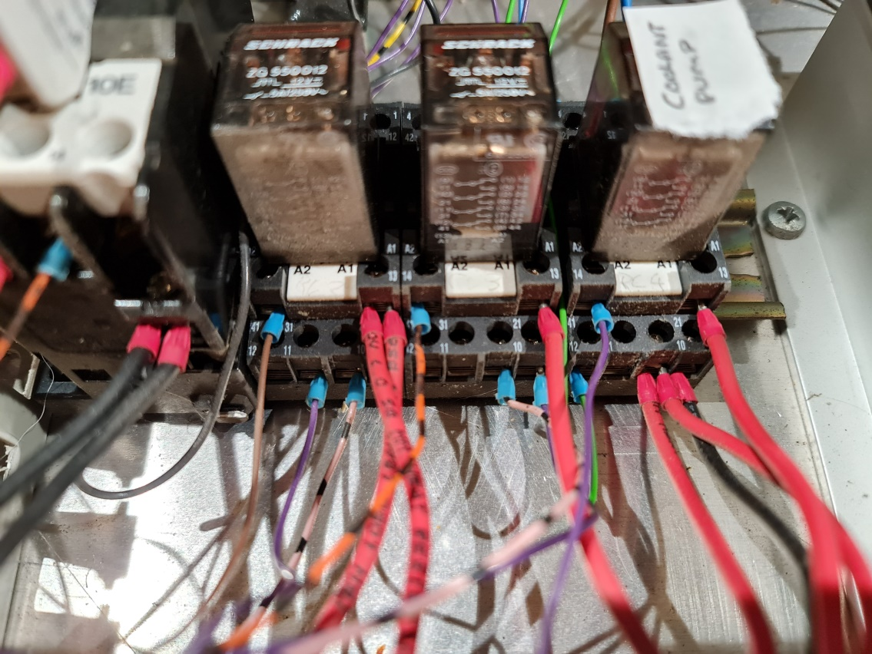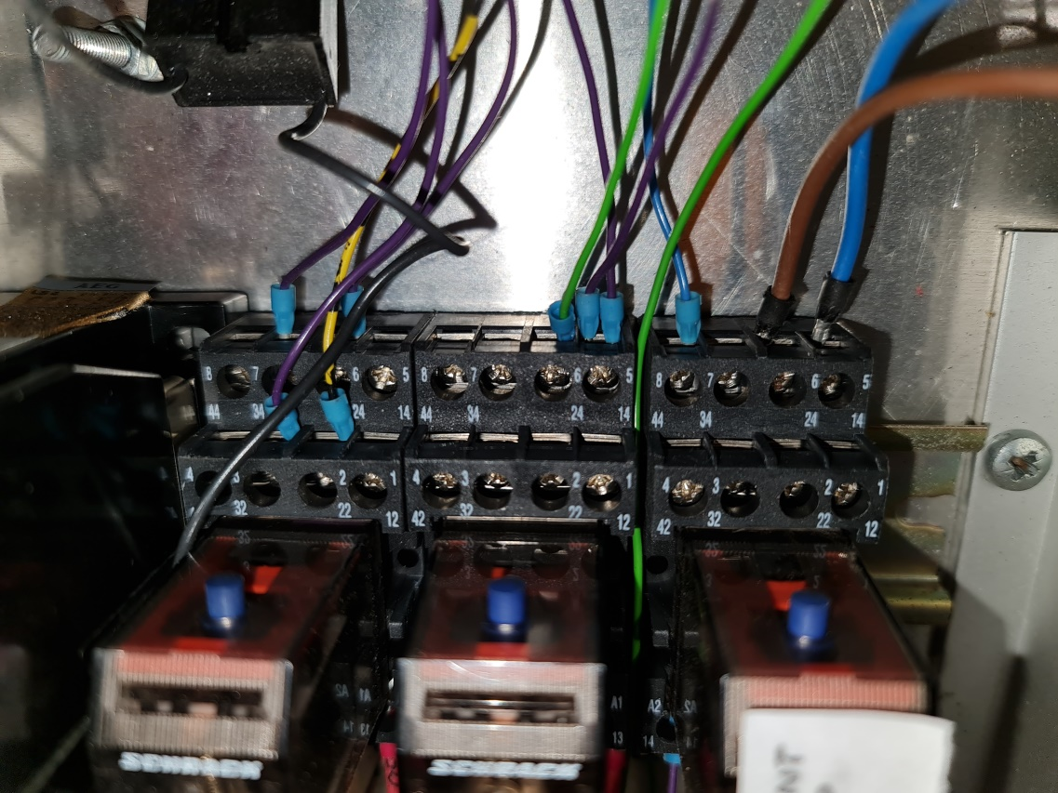

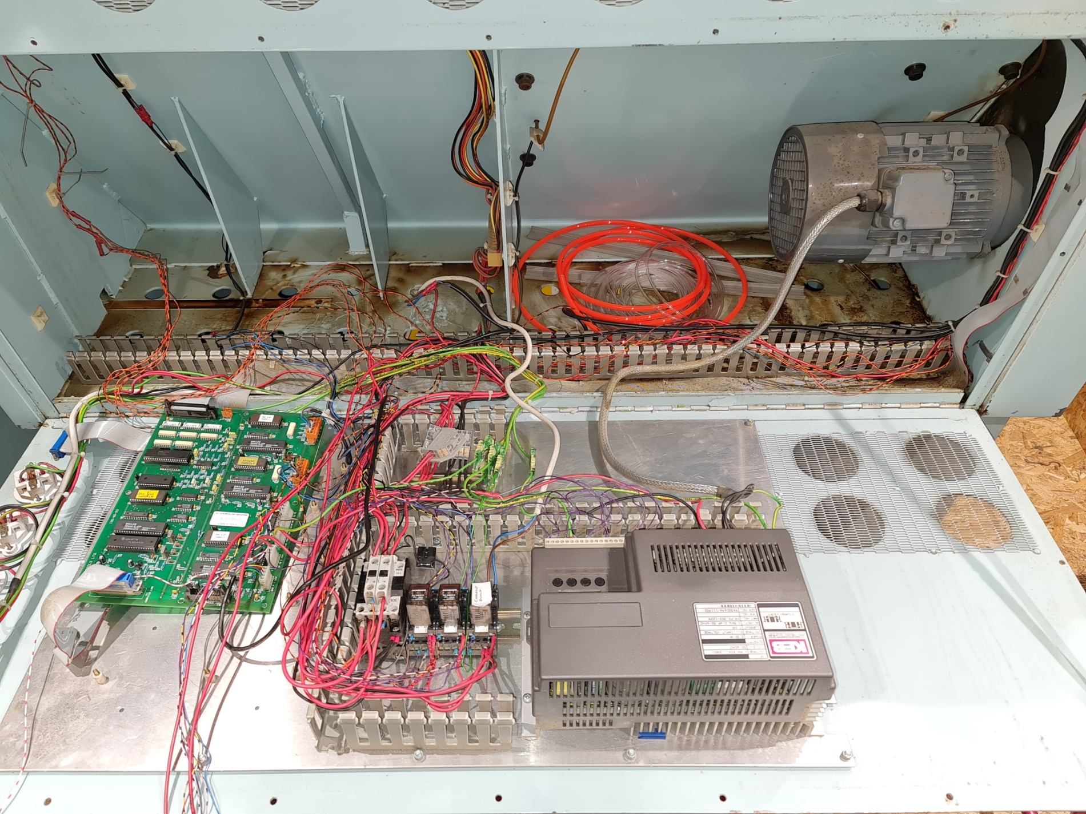
After loosening up all the wiring but nothing really disconnected

PC250 Coolant pump

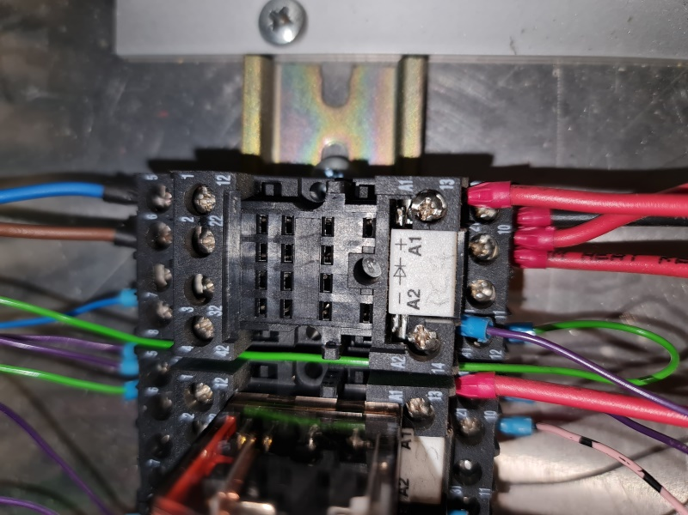
The blue wire provides a relay switched ground for the coolant LED on the control board. It is also connected to the main board via ribbon cable
Ground for the relay via MB labelled ‘C’ (for coolant) coil to activate the coolant pump. The pump runs on mains voltage (240v)
12v into relay coils
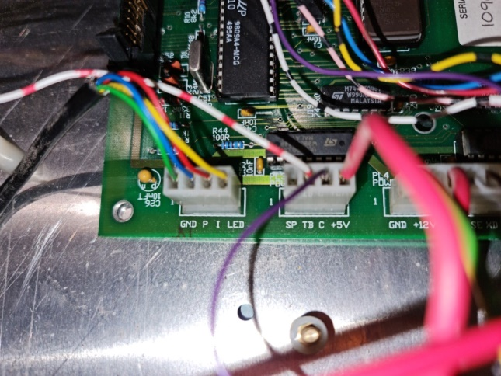
Red and white labelled TB goes to the large PCB in the bottom cabinet to label 5CL. Unknown function

PC250 VFD Connections
The KEB VFD seems to be a little more capable than that fitted to the VMC300. There are the usual 3 phase wires to the motor plus a mains in and earth and 23 separate inputs. These inputs are wired as follows with coloured arrows indicating connecting wires/terminals
- Connected to 6
- N/C
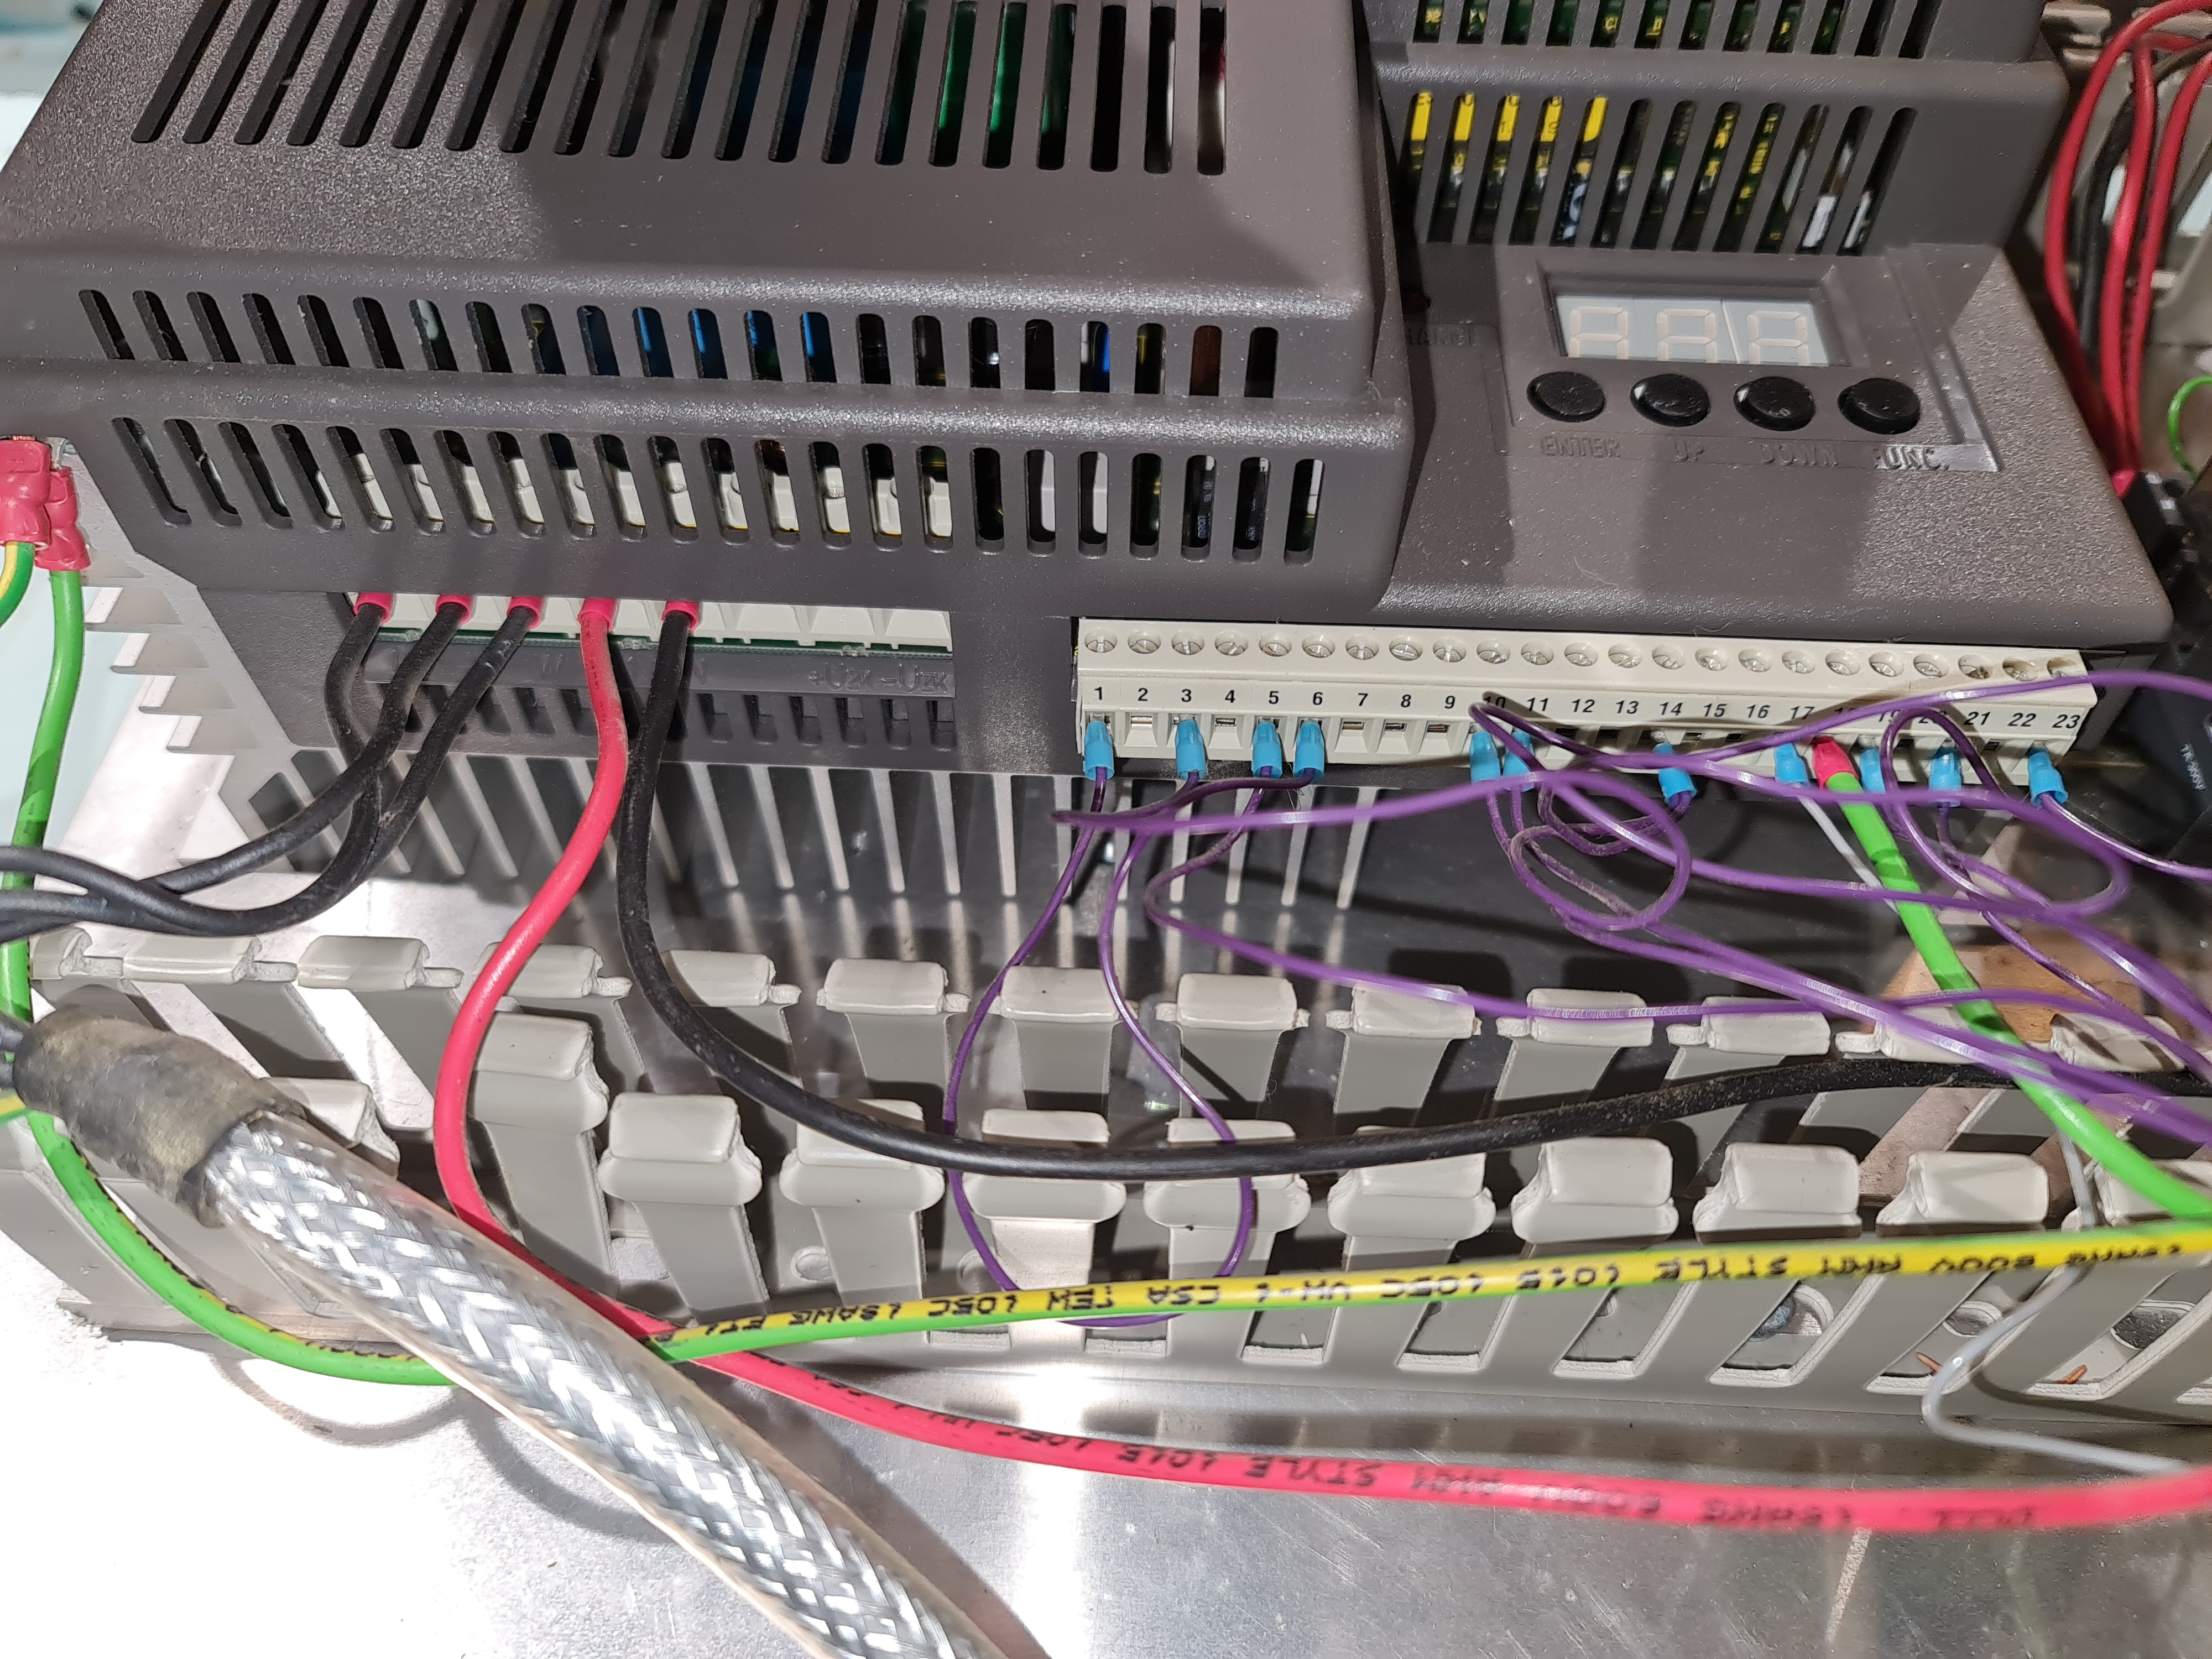
- Connected to 14
- N/C
- Connected to 21
- Connected to 1
- N/C
- N/C
- N/C
- Connected to spindle direction relay N/O (assume reverse)
- Connected to spindle direction relay N/C (assume forward)
- N/C
- N/C
- Connected to 3 and 23
- N/C
- N/C
- Connected to motherboard terminal A (analogue assume 0-10v)
- EARTH
- Connected through spindle enable relay to 23
- N/C
- Connected to 5
- N/C
- Connected through spindle enable relay back to 19

PC250 optical speed pickup

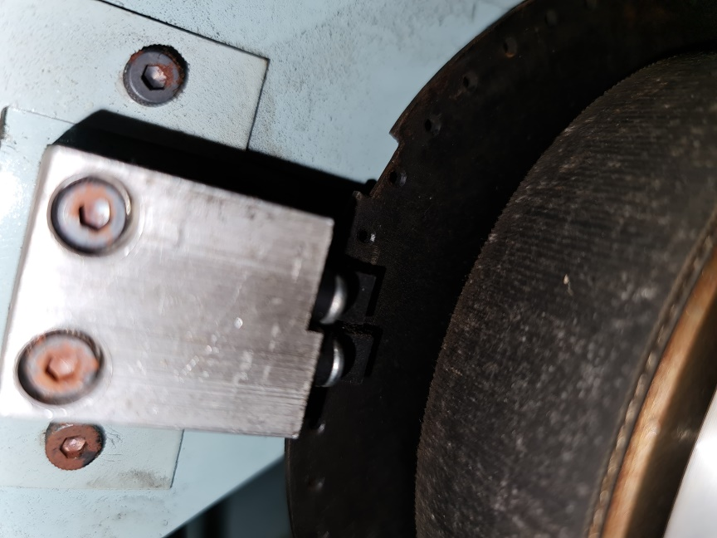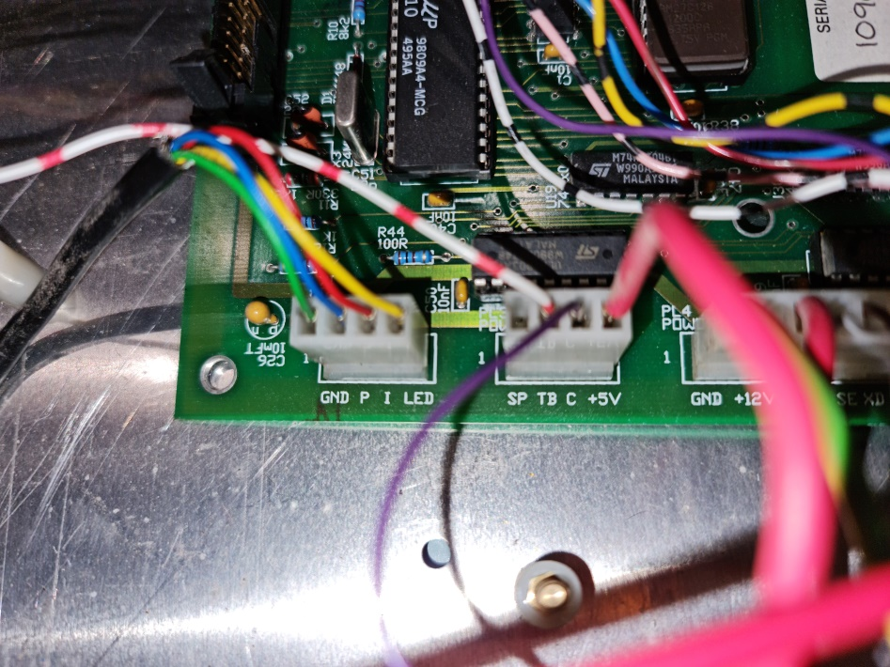
Green is ground
Blue is Pulse
Red is Index
Yellow is power for the LED
Optical pickup with 50 ‘holes’ for 360 degrees plus one index mark

How is the Emergency Stop contactor wired?
Main power comes into the top connector 3L2. This is then bridged around the NO contactor pole to 4T2. It then goes off to the emergency stop switch which has to conduct for everything to work. It then returns to the coil inbound terminal under the 3L2 terminal. The left picture is taken from the back of the cabinet looking in, the right one is taken looking out from the inside of the cabinet.
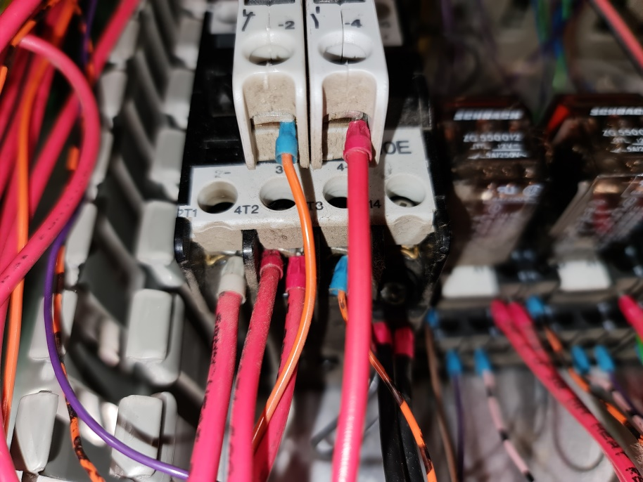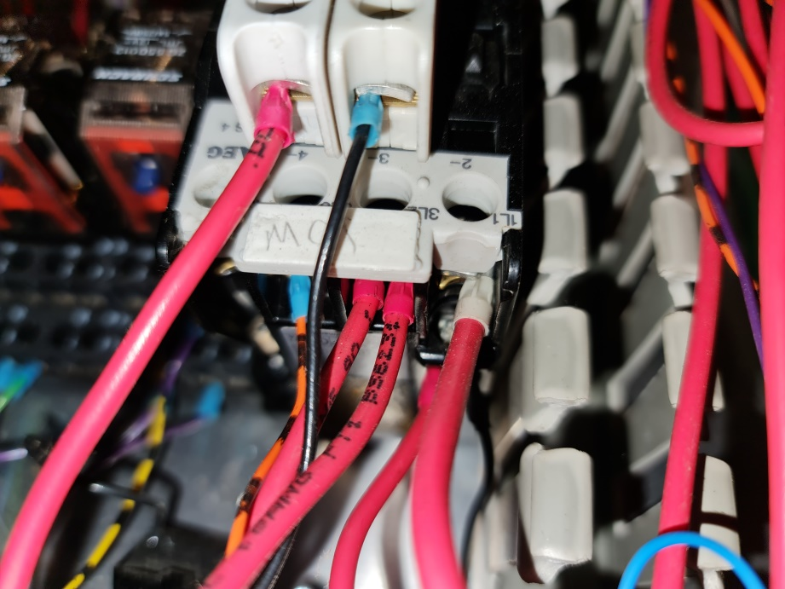

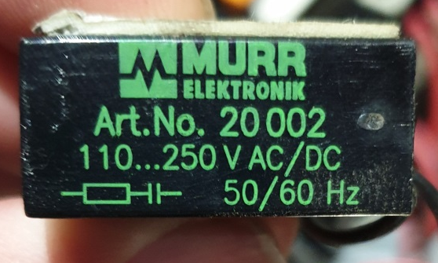These little guys attached to the contactors are surge suppressors

Red Live 240AC to coolant relay pin 21/10
Red Live 240AC
Black 115AC from the transformer

The Coil Live terminal is connected to the Estop switch

E-stop switch opens when depressed
All main contactor terminals are NO when power is off or E-stop is pressed

Black wire unknown
Orange wire unknown, maybe to do with cycle start or something?
Red Live 240AC to VFD

I think these terminals are connected to the chuck release and are normally closed. Opens when mill active but provides a ground if E-stop pressed

Red going to the bottom cabinet transformer which powers the lamp

Black 115AC to the VFD
Contactor coil output wired in black to Neutral and to lower cabinet transformer

E-stop: The new world
All the original wiring for the emergency stop remains in place meaning the motors and spindle will cut off independently of the controller. The e-stop condition is fed to the controller through the left piggy back connector on the main contactor. I take 24v from the power supply and pass it through this connector and into the controller. It is active low so when the machine is OK to run this connection is broken. As soon as the emergency stop is pressed it makes and kills the controller as intended.

Limit switches
It’s my lucky day – it seems every limit switch has decided that the prospect of having to work again was too much and they all spontaneously died. Would you believe it, every one of them!
I replaced the Z axis negative limit switch (the chuck end) as it was easy and a similar Amazon unit was readily available. All done in no time at all.
Next I started looking at the Z axis switch away from the chuck. Finding it was not a massive problem and it can be seen in the photo.
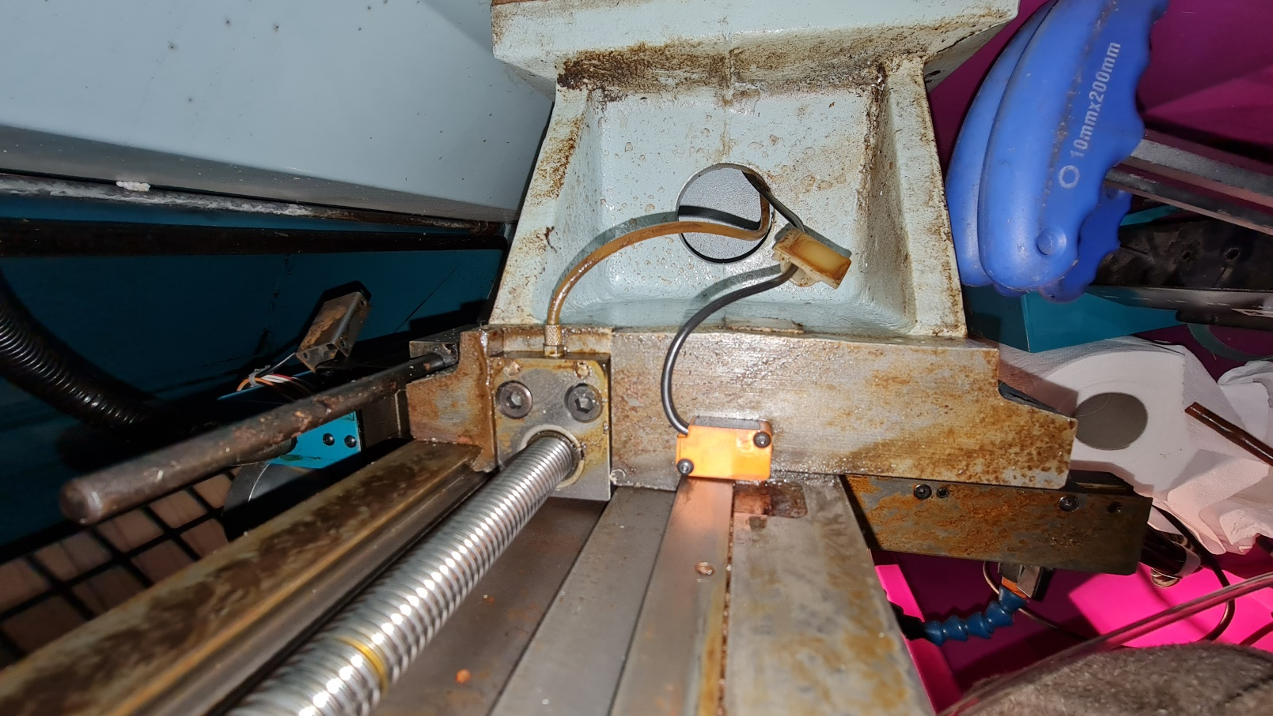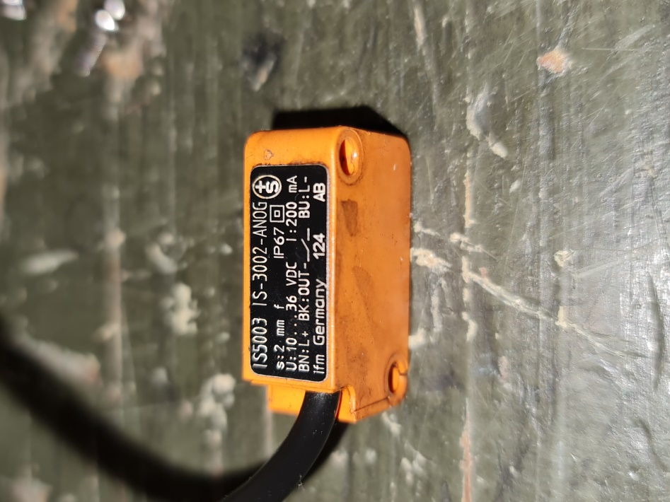
IS5003 IS-3002-ANOG. The sensing area is diagonally opposite the wire entry
The problem is the original is discontinued and the best I could find was £43 + vat and delivery. More than I am comfortable spending to be honest
So, what to do? I have ordered some of the same barrel type sensors I have used already and hope to be able to make a bracket for it. I have checked for clearance and it is looking promising so fingers crossed.

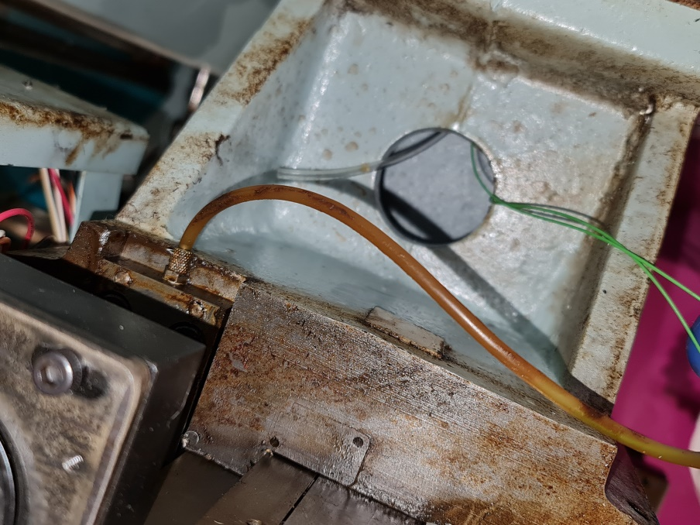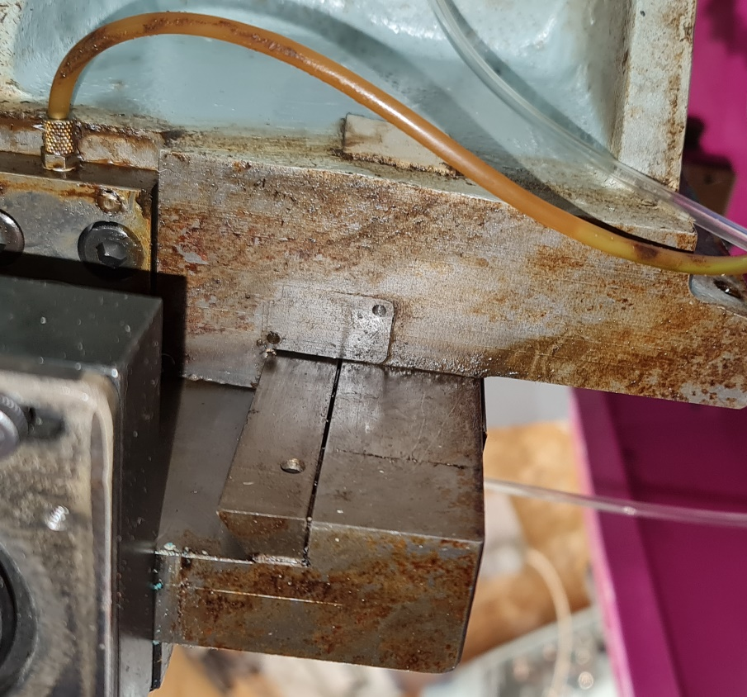

We can see where the sensor is set to NO i.e. 24v at the controller in the below photo. As the turret moves in the Z axis the cut-out in the slide gets closer triggering the limit switch. As it turns out my penchant for double checking everything meant I checked it again after removing and identifying it. Would you believe it: working fine. I must have messed up last time. So, patch it up and refit it, happy days.

Right, Z axis sorted in both directions. This leaves the X axis and that strange wire disappearing into the slide, could they be connected?
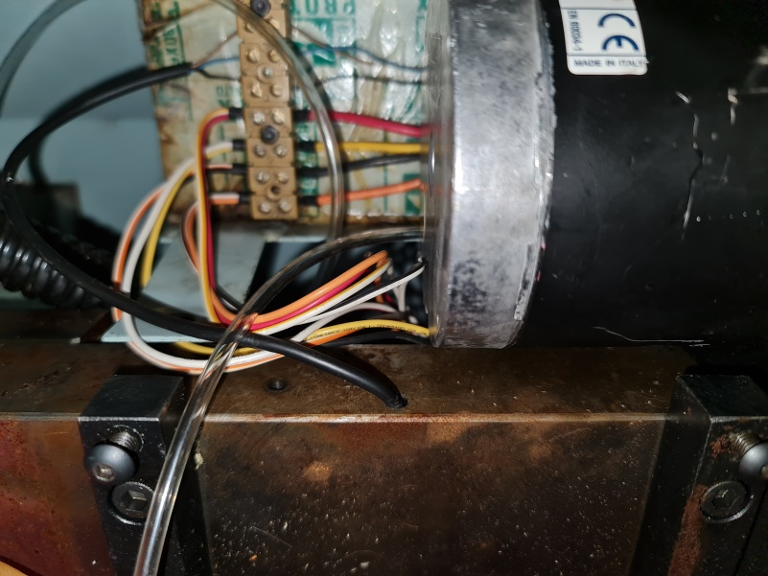 Here is the offending wire along with its connection to the back cabinet.
Here is where the cable comes in. Wiggling the wire revealed nothing……
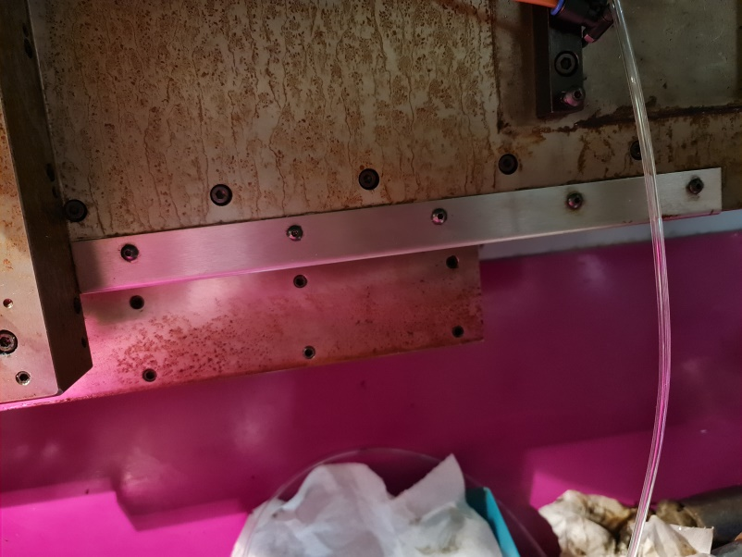 Behind this stainless plate is the next investigation point
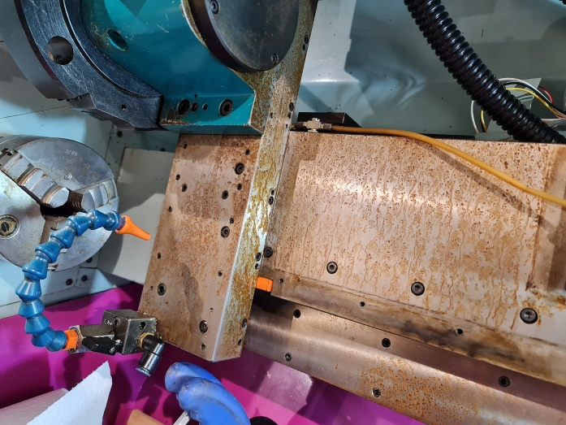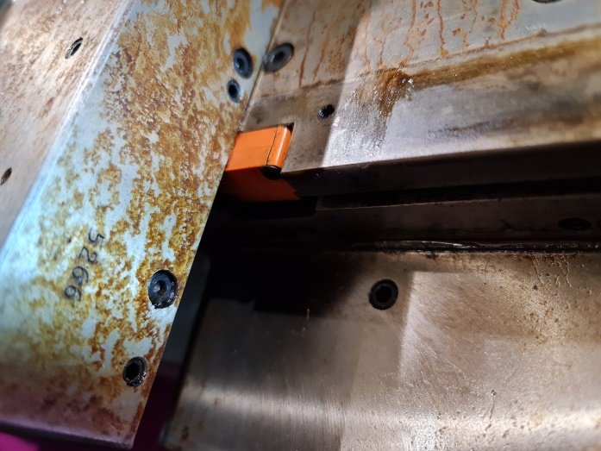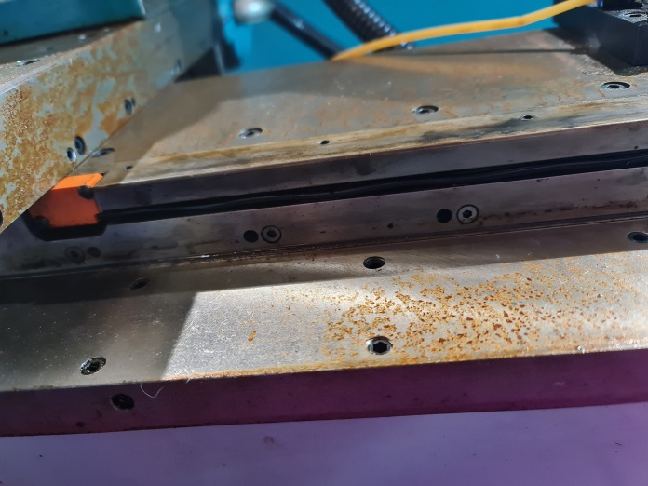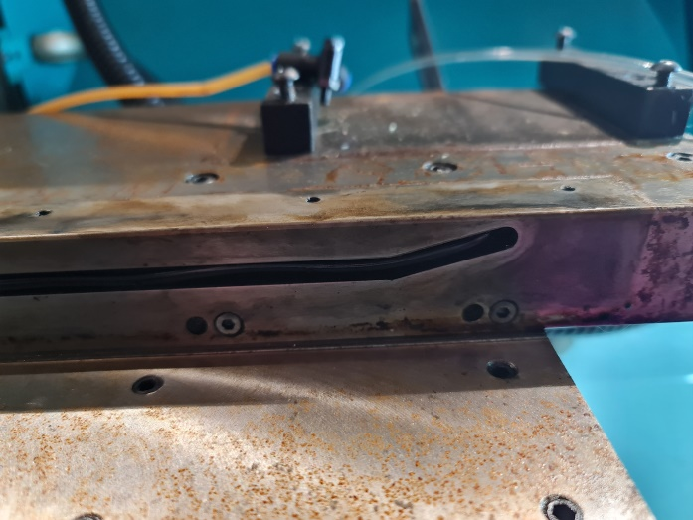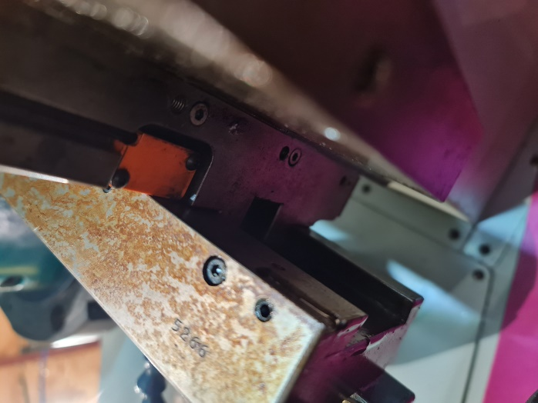
I removed the sensor, cleaned it up, tested it, refitted it and Bingo, success!!

MPG connections for use with my test connecting cable
No | Connector Number | Colour | Temp link wire colour | Link wire colour | Mach4 Input / Output number | Signal | Grouping
1 | 23 | Red | Red |  | None | +5v | Rotary Encoder
2 | 11 | Black | Black |  | None | 0v | Rotary Encoder
3 | 22 | Green | Red/Blue |  | In MPG unit | A | Rotary Encoder
4 | 21 | White | Yellow/Red |  | In MPG unit | B | Rotary Encoder
5 | 10 | Purple | Light green |  | In MPG unit | A/ | Line Driver Type
6 | 9 | Purple/Black | Green/Red |  | In MPG unit | B/ | Line Driver Type
7 | 17 | Green/Black | Yellow/Green |  | Out – Maybe connect to enable switch? | Led+ | Show Lamp
8 | 5 | White/Black | White/Blue |  | None | Led- | Show Lamp
 |  |  |  |  |  |  | Axis of Coordinates
9 | 20 | Yellow | Yellow |  | In | X | Axis of Coordinates
10 | 8 | Yellow/Black | Grey |  | None | Y | Axis of Coordinates
11 | 19 | Brown | Green |  | In | Z | Axis of Coordinates
12 | 7 | Brown/Black | White/Green |  | In | 4 | Axis of Coordinates
13 | 18 | Pink | Red/Black |  | None | 5 | Axis of Coordinates
14 | 6 | Pink/Black | Pink |  | None | 6 | Axis of Coordinates
15 | 16 | Grey | Yellow/Blue |  | In | X1 | Amplification Multiple
16 | 4 | Grey/Black | Red/Brown |  | In | X10 | Amplification Multiple
17 | 15 | Orange | Brown |  | In | X100 | Amplification Multiple
18 | 3 | Orange/Black | Blue |  | +24v | COM | Control Switch
19 | 1 | Light Blue | Blue/Black |  | None | C | Imperative Switch  (Emergency Stop)
20 | 13 | Blue/Black | Mauve |  | None | CN | Imperative Switch  (Emergency Stop)
21 | 2 | Red/Black | White |  | - |  | Spare – not used
22 | 14 | Bare Cable | ---- |  | None |  | Shield

The other relays
Relay 1

Manual Inputs
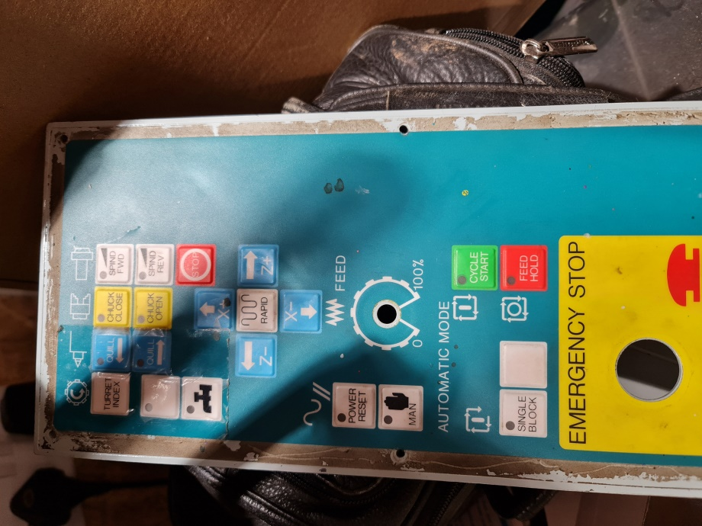
The current inputs as supported as standard
- Turret Index (one position at a time)
- Coolant
- Spindle Forward (multiple press to increase speed
- Spindle Reverse (multiple press to decrease speed
- Stop
- X+
- X-
- Z+
- Z-
- Rapid override
- 11 position feed rate override button
- Manual
- Cycle Start
- Feed hold
- Single Block
No hardware support buttons
- Quill In and Quill Out
- Close and Open pneumatic chuck

The PLAN moving forward
After a lot of abortive efforts on the VMC300 at making these inputs Mach4 friendly (grey code etc.) I have decided that maybe the best option will be a microcontroller controlled interface. I’ll debounce all the inputs and make the rotary switch output grey code which Mach4 will like.
I may also go for a Teensy 3.5 as then I can run a small graphic display for whatever. The speedy Teensy will make the display nice and responsive.

Plan B now is to use an analogue input and a potentiometer to adjust various settings. I’m not sure how many there are on the CSMIO controller but there are definitely some. I found some docs on tweaking these too so I‘m hopeful

Possible input board SPECS – probably abandoned now
- Opto isolated outputs to CSMIN/IP-S
- Max 6818 protected inputs to Teensy 3.5
- 32 input channels: 10 for the override + other functions as decided

